
Welcome to
Vibrationdata

Acoustics • Shock • Vibration • Signal Processing August 2008 Newsletter

Gamarjoba

This is the first newsletter that I have written since July 2007. I have been busy with some other projects including moving to a new home and studying Hebrew. I have also had the opportunity to teach a number of shock & vibration courses at various locations throughout the USA.

Otherwise, I have been deriving acoustic, shock & vibration environments for the Taurus II vehicle. Information about this vehicle is given at:

http://en.wikipedia.org/wiki/Taurus_II

* * * * * * * *

Each of the articles in this newsletter focuses on a particular vehicle. The first article presents an unforeseen consequence of hybrid vehicles. The second provides an acoustical analysis of the Huey helicopter. The Huey is best known for its service in Vietnam, but it is still used by the US Marines. The third article discusses a vibration problem in the Ares I launch vehicle. Enjoy.

Sincerely,
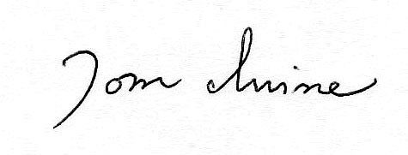
Tom Irvine
Email: tomirvine@aol.com

Feature Articles

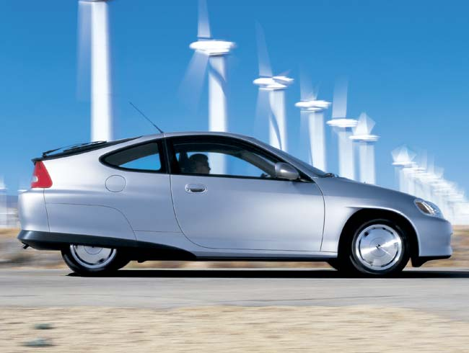
Hybrid Car Warning Sound page 2

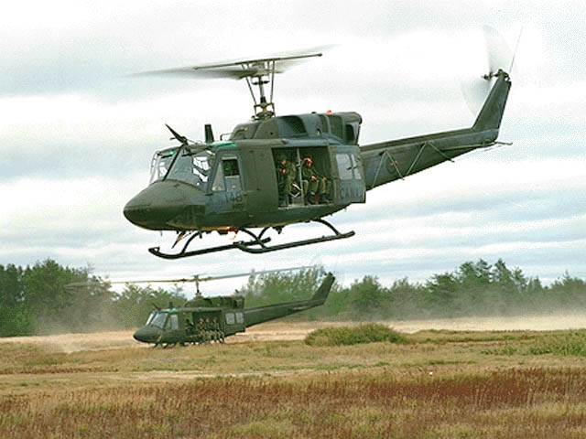

Huey Helicopter Sound & Vibration page 5

Ares I Launch Vehicle Vibration page 8

Hybrid Car Warning Sound by Tom Irvine

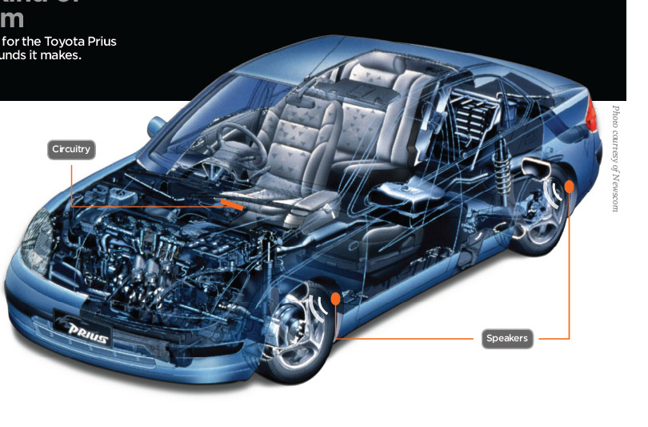

Figure 1.

Introduction

Hybrid cars are becoming increasingly popular due to the rising price of fuel and concerns about the environment. More than 350,000 were sold in the U.S. in 2007, according to marketing information firm J.D. Power and Associates.

Hybrid vehicles operate on battery-powered electric motors when idling and traveling at slow speeds. They also have internal combustion engines which activate at higher speeds.

Potential Hazard

A hybrid’s electric motor generates much less noise than its gas engine. This may be regarded as an added bonus by most people, but it poses a challenge for blind pedestrians who rely on sound to detect the presence and speed of automobiles.

Note that 1.3 million Americans are legally blind.

This hazard only occurs at lower speeds. Air flow and tire noise become noticeable above 25 miles per hour. This noise is supplemented by the sounds of the gas engine which activates at higher speeds.

Future autos may run exclusively on electrical or fuel cell power, however, somewhat exacerbating the problem.

Furthermore, guide dog training programs may need to be modified so that the dogs rely more on sight than on sound. Some guide dog schools in California are already adding the Prius hybrid car to their training regimens.

Personal Accounts from Blind People

Deborah Kent Stein is the chairwoman of the National Federation of the Blind's Committee on Automotive and Pedestrian Safety. She reported, "I'm used to being able to get sound cues from my environment and negotiate accordingly. I hadn't imagined there was anything I really wouldn't be able to hear. We did a test, and I discovered, to my great dismay, that I couldn't hear it."

Bryan Bashin, a Sacramento management consultant claims, "There's this silent-but-deadly zone where we cannot hear these cars. We're not just worried about blind people. It's a hazard to pets, joggers, young children, cyclists, people who have their back turned. . . ."

Research & Legislation
Furthermore, researchers at the University of California-Riverside have found that hybrids operating at slow speeds must be 40 percent closer to pedestrians than combustion-engine vehicles before they make enough noise for their location to be detected.
The Baltimore-based National Federation of the Blind is promoting federal legislation to protect those who rely on their hearing to know when to safely cross the street.
The Association of International Auto Manufacturers Inc., a trade group, is also studying the problem, along with a committee established by the Society of Automotive Engineers. The groups are considering "the possibility of setting a minimum noise level standard for hybrid vehicles," said Mike Camissa, the safety director for the manufacturers' association.
Solution
Everett Meyer and Bryan Bai are Stanford University graduate students who have formed a company called Enhanced Vehicle Acoustics (EVA). Start-up funding has been provided by the National Federation of the Blind.
The EVA website is:
http://evacoust.startlogic.com/
This company is developing a noise emission system as an after-market product for the Toyota Prius and other hybrid cars. A diagram is shown in Figure 1.
The system is called PANDA, for "Pedestrian Awareness Noise-emitting Device and Application.”
The system has an embedded computer that monitors whether the car is accelerating, decelerating, turning, or idling.
The computer then sends programmed sounds from mp3 files to one or more speakers on the appropriate side of the car, providing audible cues to unwary pedestrians.
The sound files mimic a combustion engine in its various operational modes.
Each particular sound is designed to be a psychoacoustic clue about the vehicle’s speed and direction.
The sound system is active at speeds up to 25 mph. Thereafter, the tire and wind noise provide a sufficient warning to pedestrians, as mentioned previously.
EVA engineers have already begun working with manufacturers to develop sounds specifically attributable to their brands.

Time (sec)
Waterfall FFT - Sound during Acceleration

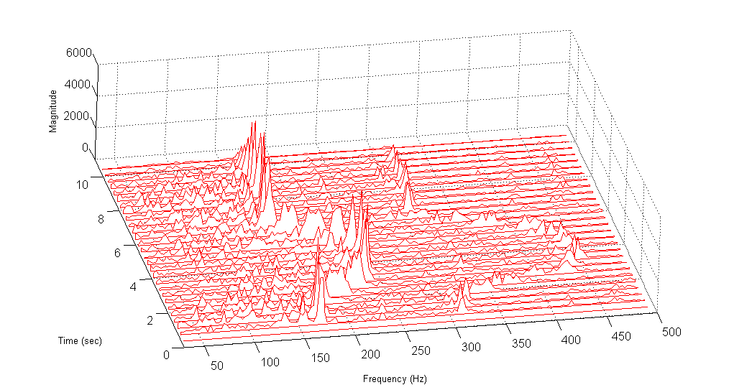
Frequency (Hz)

Figure 2.

Sound File
A sample sound file intending to mimic the acceleration of a gas-powered automobile was captured from the EVA website.
The file is posted at:
www.vibrationdata.com/hybrid_acceleration.mp3
(Whether this sound was synthesized or represents an actual recording is unclear.)
The Waterfall FFT of the sound file is shown in Figure 2. The sound begins at 160 Hz and then abruptly increases to 240 Hz. It returns later to 160 Hz.
A 2X harmonic is also present.
* * * * * * * * * * * * * * * *

“There's a difference between noise and sound, and we view
our system as producing sounds which have a purpose.”
Everett Meyer, co-founder of Enhanced Vehicle Acoustics

Huey Helicopter Sound & Vibration by Tom Irvine

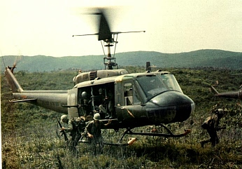

Figure 1. Huey Deploying Ground Troops

Introduction

The Bell UH-1 Iroquois or “Huey” is a multipurpose military helicopter. The Huey was developed in the 1950s. The Huey was the first turbine-equipped U.S. helicopter to go into production.

Its original role was for medical evacuation or “medevac.” It has also been used for troop transport and armed assault.

Hueys began service in Vietnam in 1962, before the United States became officially involved in the conflict. The Huey has also been used by the US Marines in Iraq.

The Huey has been featured in The Green Berets, Apocalypse Now and Platoon, as well as in numerous action adventure films.

Variants

Numerous UH-1 models have been deployed. The models are typically designed with an additional letter, such as the UH-1D. An index of models is available on Wikipedia.

The AH-1 Cobra is an attack helicopter with the same engine, transmission, and rotor system as the early UH-1 models.

Current Service

The US Army is phasing out the UH-1 Huey with the UH-60 Black Hawk as the replacement

The US Marine Corps still relies on the UH-1N model. The Marines are beginning to introduce the latest variant, the UH-1Y Venom, which has four blades on its main rotor.

The Bell Company currently offers the Huey II which is a modified and upgraded UH-1H.

Dozens of other countries also use the Huey.

In addition, some US law enforcement and fire fighting agencies currently use Hueys for search and rescue and other purposes.

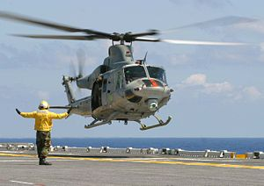

Figure 2. Bell UH-1Y during Sea Trials aboard USS Bataan

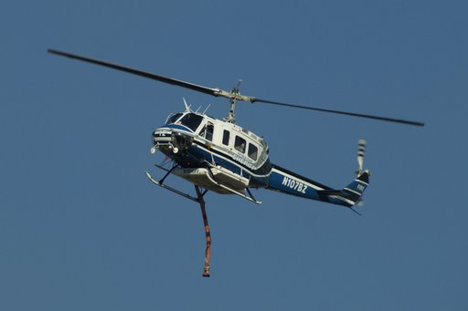

Figure 3. Civilian Counterpart of the Huey Equipped with Fire Hose

Commercial Models

Bell also built commercial versions of the military Hueys beginning in 1960, particularly the 214 and 412 models.

The Model 412 is equipped with a four-bladed rotor and more powerful engines. It was still being produced at Bell Helicopter Canada in 2000.

Specifications for Acoustic Analysis

The information in this section is for the nominal UH-1. The parameters vary per model.

Typically, the main rotor and the tail rotor each have two blades. The UH-1Y has four blades on each rotor, however.

Table 1. UH-1 Helicopter Specifications
Parameter | Value
Main Rotor Blade Length (radius) | 22 to 24 feet
Main Rotor Speed | 5.40 Hz (324 rpm)
Tail Rotor Speed | 27.7 Hz (1662 rpm)

The frequencies are taken from MIL-STD-810F, Table 514.5C-IV.

Huey Acoustic Analysis

Acoustic data is available from the flyover of seven UH-1D Hueys, which were flying in formation.

The data is taken from:

www.youtube.com/watch?v=0ghc850hkho

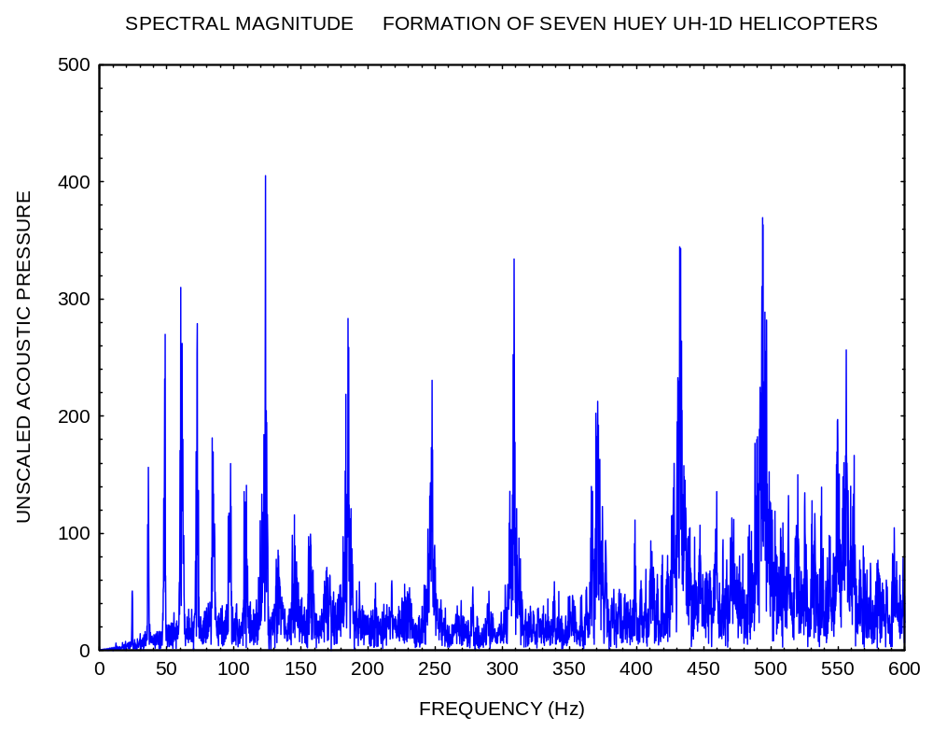
Figure 3.

The first notable peak occurs at 24.0 Hz. A series of harmonics occur at 12 Hz intervals thereafter. These are the blade passing frequencies of the main rotor.

The main rotor blade passing frequency is: 5.40 Hz x 2 blades = 10.8 Hz

The Doppler shift increases the apparent blade passing frequency to 12 Hz. The theoretical speed of the helicopters was 76 mph based on this shift.

The main rotor blade tip velocity for a stationary Huey is 814 feet/sec or Mach 0.72 assuming that the speed of sound is 1120 feet/sec.

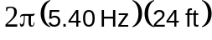 = 814 feet/sec

The blade tip velocity would be 925 feet/sec or Mach 0.82 for a Huey traveling at 76 mph.

The tail rotor blade passing frequency is 55.4 Hz for a stationary Huey. This would increase to 61.5 Hz for a Huey traveling at 76 mph toward the receiver. The highest individual peak in Figure 3 is at 123 Hz, which is twice this value. The tail rotor is thus the source of the highest individual peak.

Note that there is also a nearby peak at 120 Hz which is a harmonic of the main rotor hub frequency.

Ares I Launch Vehicle Vibration by Tom Irvine

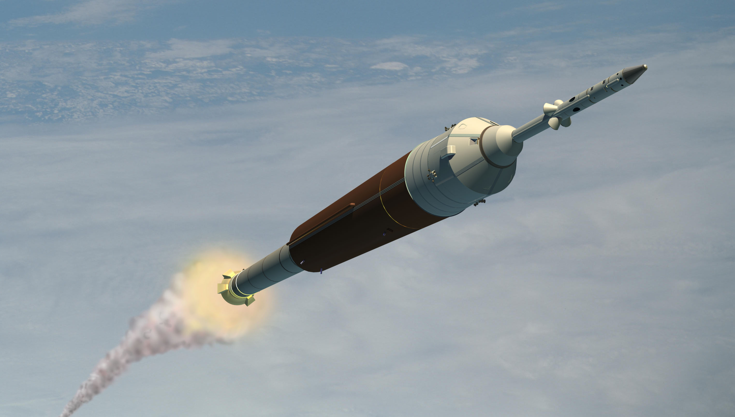

Figure 1. Ares I Launch Vehicle

Introduction

The Ares 1 is the booster for the manned Orion spacecraft.

The booster is also referred to as the Crew Launch Vehicle (CLV).

The Orion spacecraft is also referred to as the Crew Exploration Vehicle (CEV).

The Ares I / Orion vehicle is intended to replace the Space Shuttle which is scheduled to be retired in 2010.

The Ares I height is 94 meters (309 ft).

The Ares I first stage is a solid rocket motor, derived from the current Space Shuttle Solid Rocket Booster (SRB). The current Space Shuttle SRB has four segments. The Ares I motor has an additional fifth segment. This fifth segment will enable the Ares I to produce more thrust and burn longer.

The Ares I second stage has a liquid engine, model J-2X. The fuel consists of liquid hydrogen and liquid oxygen. The J-2X is derived from the J-2 engine used on the Saturn IB and Saturn V rockets. The thrust is 294,000 lbf.

Vibration Problem

The Ares I vehicle has a potential coupling between thrust oscillations in the SRM and the second longitudinal vibration natural frequency of the complete launch vehicle.
The thrust oscillation is also called resonant burn. Many solid rocket motors have this characteristic. The combustion chamber in a solid motor may behave as an “organ pipe,” with standing pressure waves.
Vortices created inside the solid rocket motor by the burning propellant or other flow disturbances, can coincide, or tune, with the acoustic pressure modes of the motor combustion chamber. Longitudinal forces are thus generated.
These longitudinal forces may increase the loads experienced by the Ares I during flight, and may exceed allowable loads on various portions of the vehicle and allowable forces on the astronaut crew.

Frequency

The thrust oscillation frequency of the Ares I five-segment booster is 12 Hz (compared with 15 Hz for the Shuttle’s four-segment version).

Amplitude

A “conservative” estimate of the corresponding acceleration input to the astronauts is 5 G.
Scott (Doc) Horowitz is a four-time shuttle veteran who later headed NASA's Exploration Systems Mission Directorate as Ares I development was getting under way. He is now a consultant. He estimates that the actual acceleration level may only be 0.25 G.
Horowitz said that about half of the shuttle astronauts report that vibrations from the twin solid-rocket boosters make it difficult for them to see displays during ascent. This will probably be the ultimate effect of the thrust oscillation in the Orion from the Ares I.
"You're probably not going to want to shake the crew more than about a quarter of a G, and people are trying to go get a more detailed number on that, if you want them to be able to operate," he said.

Reference: Frank Morring Jr., “Ares I Vibration Problem Fixable,” Aviation Week & Space Technology, March 31, 2008.

Potential Solutions

Several solutions have been proposed to attenuate the vibration. Another problem is that any solution will almost certainly add mass to the vehicle, thus reducing the maximum payload capacity.

NASA program manager Jeffrey Hanley reports that actively tuned mass dampers are being considered to solve the first stage oscillation problem.
The damper mass is mounted on a spring or springs that will be located either inside or outside the first stage aft skirt. The dampers can be actively "tuned" to respond to the oscillation frequency of the Ares I first stage solid rocket motor.

This damping device is also described as a spring-like electromagnetic mass absorber.

The author plans to give further information about the proposed damping system in future Vibrationdata Newsletters.

Additional Concerns

Other issues for Ares I include:

- pocket buckling in the upper-stage liquid hydrogen (LH2) tank

- an immature first-stage forward skirt avionics box design

- protection for parachutes against the interstage's shaped linear charge separation system

- first-stage thrust vector control (TVC) changes

Ares I / Orion First Flight

NASA officials have said that March 2015 is the official target to begin operational manned flights of the Orion spacecraft. This will create a five year gap since the Space Shuttle is being retired in 2010.



