

**Welcome to**

**Vibrationdata**

# Acoustics • Shock • Vibration • Signal Processing August 2011 Newsletter

#### Feature Articles

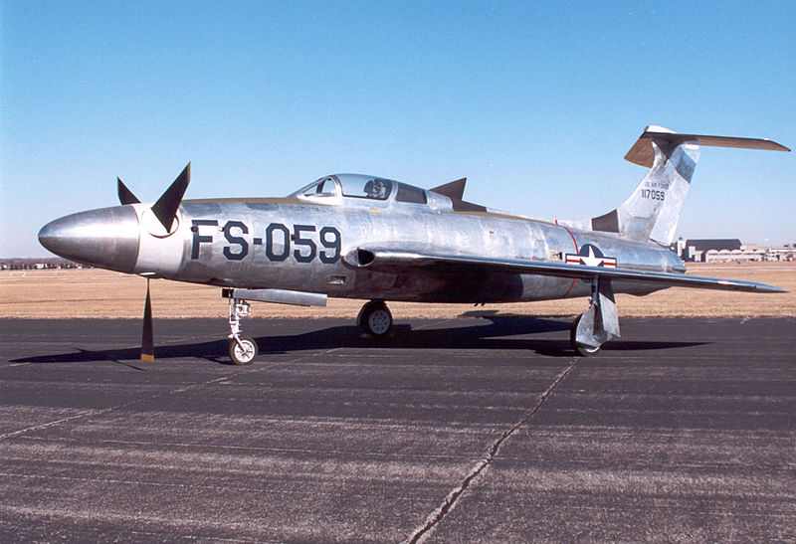

**Republic XF-84H Aircraft Sound & Vibration** page 1

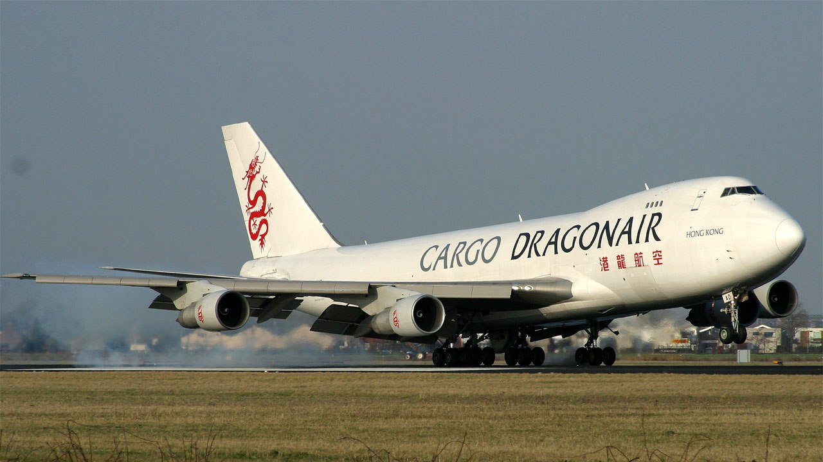

**Aircraft Landing Shock** page 4

**Turbofan Engine Buzz-Saw Noise** page 10

**Hello World**

Aviation is the theme of this newsletter. My interest in aviation began with my late father who was a private pilot. He took me for rides in Mooneys and Cessnas over the deserts of Arizona.

I also remember going with him to watch T-38s do touch-and-goes at the former Williams Air Force Base in Mesa, Arizona.

In a bygone era, we watched skywriters using smoke particles to advertise for a local car dealership.

My interest in aviation morphed into spaceflight as we watched Neil Armstrong and Buzz Aldrin set foot on the Moon on Sunday night, July 20, 1969.

After twenty-some years in the aerospace industry, I am now a representative to the NASA Engineering & Safety Center (NESC) Technical Disciplines Team for Loads & Dynamics under the leadership of Dr. Curtis Larsen.

Such was the influence of my father on my education and career.

Sincerely,

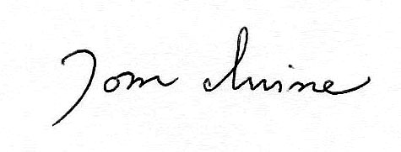

Tom Irvine

Email: tomirvine@aol.com

**Republic XF-84H Aircraft Sound & Vibration**  by Tom Irvine

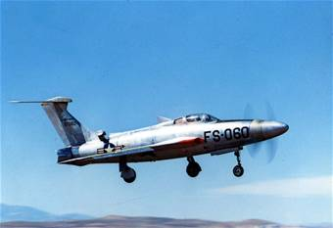

Figure 1. XF-84H Prototype

Introduction

The U.S. Navy had a short-lived requirement in the 1950s for a carrier fighter that could take off under its own power, without catapult assistance.

Note that the turbojet aircraft of the time were underpowered and had high fuel consumption rates. Thus there was interest in a high-performance turboprop aircraft as an alternative.

The USAF Wright Air Development Center took over the development of the prototype after the US Navy abandoned the project. The UASF built two prototypes, but the aircraft never went into production.

The XF-84H was built from a modified F84F airframe with a 5,850 hp Allison XT40-A-1 turboprop engine. The T40 was a pair of 2,750-shaft-horsepower T38 engines inside a common case.

The propellers had variable pitch for thrust control.

The XF-84H was also the first airplane to carry a ram air turbine, which automatically deployed from a compartment in the dorsal fin and pinwheeled in the airstream to provide extra electrical and hydraulic power.

Supersonic Blade Tips

Note that standard propellers have subsonic blade tip speeds. But the XF-84H had supersonic propellers, which had a tip velocity of 901 mph or Mach 1.18, even when the aircraft was idling on the ground. Actually, the twelve-inch long section of the blade up to the tip had a supersonic tangential velocity.

The aircraft became known as *Thunderscreech* due to the resulting sonic boom, shock waves, noise, and vibration.

The shock waves caused the flow over the blades to separate. This reduced the efficiency of the propeller due to increased drag.

The XF-84H may have even been the loudest aircraft ever built. The Smithsonian Air & Space Magazine, July, 2003 reported:

Most accounts of the XF-84H program specify that the propeller spun at 3,000 rpm, which would have resulted in the prop tips traveling at an incredible Mach 1.71. Extensive research and computation by John M. Leonard of the Rolls-Royce Heritage Trust (Rolls Aerospace currently owns Allison) indicate that an engine turning at 14,300 rpm driving a 6.8:1 gearbox, as the T40 did, would push the tips of a 12-foot-diameter propeller to a far more logical Mach 1.18.

The propeller hub frequency would have thus been 2100 rpm, or 35 Hz. The blade passing frequency would have been 105 Hz with integer harmonics thereof.

Ground Noise

The pervasive noise also severely disrupted operations in the Edwards AFB control tower by risking vibration damage to sensitive components and forcing air traffic personnel to communicate with the XF-84H's crew on the flight line by light.

Testing was thus moved to Rogers Dry Lake Bed in the Mojave Desert.

Henry Beaird was a Republic test pilot at the time and one of only two men ever to fly the XF-84H.  He claimed that he could hear the aircraft 22 miles away from the base, when the crew ran up the engine to full power.

Beaird said that “As long as you stood ahead of or behind the airplane, it really wasn’t so bad, but if you got in the plane of the prop, it’d knock you down.”

Beaird also recalled a ground test where the XF-84H was run for 30 minutes near a presumed empty C-47. As the test crew was getting ready to tow the XF-84H back to the ramp, they heard this banging in the back of the C-47. It was the crew chief, Beaird relates, knocked silly by the high-intensity noise and on his back on the floor of the C–47, flailing his limbs. “He eventually came out of it.”

Stability Problems

Furthermore, the XF-84H had two stability problems.

1. It was destabilized by the powerful torque from the propeller.
2. The propeller governor, which controlled rotational speed, would start surging at 400 knots, and the aircraft would roll rather violently.

Test Flights

The two prototypes flew a total of twelve test flights from Edwards, accumulating only 6 hours and 40 minutes of flight time. Ten of these flights ended in forced landings due to problems with engine and driveshaft vibration and instability.

The XF-84H was expected to have a flight speed of 670 mph, but neither of the two X-planes ever made it past 450 mph.

Additional Aircraft with Supersonic Propellers

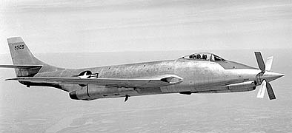

Figure 2. XF-88B

The XF-88B was powered by a nose-mounted Allison T38 turboprop engine and two turbojets. Typical takeoffs and landings were made with the propeller blades feathered and clocked in the X position. Propeller ground noise was thus not an issue.

The aircraft achieved speeds slightly exceeding Mach 1.0 during test flights through 1956. The maximum speed occurred during dives.

The XF-88B was an experimental aircraft which was never put into production. The National Committee for Aeronautics (NACA) conducted the research.

NACA found that the blades needed to be shorter and thinner and set at a reduced blade angle in order to make the blades supercritical. The regions of supersonic flow would thus form at higher speeds than is possible with standard props.

The supersonic prop can operate at higher speeds by delaying the onset of shock waves and reducing their strength once they do form.

**Aircraft Landing Shock** by Tom Irvine

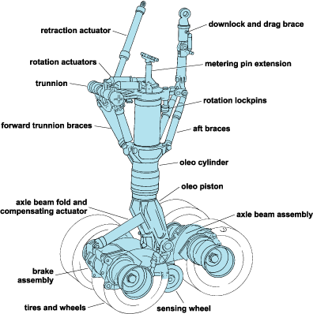

Figure 1. Main-wheel Bogie for the XB-70A aircraft

Introduction

Commercial pilots must achieve smooth but firm landings by carefully controlling the sink rate, flare angle, and other settings. A smooth landing is desirable for the passengers. But the landing must also be firm enough to prevent runway overrun. Furthermore, wind and rain present hazards.

As a result of these challenges, some aircraft experience hard landings, damaging the aircraft. Injuries to crew and passengers may occur.

Hard landings are the leading cause of aircraft accidents in terms of airframe structural damage according to Flight Safety Digest.

Fatalities have occurred in extreme hard landing cases but are rare. The leading causes of deaths are controlled flight into terrain (CFIT) and in loss of control cases.

Landing Gear, Energy Dissipation

The aircraft’s kinetic energy at touchdown is dissipated by the landing gear, primarily by the oleo struts. Each strut is filled with oil that is forced at a controlled rate through an orifice as the strut is compressed on touchdown. An efficient landing gear design thus reduces the loads transmitted into the airframe during landing. It also damps the vertical oscillations.

Landing Gear Deflection

The shock strut static deflection varies per aircraft model. The Boeing 737-200 has a total stroke of 14.0 inches. The C-141 has a total stroke of 28.0 inches. The static deflection for transport aircraft is typically ~15% of the total stroke. In addition, the tires undergo static and dynamic deflection. The preceding values were taken from Reference 3.

Landing Shock Environment

There are many variables which affect the touchdown shock level of an aircraft. These include:

1. Descent or sink rate
2. Flare
3. Forward and side velocities
4. Roll, pitch, and yaw angles and corresponding rates
5. Weight and center of gravity
6. Cross wind, wind shear, gusts, etc.
7. Runway contact loads

Note that the flare is a maneuver to raise the aircraft’s nose just before landing on the runway in order to reduce forward and descending speeds.

Sink Rate

Note that the FAA requires that a transport aircraft be able to withstand the shock of landing at 10 ft/sec at the design landing weight, per Reference 1. The FAA does not give a corresponding acceleration level, however.

A brief survey of transport aircraft incident reports has shown that damage has occurred in hard landings with acceleration levels of 1.86 G and higher, as measured by flight data recorders.[1]

Boeing has established a landing acceleration limit of 1.8 G for the 747 aircraft. This is a “Net vertical CG load factor.” It is the trigger level for unscheduled inspection and maintenance.

The trigger levels are shown in Table 1, as taken from Boeing, Reference 2.

Case Histories

Sample case histories of hard landings are given in Table 2. Catastrophic crash landings are not included.

The date and airport are omitted from the Table 2 for brevity, but this data is given in the references.

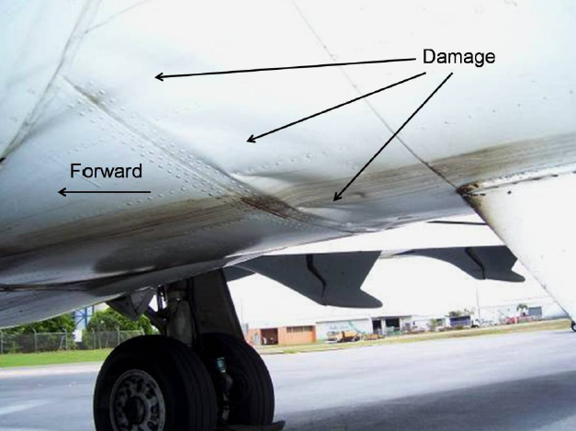

Figure 2. Fuselage Skin Panel Damage

The damage occurred in a Boeing 717-200 due to hard landing, Reference 4.



Figure 3. Tail-strike Damage

Swiss-operated BAE Systems [Avro](http://www.flightglobal.com/landingpage/avro.html) RJ100 at London City Airport, August 18, 2007.

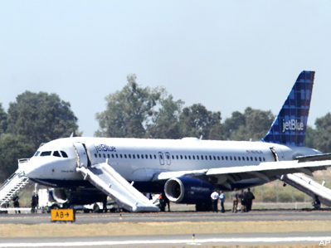

Figure 4. JetBlue Airbus A320, Hard Landing, Sacramento, August 26, 2010

The hard landing occurred because the parking brake was engaged, either through pilot error or a technical fault. Four main landing gear tires blew out, and a minor tire-related fire erupted. The passengers exited via emergency slides after the aircraft came to a standstill. Seven people had minor injuries from either the landing shock or the rapid evacuation, per NTSB report WPR10IA430.

Table 1. Trigger Levels for Unscheduled Inspection and Maintenance

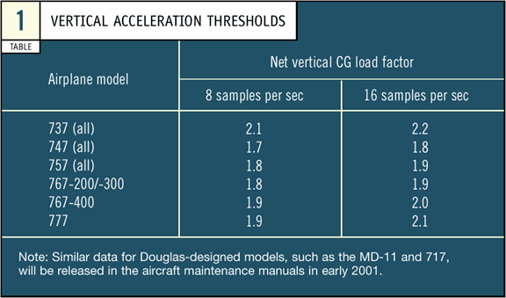

|  |  |  |  |  |
| --- | --- | --- | --- | --- |
| Table 2. Sample Hard Landings, Ranked in order of G Level | | | | |
| Ref. | Aircraft | Sink Rate (ft/sec) | Accel (G) | Damage |
| 4 | Boeing  717-200 | 17.9 | 3.6 | Rear fuselage skin panels deformed and wrinkled. |
| 5 | Airbus  A340-600 | 18.3 | 3.0 | Serious damage to undercarriage |
| 6 | Boeing  747-436 | 17.8 | 2.86 | Structural damage to the fuselage keel beam in the area of the landing gears, and slight *out-of-round* damage to some of the wheel hubs. *Quilting* and *rippling* of the skin panels just aft of the wing. |
| 7 | Boeing  MD11 | 18 to 20 | 2.6 | Right landing gear collapsed. Right wing separated. |
| 8 | Airbus  A340-311 | 16.7 | 2.17 | Damage to tires and landing gear hardware. No structural damage. |
| 9 | **Airbus**  **A321**-2009 | 9.1 | 1.91 | Tail-strike & other structural damage |
| 10 | Boeing  737-210C | 6.7 | 1.86 | Substantial damage. Left nose tire burst. |



Figure 5.

The data points from Table 2 are plotted in Figure 5.

Higher sink rates tend to yield higher acceleration levels. But the scatter is too much for a curve-fit, partially because the aircraft models differ.

References

1. Federal Aviation Administration, FAR Part 25, Airworthy Standards: Transport Category Airplanes, Subpart C, Section 25.473.
2. http://www.boeing.com/commercial/aeromagazine/aero_14/conditional_story.html#tab1
3. Norman S. Currey, Aircraft Landing Gear Design: Principles and Practices, AIAA Education Series, 1988.
4. Australian Transport Safety Bureau, Hard landing - Darwin Airport, Northern Territory, 7 February 2008, VH-NXE, Boeing Company 717–200**,**  Investigation Number: AO-2008-007.
5. David Kaminski-Morrow,Extremely hard landing led Iberia A340 to overrun at Quito, Flightglobal, Date: 25/01/08.
6. UK Air Accidents Investigation Branch, Boeing 747-436, G-BNLF, AAIB Bulletin No: 11/97, Ref: EW/A97/4/01, Category: 1.1.
7. Civil Aviation Department Hong Kong, Accident Investigation Division, Aircraft Accident Report, 1/2004, Report on the accident to Boeing MD11 B-150 at Hong Kong International Airport on 22 August 1999.
8. Bureau d’Enquêtes et d’Analyses pour la sécurité de l’aviation civile, Report: Incident on 25 May 2001 at Cayenne-Rochambeau Airport (French Guyana) to the Airbus A340-311 registered F-GLZC operated by Air France.
9. Japan Transport Safety Board, Aircraft Accident Investigation Report, AA2011-3, Asiana Airlines Inc. HL7763, March 25, 2011.
10. Transportation Safety Board of Canada, Aviation Investigation Report Number A01W0117, Landing Event - Hard Landing, First Air Boeing 737-210C C-GNWI, Yellowknife Airport, Northwest Territories, 22 May 2001.**TransS**
11. *Stabilized Approach and Flare are Keys to Avoiding Hard Landings,* Flight Safety Digest, August 2004.

**Turbofan Engine Buzz-Saw Noise** by Tom Irvine

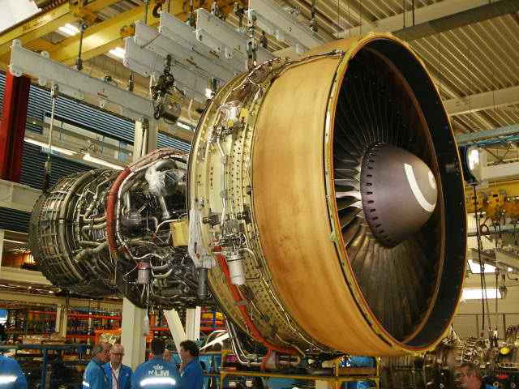

Figure 1. General Electric CF6 Turbofan Engine

Introduction

Turbofan blades undergo supersonic motion.

The total Mach number depends on the blade tangential velocity and on the airflow speed. Note that the speed of sound varies with air temperature, which varies with altitude.

Aerodynamic shock waves form in the airflow around the blades. The shock waves combine at the fan shaft frequency and its integer harmonics.

Minute differences in the blade dimensions due to manufacturing tolerances contribute to this effect. The shock wave in front of each blade has unique physical properties accordingly.

The resulting sound is referred to as *buzz-saw noise.* It is also known as Multiple Pure Tone (MPT) noise.

Diagrams

The turbofan engine noise sources and radiation patterns are shown in Figures 2 and 3. The engine subsystems are given in Figure 4.

GE CF6-6

The CF6-6 is an example of a turbofan engine with supersonic fan blades. It was developed as a commercial version of the TF39 used on the C-5 Galaxy, a military transport jet.

The CF6-6 engine generates 40,000 lbf thrust, with a fan rotor speed of 3810 rpm (63.5 Hz). The radius of the fan and hub assembly is 48 inches. The resulting blade tip velocity is nearly 1600 feet/sec, which is Mach 1.4. The Mach number in flight is actually higher due to the velocity contribution of the airflow.

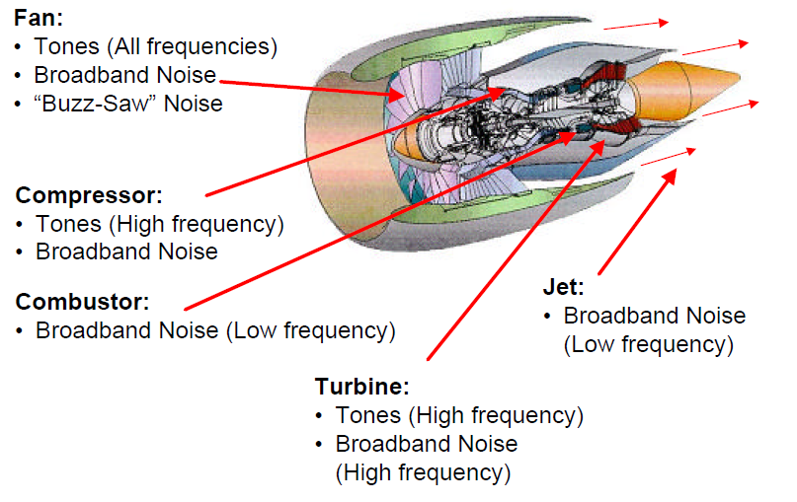

Figure 2. Turbofan Engine Noise Sources

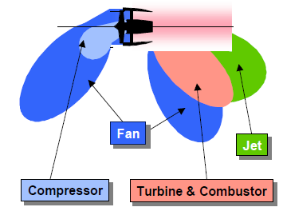

Figure 3. Turbofan Engine Radiation Pattern

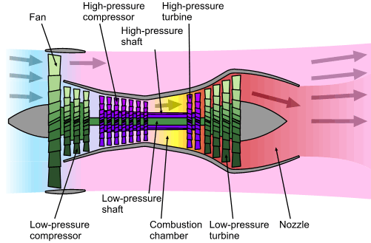

Figure 4. Turbofan Engine Subsystems

The engine has two concentric rotors, which operate at different speeds.

The low-pressure shaft drives the fan and the low-pressure turbine.

The other shaft drives the compressor and high-pressure turbine.



Figure 5.

C-5 Galaxy with TF-39 Engines

A sound file from the takeoff of a C-5 was taken from:

www.youtube.com/watch?v=A5pojoZwYnI

The sound was recorded by a passenger.

The Fourier transform from the sound file is shown in Figure 5. The frequency spacing is 51 Hz, which corresponds to a fan shaft speed of 3120 rpm.

The blade tip velocity is about Mach 1.1. The true Mach number is higher due to the airflow speed.



Figure 6.

A320-232 with IAE V2527-A5 Engines

A sound file from the takeoff of a Hungarian Wizz Air A320-232 was taken from:

www.youtube.com/watch?v=VeAoJrvU2Ho

The sound was recorded by a passenger who presumably ignored the safety warning about turning off all portable electronic devices prior to takeoff.

The Fourier transform from the sound file is shown in Figure 6. The spectral peaks occur at increments of 79 Hz.

There is a spectral peak at 79 Hz, but it is surrounded by other peaks at nearby frequencies.

The frequency spacing indicates a fan shaft speed of 4740 rpm. The maximum allowable speed for this engine model is 5650 rpm.

The fan and hub assembly have a radius of 0.79 meters. The resulting blade tip velocity is Mach 1.15. Again, the true Mach number is higher due to the airflow speed.

1. Note that the recorders have a convention that the aircraft is under a 1 G vertical load while it is stationary on the ground, or during level flight.