
Welcome to
Vibrationdata

Acoustics • Shock • Vibration • Signal Processing February 2007 Newsletter

Greetings

I encourage everyone to research his family history and to draw strength from his heritage, particularly in the face of adversity.

Although my ancestors came to America from a number of European nations, my family name comes from Scotland. Clan Irvine is a lowland Scottish clan.

The clan’s motto is:

Sub sole sub umbra virens.

This is a Latin phrase for “Flourishing in the sun and in the shade.”

This month I pay honor to my Scottish ancestors via two articles on bagpipe music.

The bagpipes are not exclusively Scottish, however. Historically, people throughout many regions of the world enjoyed bagpipe music. The Italian Zampognari, for example, continue this tradition.

Sincerely,

Tom Irvine
Email: tomirvine@aol.com

Feature Articles

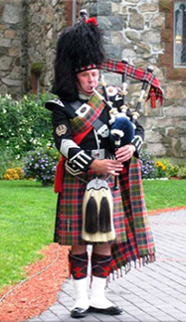

Bagpipe History page 2

Bagpipe Acoustics page 9

The photo is of professional bagpiper Ken Smith.

Bagpipe History by Tom Irvine

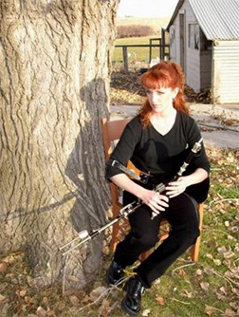

Figure 1. Uilleann Pipes

Uilleann Pipes are a bellows-blown bagpipe. The bellows bag is under the piper’s left elbow. Uilleann is the Irish word for elbow.

Introduction

The bagpipe is a reeded woodwind instrument with a number of pipes and a bag.

There are a variety of bagpipe instruments. The most recognizable are the Scottish Great Highland Bagpipes (GHB). The Irish Uilleann pipes and the Northumbrian smallpipes are also played throughout the British Isles.

People have a tendency to either love or loathe bagpipe music. Legendary filmmaker Alfred Hitchcock quipped:

I understand the inventor of the bagpipes was inspired when he saw a man carrying an indignant, asthmatic pig under his arm. Unfortunately, the manmade sound never equaled the purity of the sound achieved by the pig.

On the other hand, a piper’s rendition of “Amazing Grace” or “Scotland the Brave” can stir the soul of some listeners, bringing tears to their eyes.

Bagpipes throughout the World

The bagpipe is commonly associated with music from the British Isles, particularly with the Celts of Scotland. The bagpipe originated, however, in the Middle East, some four thousand years ago, perhaps among shepherds who had ready access to the animal skins from which the bag was made.

A myriad of folk bagpipe instruments have appeared in many cultures of the world throughout history. Bagpipes were popular in Europe for many centuries.

Pipes are also mentioned throughout the Bible. King Solomon’s coronation is described in 1 Kings 1:40 as follows

And all the people came up after him, and the people piped with pipes, and rejoiced with great joy, so that the earth rent with the sound of them.

Regardless of whether this verse refers to bagpipes per se, the people of the Bible are widely believed to have had bagpipes. They enjoyed “all kinds of music” as reported in Daniel 3:10.

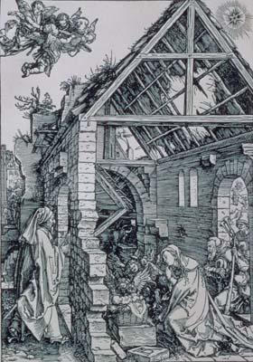

Figure 2. The Adoration of the Shepherds

German artist Albrecht Durer (1471-1528) created this woodcut engraving. The shepherd entering the doorway on the right is carrying a bagpipe.

Furthermore, some scholars claim that the term dulcimer in the King James Bible is a mistranslation of the Aramaic word sum·pon·yah´ (סומפניה) or the Greek symphonia, which actually refers to a bagpipe.

Some versions of the Bible, such as the New American Standard, substitute bagpipe for dulcimer in Daniel 3:5 and in other verses.

The Roman Emperor Nero (37-68) played a bagpipe according to some historical accounts. Roman coins depict Nero playing a bagpipe rather than a fiddle.

Furthermore, there was a saying in Bulgaria that "A wedding without a bagpipe is like a funeral."

The Hungarian hussars, or cavalry, used the bagpipe as its principle instrument up until the sixteenth century.

Traveling minstrels in Britain played bagpipes as they carried news and music around the country. Shakespeare’s "Henry IV" refers to the "Drone of a Lincolnshire Bagpipe."

Pipers also played music for reels, jigs and other dances.

Musical preference began to change during the Little Ice Age, which began as early as the fourteenth century according so some researchers. Bagpipes were regarded as an outdoor instrument, although smaller version could be played indoors. People moving indoors to the warmth of the fireplace preferred the harp, psaltery, viola, and flute.

The development of classical music also led to the bagpipes decline in popularity because the pipes had limited range and function. Specifically, the bagpipe’s drone would preclude the possibility of any change of mode, and the continuous sound would prohibit observance of rests.

Nevertheless, bagpipes remained prominent in the Highlands of Scotland, although they were outlawed after the Jacobite Uprising by the Hanoverians who ruled Great Britain from 1714 to 1837, as discussed in the next section.

Renewed Interest in Bagpipe Music

Bagpipes have regained some popularity over the last fifty years driven by revivals in native folk music. Bagpipes have become commonplace at weddings, parades, and military funerals. Bagpipe music is featured at Scottish festivals and Highland Games held throughout the United States, Canada and Australia. Bagpipe bands compete for awards in some of these festivals.

President John F. Kennedy

President Kennedy (1917-1963), who was of Irish descent, enjoyed bagpipe music. A number of bagpipe bands played at the White House South Lawn for Kennedy’s state dinners and other functions.

The U.S. Air Force Pipe Band played “The Mist Covered Mountain” at Kennedy’s funeral on November 22, 1963.

Italian Zampognari
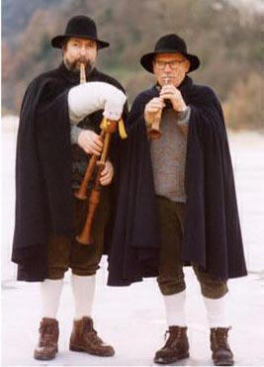
Figure 3. Zampognari
Bagpipes are a common Italian Christmas sound. The zampognari are shepherds who play the bagpipes, come down from their mountain homes at Christmas time and perform in the market squares and at nativity displays. This custom stems from a tradition that the shepherds visited the manger at Bethlehem, playing bagpipes to praise Mary and the Christ child. The pifferai are flute players who accompany the zampognari.

The Celts

The ancient Celts emerged as a people around 600 B.C. The Celts succeeded previous cultures, with the Iron Age serving as a catalyst in the transformation. The Celts migrated from central Europe to Britain, bringing bagpipes with them. The Roman Army brought bagpipes to Britain by Caesar's time, but the Celts in the northern regions probably already had them.

The Scottish King Robert the Bruce (1274-1329) used bagpipes to rally his troops as they marched to the Battle of Bannockburn against Edward’s English army in 1314.

The shrill and penetrating notes worked well in the roar and din of battle. The pipes could be heard at distances up to 10 miles.

The Jacobites
The Highlanders marched with their bagpipes and drums into battle during the Jacobite Uprisings.
The Jacobite Uprisings were a series of rebellions and wars in the British Isles occurring between 1688 and 1746. The conflict takes its name from Jacobus, the Latin form of James.
The Uprisings were aimed at restoring James VII of Scotland (aka James II of England), and later his descendants of the House of Stuart, to the throne after he was deposed by Parliament during the Glorious Revolution.

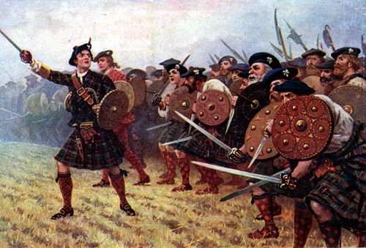
Figure 4. Jacobite Uprisings

The Glorious Revolution is also known as the Revolution of 1688. King James II of England was forced to flee to France by a union of Parliamentarians and Dutch Stadholder William of Orange.
William was married to James II's daughter Mary (aka Mary II), who was also his cousin. He became King William III of England (aka William II of Scotland) after he forced his father-in-law into exile. He ruled jointly with Mary, who was the Queen of England and Ireland.
The Highlanders could not accept William who was a Dutchman as their king, however.
Charles Stuart, aka “Bonnie Prince Charlie,” was James II’s grandson. His army of Highlanders was defeated at the Battle of Culloden on April 16, 1746. This loss ended the Uprising.
The House of Hanover
The Hanoverians were a German royal dynasty which succeeded the House of Stuart as kings of Great Britain in 1714. They also ruled Hanover in Germany, their original possession. The rulers of Great Britain were also the rulers of Hanover from 1714 to 1837.
The Hanoverians were descended from Sophia (1630-1714), the daughter of Frederick V, Elector Palatine of the Rhine, and of Elizabeth Stuart. Sophia’s grandfather was King James I of England. She married the Elector of Hanover.

Furthermore, Sophia was the nearest Protestant relative to King William III. Parliament’s Act of Settlement of 1701 decreed Roman Catholics could not accede to the throne. This same Act also declared Sophia as heiress of the throne. She would have become Queen of Great Britain had she not died before her cousin Queen Anne (1665-1714). Sophia’s eldest son King George I of Great Britain succeeded Queen Anne.

Scottish by birth, British by law,
a Highlander by the grace of God.

– Scottish Proverb

The Acts of Disarming and Proscription

The German House of Hanover which ruled over Britain tried to eliminate all vestiges of Scottish culture after the Jacobite rebellion ended. The British Parliament thus outlawed Scots from wearing the tartan and carrying weapons. This law was known as the Act of Proscription 1746. It was a reinstatement and strengthening of the Disarming Act of 1716.
Furthermore, bagpipes were banned as a weapon of war since no clan ever went into battle without a piper.
The Black Watch
The Hanoverians controlled a militia called the Black Watch. The purpose of this regiment was to enlist Highlanders to keep watch on their fellow countrymen. Scots who joined the Black Watch were permitted to wear kilts and play bagpipes in the course of their duties. Many years later, the Black Watch fought against the Germans in World War I, as discussed in the next section.
In addition, large numbers of Highlanders including pipers joined the British army and went to fight in the American Colonies in the Revolutionary War. The skirl of the pipes is mentioned in the account of the Battle of Savannah, Georgia in 1779.
The wail of bagpipes was also heard in the battle of Cowpens in 1781.
Battle of Waterloo 1815
The 79th Cameron Highlanders formed a square upon being attacked by French Cavalry of Napoleon Bonaparte at the Battle of Waterloo.
Piper Kenneth Mackay, showing no fear, marched out of the square and played the tune "War or Peace" (Gogadh No Sith). His stirring rendition strengthened the resolve of Wellington’s troops who defeated the French “Old Guard.”
This was Napoleon’s last battle. His defeat led swiftly to his final overthrow as ruler of France.
King George III presented Mackay with a set of Silver Pipes for his bravery.
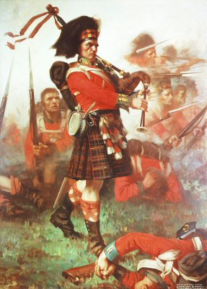

Figure 5. Piper Kenneth MacKay at the Battle of Waterloo, 1815

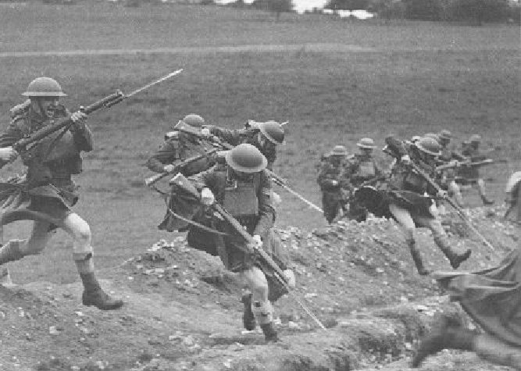
Figure 6. Ladies from Hell

Ladies from Hell
The fierce kilted Highlanders from the Black Watch, 3rd Battalion, Royal Regiment of Scotland, were called the “Ladies from Hell” by the Germans in World War I. The Scots actually wore their kilts into battle.

Among the heroes of this regiment was Harry Lunen who armed only with his bagpipes, led a desperate charge into machine gun fire until he reached the enemy trenches, at High Wood in the Battle of the Somme in 1916. Lunen survived.

Furthermore, Piper James C. Richardson was awarded the Victoria Cross for piping his company "over the top" at a crucial moment in the Battle of the Somme in 1916.
Scottish military pipers also served in World War II and the Falklands War.

O that I had three hands, two for the bagpipe and one for the sword
--old Scottish ballad

For that is the mark of the Scots of all classes: that he stands in an attitude towards the past unthinkable to Englishmen, and remembers and cherishes the memory of his forebears, good or bad; and there burns alive in him a sense of identity with the dead even to the twentieth generation.

-- Robert Louis Stevenson

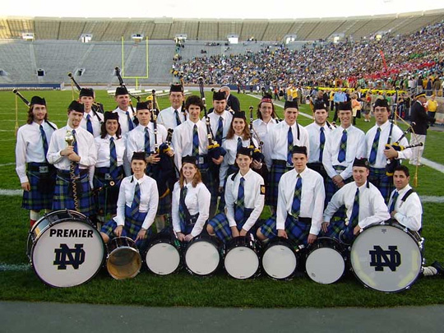

Figure 7. Notre Dame Bagpipe Band

The Notre Dame University in Indiana has a Bagpipe band that performs before all home football games and at parades and other events.

Bagpipe Acoustics by Tom Irvine

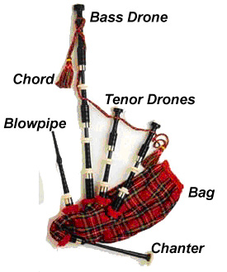
Figure 1. Highland Bagpipe

The Bag
The bag is an airtight reservoir.
The piper initially blows into the bag via the blowpipe to inflate the bag. The piper can then maintain the air flow in both the drone pipes and chanter by squeezing the bag with his left arm while taking a breath. This enables the player to maintain continuous sound for some time.
The bag was traditionally made from the cured skin of a pig, sheep, goat or calf. The bag was stitched and turned inside-out.
Modern bags are made from rubber or Gore-Tex. Synthetic materials are more durable than animal skins.
A recent innovation for mouth-blown bagpipes is the addition of moisture control cartridges that keep moisture from the piper’s breath from condensing on the pipes. This system requires that the bag have a zipper.

The Stocks
The stocks are wooden sockets that connect the pipes to the bag and ensure the delicate reeds are protected. They are sewn into the bag with strong thread so that the bag is airtight.

The Blowpipe
The blowpipe contains a round piece of leather hinged onto the bag end which acts as a one way valve. The flap opens as the piper blows air in. The air pressure within the bag forces the flap shut when he stops blowing.
The length of the blowpipe should be chosen according to the piper’s height.

The Chanter
The chanter is a pipe that provides the melody. It may have either a single or double reed. The bagpipe can only play one melody note at time.
The chanter has seven finger holes and a thumb hole. It has a usual range of an octave and one note.
The piper controls the note by the fingering on the chanter.
The Highland bagpipes have a range of nine notes (G, A, B, C# D, E, F#, G, A). The nine notes available on the chanter are fixed. Pipe music does not require the ability to modulate to different keys.
The pipe’s scale is known as the mixolydian (pronounced mix-o-lid'-ian) mode in music theory. There is some variation in step size between the respective tunings of the piano and the bagpipes. The bagpipe’s tuning is sharper.
The low “A” note of the Highland chanter is actually tuned sharper than B-flat, which makes it difficult to play in tune with other instruments.
The pitch may have been closer to A when the music first began to be written down, but pipe makers have been producing sharper and sharper chanters over the course of the past centuries.
A standard A note is 440 Hz, but a bagpipe’s A note is typically 470 Hz, with some as high as 485 Hz.
The chanter is usually open-ended. The piper cannot readily stop the pipe from sounding. Most bagpipes thus have a legato sound with no rests in the music.
As a compensation, pipers use embellishments or grace notes to break up notes and to create the illusion of dynamic effect. The grace notes vary depending on the bagpipe type.

The Drones
The drones are the pipes that point upward. The Highland bagpipe has two tenor drones and one bass drone.

The drone pipes are tied together with a chord to keep them form flopping around. The drones are all single-reeded.
The tenor drones are tuned an octave below low “A” note of the chanter and the bass drone is tuned two octaves below low “A.” These “A” notes are actually sharper than a B flat.

The essence of bagpipe music is the harmony created by the chanter’s melody playing against the drones.

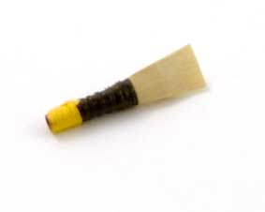
Figure 2. Chanter Reed
The Chanter Reed
The chanter reed is a double-reed, similar to an oboe reed. It consists of a piece of either cane or Elder tree wood. It is folded double over a brass or copper staple, then gouged into a flat shape with a very narrow opening and wrapped tightly with waxed twine.
The reed vibrates as air passes over it. The mechanical vibrations of the reed generate sound waves in the pipe. The frequency of these waves is controlled by the piper’s fingering on the pipe’s holes.
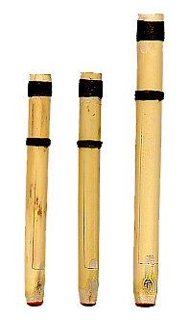
Figure 3. Drone Reeds

The Drone Reed
Drone reeds are tubular, single-bladed reeds. They are traditionally made from a complete tube of cane, closed at one end by wax or cork and inserted into the lower end of the drone, above the stocks.
A single “tongue” is cut into the tube of the reed, which is the part of the reed that vibrates. A small thread is tied around the base of the tongue to allow for tuning the reed. Moving the thread upwards sharpens the tone, moving it downwards flattens it.
Cane reeds are known for their outstanding sound quality, but synthetic drone reeds are becoming common because they are easier to set up and maintain.

Waterfall FFT



Frequency (Hz)
Magnitude

Chanter, 473 Hz, A#
Tenor Drone, 237 Hz, A#
Bass Drone, 117 Hz, A#

Figure 4. First 16 seconds of Amazing Grace, U.S. Air Force Band, Solo Bagpipe
Each of the A# notes has a slightly higher pitch than a standard A#.
The Tenor Drone A# is also a harmonic of the Bass Drone A#.
Likewise, the Chanter A# is also a harmonic of both the Tenor and Bass Drone A#.
This plot shows that the Drone tones remain nearly constant and steady throughout the duration shown. Notes at higher frequencies as played on the Chanter come and go.

A dulcimer is a stringed instrument.
The Black Watch wore kilts as a battlefield uniform up until 1940. The kilts were worn without undergarments per military regulation. Many civilian Highlanders still follow this custom. Kilts are made from wool which apparently provides enough warmth for the wearer.

