

Acoustics • Shock • Vibration • Signal Processing July 2002 Newsletter
Shalom

This is the One Year Anniversary edition of the Vibrationdata Newsletter. I hope that you are enjoying the articles. I plan to continue this newsletter for many years to come.

I look forward to meeting some of you. I am making plans to participate in the AIAA conference to be held in Norfolk, Virginia, from April 7-10, 2003.

In addition, my colleague Paul Jackson and I and are planning to offer a three-day seminar called Shock and Vibration Response Spectra and Software Training. I will announce the dates in an upcoming newsletter.

Paul Jackson has built a successful environmental test lab called Dynamic Labs in Phoenix, Arizona.

Again, I welcome feedback. Thank you for your support.

Sincerely,
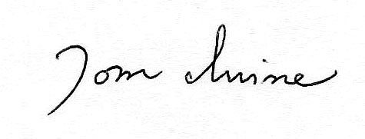
Tom Irvine
Email: tomirvine@aol.com

Feature Articles

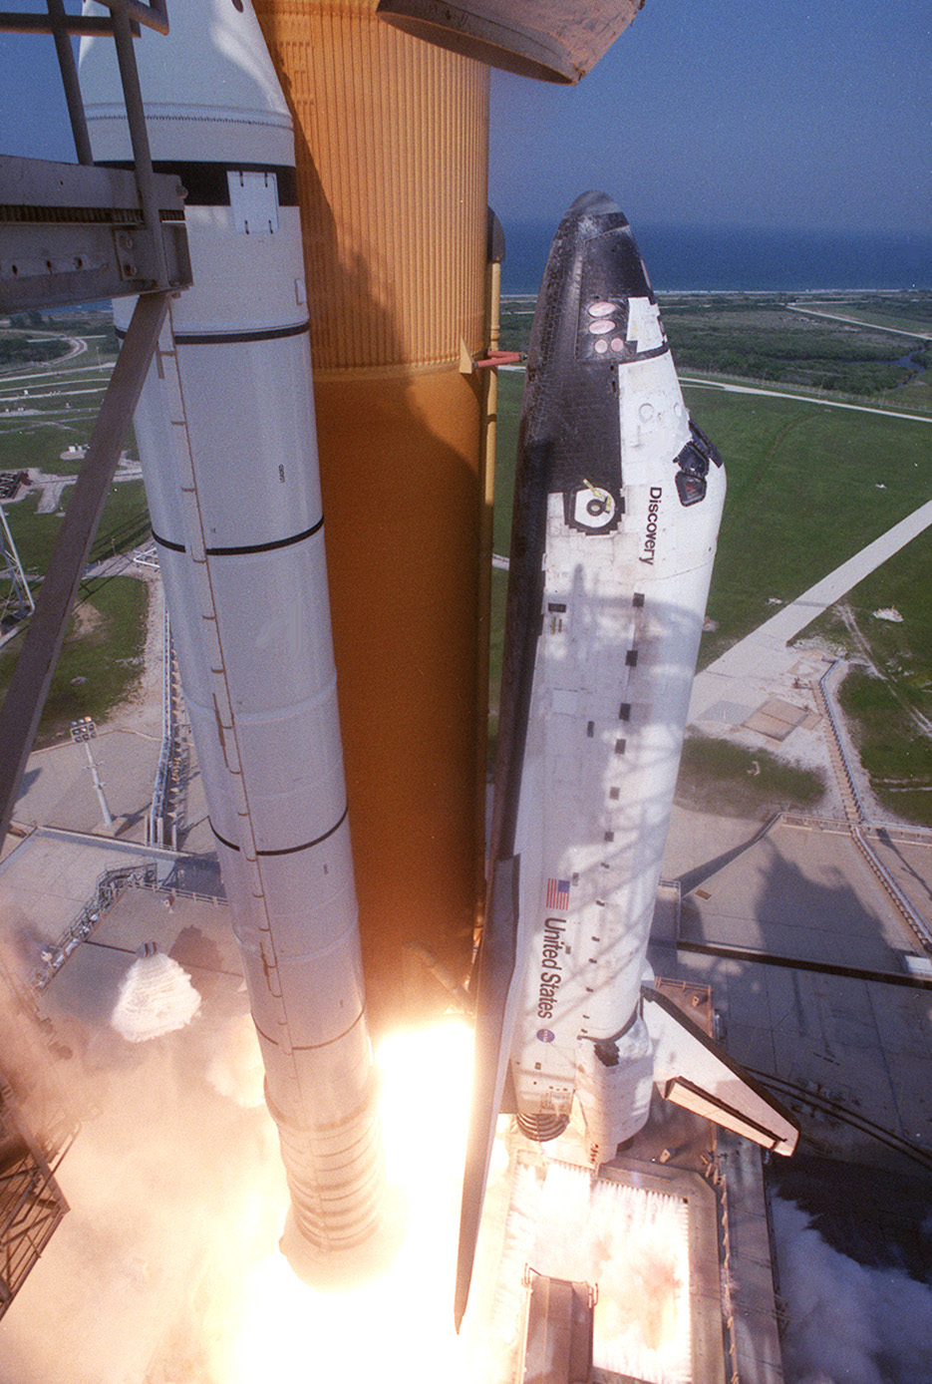

Space Shuttle Acoustics, Overpressure, and Vibration page 3

Introduction

The damping in suspension bridges is fairly small. A small oscillating are some times used as vibration exciters during structural tests of bridges, as reported by Bishop in Reference 1.

Suspension Bridge Resonance
By Tom Irvine

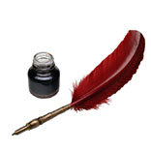 | Please Subscribe to Vibrationdata.com  Software and Tutorials
Subscribers receive a password to download over one hundred tutorial papers and dozens of software programs on the following topics:

Accelerometers  Acoustics  Beam Vibration  Butterworth Filter  Damping  Fourier Transforms  Helmholtz Resonators  Isolation  Laplace Transforms  Modal Testing  Overpressure  Pogo  Power Spectral Density  Pyrotechnic Shock |  | Rayleigh’s Method  Rocket Vehicle Vibration  Shock Response Spectrum  Signal Processing  Sine Vibration  Spacecraft Dynamics  Speed of Sound  Strength of Materials  Structural Dynamics – Classical Methods  Structural Dynamics – Finite Element Method  Tacoma Narrows Bridge  Testing Standards  Vibration Response Spectrum  Vibroacoustics  Waves  Wind Engineering
Subscription Instructions

The cost is $24.00. The instructions are given at: http://www.vibrationdata.com

For questions, please contact Tom Irvine.
Email: tomirvine@aol.com

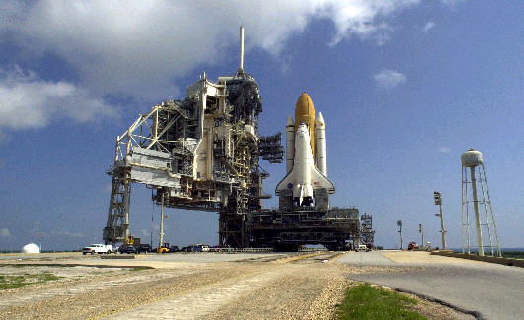
Figure 1. Water Supply Tank Adjacent to Launch Pad

Space Shuttle Acoustics, Overpressure, and Vibration by Tom Irvine

Introduction
The ignition of the Space Shuttle’s three main engines followed by the ignition of the twin solid rocket boosters generates the thrust necessary for the Space Shuttle liftoff.
Unfortunately, the ignition and liftoff events create a tremendous amount of overpressure and acoustic noise.
Overpressure is a shock wave that appears as a short duration transient as measured by a pressure sensor. The frequency content of this overpressure pulse is typically below 40 Hz.

Acoustic noise is typically dominated by energy above 20 Hz. Furthermore, the acoustic noise at launch may persist for several seconds.

Flame trenches and a water suppression system are used to attenuate the acoustic and overpressure environments.
The Space Shuttle’s payloads and components must be rigorously tested in order to verify that they can withstand the resulting environments.
Damage Potential
The overpressure and acoustic environments have the potential to dislodge the shuttle’s thermal tiles. This problem occurred on the STS-1 Columbia mission, launched on April 12, 1981. Modifications to water suppression system mitigated this problem for following flights.
Furthermore, the acoustic environment may damage payload insides the shuttle’s cargo bay. A payload might be a satellite or space probe. These spacecraft usually have numerous components that are sensitive to sound and vibration. Solar panels are a particular concern, because they usually have a large surface area relative to their volume. Fatigue cracks can thus form and propagate in the panels under harsh environments. A similar concern exists for high-gain, dish antennae.
In addition, the shuttle’s wings and ailerons could be damaged by overpressure.
Launch Acoustics
Acoustic noise is generated in the exhaust plumes flowing from the nozzles, as the vehicle lifts off. This is due to the turbulent mixing of the exhaust gas with the ambient atmosphere. Note that the exhaust gas velocity is typically 10,000 feet/sec (3000 meters/sec), which is nearly nine times greater than the speed of sound.
The rocket exhaust is channeled the flame deflectors and into the flame trench during the ignition and early liftoff phase. The flame deflectors and trench system are effective until the shuttle reaches about 300 feet altitude above the launch platform.
The acoustical levels reach their peak when the Space Shuttle reaches about 300 feet in altitude. This occurs about five second after liftoff.
As the shuttle ascends above 300 feet, sound is reflected off the metal plates of the mobile launcher platform's surface.
The launch acoustic problem effectively ends after the shuttle has been airborne for about 10 seconds and has reached an altitude of 1,000 feet.
Water Suppression System
The Space Shuttle orbiter and its payloads are partially protected from the overpressure and acoustic noise by a water suppression system.
The system includes an elevated water tank with a capacity of 300,000 gallons. The tank is 290 feet high and stands on the northeast side of the launch pad, as shown in Figure 1 at the beginning of this article.

The water is released just before the ignition of the orbiter's three main engines and twin solid rocket boosters and flows through parallel 7-foot-diameter pipes to the pad area.

The peak flow rate from the pre-liftoff and post-liftoff systems is 900,000 gallons per minute, at nine seconds after lift-off.

Main Engine Exhaust Hole

Some of this water flows through outlets in the shuttle main engine exhaust holes in the mobile launcher platform at main engine ignition (T minus 6.6 seconds). The exhaust hole is shown in Figure 2. There are 22 nozzles around the exhaust hole for the main engines within the
Mobile Launcher Platform. Fed by a 6-inch-diameter supply line, water flows at a rate up to 2,500 gallons per minute.

The water suppression system is also used to cool the aft end of the orbiter following flight readiness firing of the main engines.

Rainbirds

In addition, a torrent of water flows onto the mobile launcher from six large quench nozzles, called Rainbirds, mounted on its surface. The nozzles are 12-foot high.

The flow rate through the Rainbirds is 400,000 gal/min. This flow begins at solid rocket booster ignition, at T minus zero.

An example of a Rainbird is shown in Figure 3.

Solid Rocket Booster Overpressure Suppression

Water is also sprayed into the primary solid rocket booster exhaust trenches to provide overpressure protection to the orbiter at solid rocket booster ignition. A flame trench is shown in Figure 4.

This system is augmented by water bags in the primary and secondary flame holes that provide a mass of water to dampen the "blowback" pressure pulse from the engines.

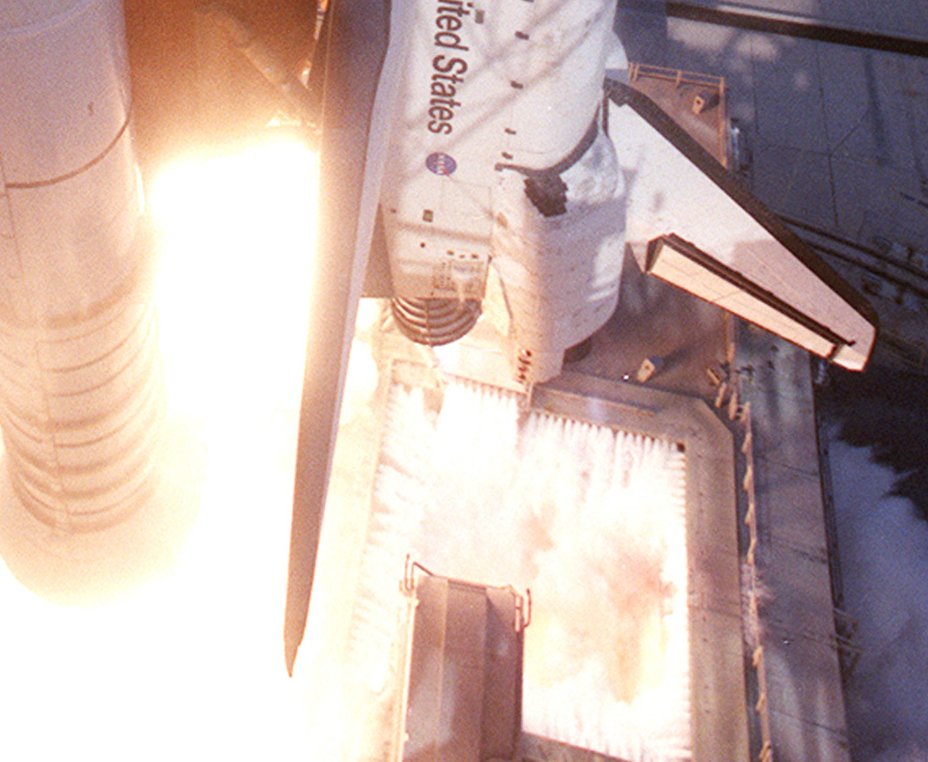

Figure 2. Main Engine Exhaust Hole and Water Spray

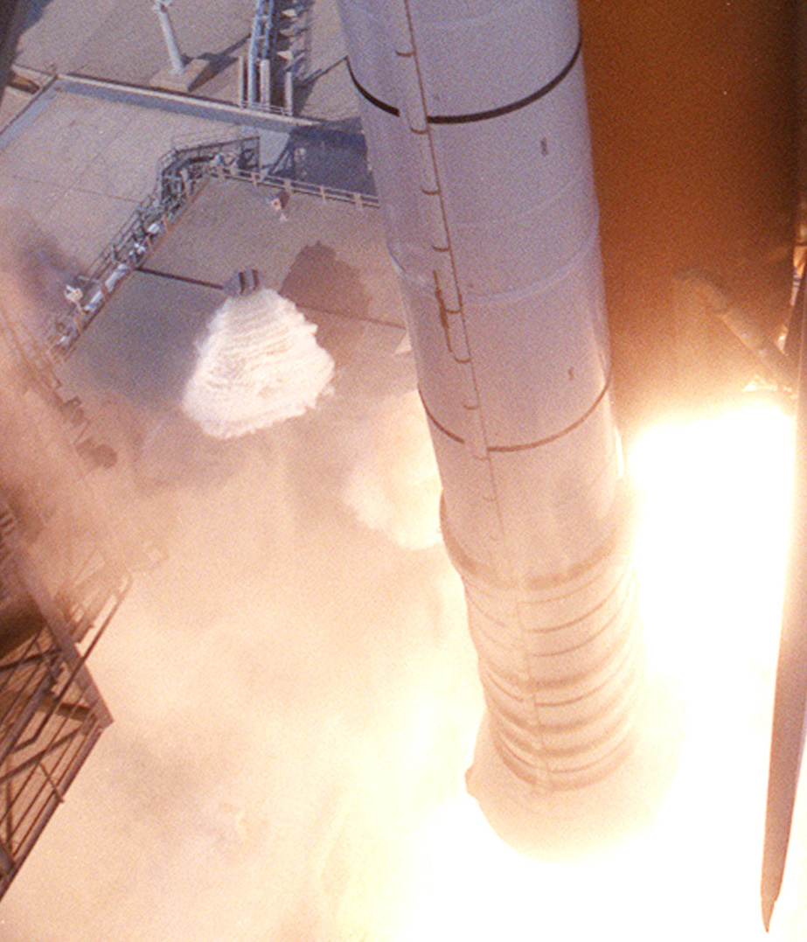
Figure 3. Rainbird, Left of the Solid Rocket Booster

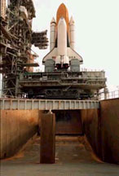
Figure 4. Flame Trench

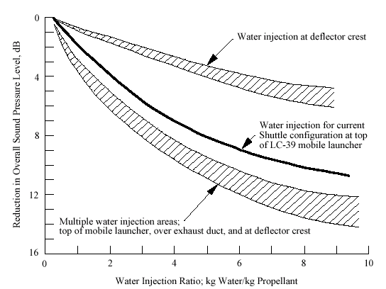

Figure 5. Water Suppression Attenuation Curves

Water Suppression Attenuation Curves
The water suppression attenuation curves are given in Figure 5, as taken from Reference 1. The curves are based on empirical data.
The curve for the current Shuttle configuration shows that 10 dB of attenuation can be achieved for an injection ratio of 9 kg water/kg propellant.
Sound Propagation
Each Space Shuttle launch produces a somewhat unique acoustic field. The acoustics are influenced by factors such as wind speed and direction, humidity and temperature.
The Space Shuttle produces acoustic levels of about 188 dB on the launch platform, 160 dB at the pad perimeter, and 120 dB at the vehicle assembly building.
The sound level during launch can vary from 77 to 95 dB in Cocoa Beach, 25 miles south of the launch pad.
The launch environments also generate seismic waves.
Water Vapor
Most of the water is transformed by heat into billowing white clouds of steam.
The three main engines also produce water vapor.
The solid rocket motors produces water vapor due to afterburning of hydrogen. They also produce carbon dioxide and aluminum oxide.
Ignition Overpressure Level
An envelope of energy spectra computed from measured overpressures on the aft fuselage of the Space Shuttle due to the ignition of the Solid Rocket Boosters is shown in Figure 6. The data is taken from Reference 1.
Note in this figure that the energy is concentrated below 20 Hz, but ignition overpressure spectra for other solid propellant rocket motors might extend up to 40 Hz.
Test Types
Space Shuttle components and payloads must be subjected to various acoustics and vibration tests. Ideally, there is a qualification and acceptance unit for each component.
The purpose of the qualification test is to verify the design integrity. Qualification units are never flown since they are exposed to harsh test levels with margins well above the maximum expected flight levels.
The acceptance test has two purposes. The first is to subject the component to the expected environment. The second is to uncover latent defects in parts and workmanship, such as bad solder joints. The acceptance test levels are lower than the respective qualification levels. Components that successfully pass the acceptance test are then flown on the Space Shuttle.
As an alternative, some components or payloads may be one-of-a-kind. These components are subjected to proto-flight test levels that are intermediate between qualification and acceptance levels.

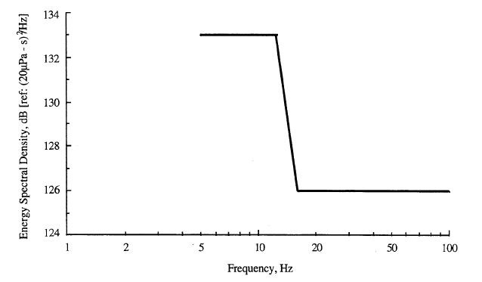
Figure 6. Energy Spectrum for Overpressure on Space Shuttle Due to SRB Ignition

Acoustic Test Level
The acoustic test specification covers the liftoff and the aerodynamic buffeting environments. This buffeting occurs as the Space Shuttle accelerates through the transonic velocity and encounters the maximum dynamic pressure (max-Q) event. A typical RMS vibration time history for a Space Shuttle Launch is shown in Figure 7, as taken from Reference 1. Note that most of the vibration is driven by external acoustic and aerodynamic sources.
The acoustic test levels for cargo bay payloads is given in Figure 8 and in Table 1, as taken from Reference 2. The duration is 1 minute for each test. The test is to be performed inside an acoustic reverberant chamber.
Random Vibration Test Level
Space Shuttle components must also be subjected to a base excitation random vibration test. The levels are given in Table 2, as taken from Reference 2.

References
1 | NASA-HDBK-7005, Dynamic and Environmental Criteria, 2001.
2 | NASA/GSFC, General Environmental Verification Specification for STS and ELV, Payloads, Subsystems, and Components; 1996.

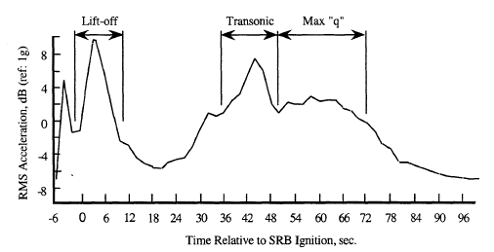

Figure 7. Typical RMS Vibration Time History as Measured on Space Shuttle
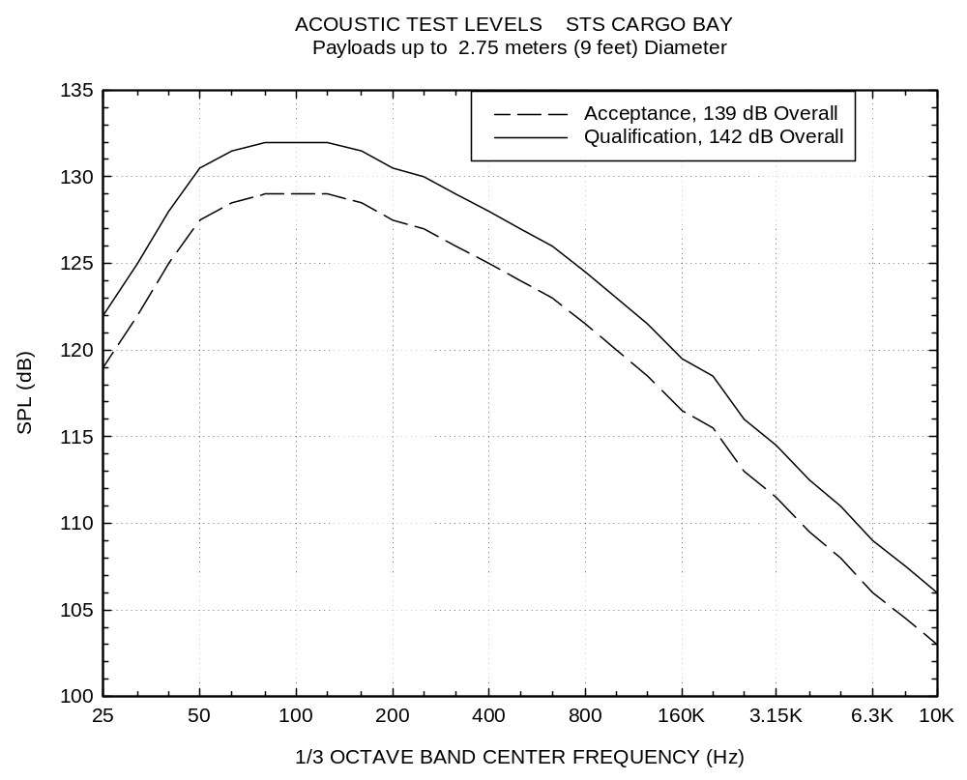
Figure 8. Acoustic Test Levels for Space Shuttle Payloads

Table 1. Sound Pressure Level
Acoustic Test Levels, STS Cargo Bay, Payloads up to 2.75 meters (9 feet) in Diameter,
Zero dB Reference = 20 micro Pa
One-Third Octave Center Frequency (Hz) | Qualification  SPL (dB) | Acceptance  SPL (dB)
25 | 122 | 119
32 | 125 | 122
40 | 128 | 125
50 | 130.5 | 127.5
63 | 131.5 | 128.5
80 | 132 | 129
100 | 132 | 129
125 | 132 | 129
160 | 131.5 | 128.5
200 | 130.5 | 127.5
250 | 130 | 127
315 | 129 | 126
400 | 128 | 125
500 | 127 | 124
630 | 126 | 123
800 | 124.5 | 121.5
1000 | 123 | 120
1250 | 121.5 | 118.5
1600 | 119.5 | 116.5
2000 | 118.5 | 115.5
2500 | 116 | 113
3150 | 114.5 | 111.5
4000 | 112.5 | 109.5
5000 | 111 | 108
6300 | 109 | 106
8000 | 107.5 | 104.5
10000 | 106 | 103
Overall | 142 | 139

Table 2. Power Spectral Density
Generalized Random Vibration Test Levels, STS Components, 22.7 kg (50 lbm) or less

Frequency  (Hz) | Qualification  (G^2/Hz) | Acceptance  (G^2/Hz)
20 | 0.025 | 0.0125
20-50 | +6 dB/oct | +6 dB/oct
50-600 | 0.15 | 0.075
600-2000 | -4.5 dB/oct | -4.5 dB/oct
2000 | 0.025 | 0.0125
Overall | 12.9 GRMS | 9.1 GRMS

Note that the power spectral density levels may be reduced for components weighing more than 22.7 kg (50 lbm) according the following equations for weight W.

Weight in kg

dB reduction = 10 LOG(W/22.7)
ASD (50-800 Hz) = 0.15·(22.7/W) for proto-flight
ASD (50-800 Hz) = 0.075·(22.7/W) for acceptance

Weight in lb

dB reduction = 10 LOG(W/50)
ASD (50-800 Hz) = 0.15·(50/W) for proto-flight
ASD (50-800 Hz) = 0.075·(50/W) for acceptance

The slopes shall be maintained at +6 and -4.5 dB/oct for components weighing up to 57-kg (125-lb).

Above that weight, the slopes shall be adjusted to maintain an ASD level of 0.01 G ² /Hz at 20 and 2000 Hz.

For components weighing over 182-kg (400-lb), the test specification will be maintained at the level for 182-kg (400 pounds).

