
Welcome to
Vibrationdata

Acoustics • Shock • Vibration • Signal Processing July 2007 Newsletter

Howdy!

You know that you are an engineer when your favorite part of your Las Vegas trip was the Hoover Dam tour.

Man’s ability to harness the forces of nature is remarkable. The Hoover Dam is clear evidence of this. Those of us who live in the Southwest greatly benefit from the water storage, flood control, and power generation which the dam provides. We owe a debt of gratitude to the men who labored under harsh conditions to build this marvelous structure.

The first article pays tribute to the architects, engineers and laborers who created the dam. The article gives a description of the dam and its history. It then presents an acoustical analysis of the sound produced by the generator turbines.

The second article describes a neurological or psychological condition, called “phantom vibration” whereby some people mistakenly answer their cell phones.

Sincerely,

Tom Irvine
Email: tomirvine@aol.com

Feature Articles


Hoover Dam Turbine Generator Acoustics page 1

Cell Phone Phantom Vibration page 8

Hoover Dam Turbine Generator Acoustics by Tom Irvine

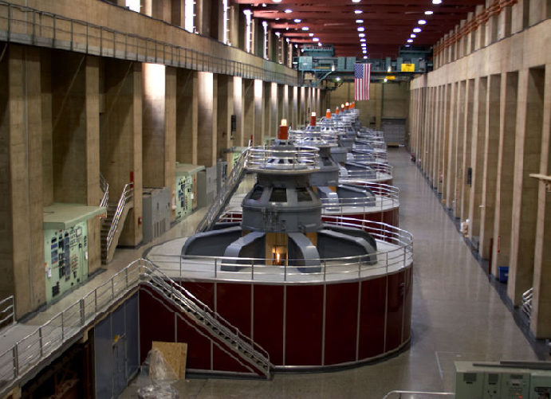
Figure 1. Hoover Dam Turbine Generators (Image courtesy of Wikipedia)
The Bureau of Reclamation of the U.S. Department of the Interior operates the dam and its power plant.

Introduction
The Colorado River is a vital source of water for seven western states. The Colorado River begins in the snowcapped Rocky Mountains. It flows 1400 miles through mountains and deserts to the Gulf of California.
The Colorado River was one of the world’s wildest rivers for many centuries. Each spring, melting snow in the mountains swelled the flow into a raging torrent, flooding low valleys in southern California and Arizona. The flooding spreads topsoil into the valleys, forming fertile deltas.
Early settlers established farms in these deltas. They built irrigation canals to bring water from the Colorado River to their fields. They also built levees to regulate the flow.
Flooding overwhelmed the levees, however. The worst flood in modern times began in 1905 and continued through 1907, forming the inland Salton Sea in Imperial Valley.
Drought was another problem. The Colorado River’s tributaries often dried up completely in later summer or early fall. The Colorado River’s flow dwindled as a result.
Boulder Canyon Project Act
The U.S. Congress approved Boulder Canyon Project Act in 1928 which included Hoover Dam, the infrastructure to build the dam, and the All-American Canal. The main purposes of the dam were to eliminate floods and to store water for times of drought.
The dam was built on the Colorado River between Arizona and Nevada. Construction of the dam began in 1931. The dam was dedicated in 1935.
The dam is a concrete arch-gravity dam. Its crest length is 1244 ft (379 m). Its height is 726.4 ft (221 m).
Lake Mead Reservoir was created by Hoover Dam. It is the largest man-made reservoir in the United States, as measured by volume.
Hydroelectric Generators
A hydroelectric plant was also included in the project. Revenues from sale of power have paid back the original cost of the dam with interest to the Federal Treasury.
About one-half of the power is allocated to Los Angeles and other cities in southern California.
The 17 generators can supply enough electricity for 1.3 million people.

Technical Description
The following technical description is taken from Reference 1.
The power plant is located in a U-shaped structure at the base of the dam.
There are 17 main turbines in Hoover power plant. The turbines produce more than 4 billion kilowatt-hours a year.
A kilowatt-hour is a unit of work or energy equal to that done by one kilowatt of power acting for one hour. A kilowatt is 1,000 watts or 1.34 horsepower.

Figure 2. Two of the Four Intake Towers
The intakes provide water for the power plant turbines.

The power plant nameplate capacity is about 2,080 megawatts.
Water reaches the turbines through four penstocks, two on each side of the river.
Each penstock is a pipe with a diameter of 30 feet (9.1 meters).
Wicket gates control water delivery to the turbines.
The maximum head, which is the vertical distance that the water travels, is 590 feet.
The turbines are Francis-type vertical hydraulic turbines.
Water impacts the turbine at a speed of 60 miles per hour (97 km/hr), causing the turbine to rotate at 180 rpm. The volume flow rate into each generator is 22,000 gallons per second (83,000 liters per second).
The turbine then rotates the connecting shaft, which then turns the generator. Magnets spinning inside wire coils in the generator make the electricity. In this way, the generator and turbine change mechanical energy into electrical energy.
The electricity then flows by transmission wires to cities and homes where it is used.
In addition, there are also two 2,400 kilowatt station-service units driven by Pelton water wheels. These provide electrical energy for lights and for operating cranes, pumps, motors, compressors, and other electrical equipment within the dam and power plant.

Generator Subsystems

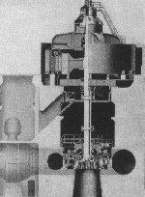
Exciter
Rotor
Stator
Shaft
Turbine

Figure 3. Turbine Generator Diagram

The exciter is itself a small generator that makes electricity, which is sent to the rotor, charging it with a magnetic field.
The rotor is a series of electromagnets, also called poles. Each rotor has 40 poles.
The rotor is connected to the shaft, so that the rotor rotates when the shaft rotates.
The stator is a coil of copper wire. It is stationary.
The shaft connects the exciter and the rotor to the turbine.

Electricity is produced as the magnets of the rotors spin past the stationary wiring of the stator.

This concept was discovered by scientist Michael Faraday in 1831 when he found that electricity could be created by rotating magnets within copper coils.

Turbine Vanes
Among the 17 turbines, there are five configurations in terms of the number of blades or vanes.

Table 1. Turbine Configurations
QTY | Number of Vanes
9 | 15
5 | 16
2 | 17
1 | 19

Acoustic Measurements
The following sound measurements were taken during a tour of the dam and its power plant on May 4, 2007. The turbine and generator sound was measured using an Edirol R-09 recorder.
Two views of the resulting power spectrum are shown in Figures 4 and 5.

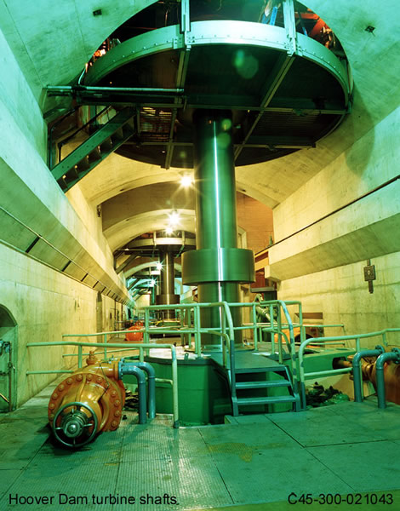

Figure 4. Turbine Shafts underneath the Generators
The shaft is 65 feet (19.8 meters) tall. The shaft diameter is 38 inch (96.5 cm).

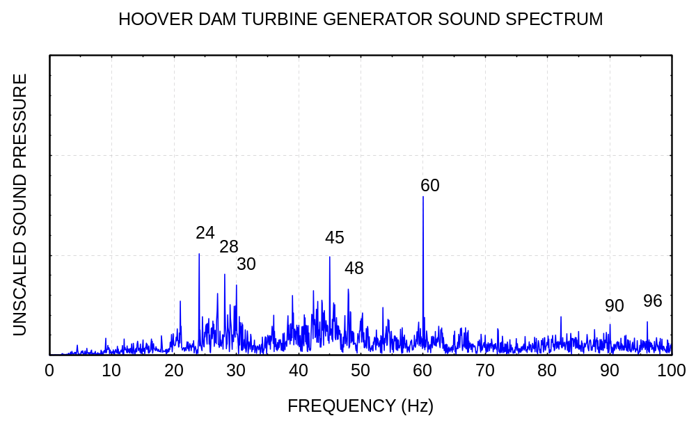
Figure 5.

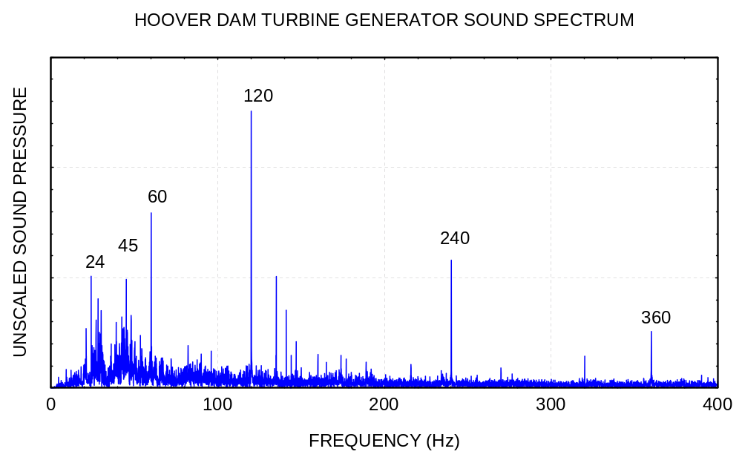
Figure 6.

To the human ear, the sound is mainly random, similar to pink noise. The sound spectrum does contain some distinct peaks, however.

The peak with the highest amplitude is 120 Hz. This corresponds to the 3 Hz (180 rpm) turbine rotor speed multiplied by the 40 magnetic poles. More specifically, magnetostriction in the stator laminations drives the 120 Hz oscillation. Note that generators use armatures with laminated cores to reduce eddy current losses.

A related cause of the 120 Hz vibration is air gap eccentricity which creates unbalanced forces on the rotor.

The sources of the spectral peaks are identified in Table 2, although the respective causes of the peaks up to 30 Hz is unclear.

Reference
1. http://www.usbr.gov/lc/hooverdam/faqs/powerfaq.html

Table 2. Frequency Results, Rotor Speed = 3 Hz
Freq (Hz) | Source
24 | -
28 | -
30 | -
45 | Rotor Speed x 15 Vanes
48 | Rotor Speed x 16 Vanes
60 | (1/2) x Rotor Speed x 40 Poles
90 | 2 x Rotor Speed x 15 Vanes
96 | 2 x Rotor Speed x 16 Vanes
120 | Rotor Speed x 40 Poles
240 | 2 x Rotor Speed x 40 Poles
360 | 3 x Rotor Speed x 40 Poles

Cell Phone Phantom Vibration by Tom Irvine


Figure 1. Vibrating Cell Phone

Introduction

The ubiquitous cell phone has become a seemingly indispensable link to our family, friends, business associates, and occasionally emergency services. The cell phone provides a means for temporal coordination of our increasingly complex schedule of arrivals, appointments, departures, commerce, security and other activities.
Cell phones notify the users of an incoming call either by a ring tone or by a vibration. The user typically sets his or her cell phone to vibration mode if the location is a theater, restaurant, library, classroom, or some other place where the rules of etiquette require this choice.
Other users prefer to use vibration mode continually, regardless of their surroundings. As a result, some have developed a condition called “phantom vibration syndrome” or "vibranxiety." This is a condition whereby users mistakenly answer their phones although nobody has actually called. The condition may result from neurological or psychological factors.
In some cases, the phantom vibration may be triggered by sound and vibration sources other than the phone itself. In other cases, it may occur without any external stimuli.

Neuroplasticity
Jeffrey Janata is the director of the behavioral medicine program at University Hospitals in Cleveland. He explained:
“You come armed with this template that leads you to be attentive to sensations that represent a cell phone vibrating. And it leads you to over-incorporate non-vibratory sensations and attribute them to the idea that you're receiving a phone call.
When cell phone users regularly experience sensations, such as vibrating, their brains become wired to those sensations. Neurological connections that have been used or formed by the sensation of vibrating are easily activated. They're over-solidified, and similar sensations are incorporated into that template. They become a habit of the brain.”
This condition results from neuroplasticity — the brain's ability to form new connections in response to changes in the environment.
Alejandro Lleras is a sensation and perception professor at the University of Illinois at Urbana-Champaign. He adds that learning to detect rings and vibrations is part of a perceptual learning process.
"When we learn to respond to a cell phone, we're setting perceptual filters so that we can pick out that (ring or vibration), even under noisy conditions. As the filter is created, it is imperfect, and false alarms will occur. Random noise is interpreted as a real signal, when in fact, it isn't."
David Laramie is a doctoral student at the California School of Professional Psychology. He said that “Your brain will hear the first note in the outside world and fill in the rest of the sequence mentally.” He also said the same is probably true with the phantom vibration. He mentioned that he would experience a false cell phone alarm if his belt buckle simply rubbed against a table.
Psychosomatic Causes
Others claim that this syndrome is due to the user’s anticipation of important calls or even wishful thinking.
Christine Rosen is a senior editor of “The New Atlantis,” a journal of technology and society. She speculated that phantom cell phone vibrations are psychosomatic.
“Cell phone users talk about the reassurance of being constantly connected. It signals to everyone around you that you’re part of another community. So you’re not just a stranger in a public space, but you’re a person who’s in demand and who can demand the attention of someone else.”
Erin Hall, a 29-year-old from Boise, Idaho, has experienced phantom cell phone vibrations and says they usually happen when she is awaiting an important call. For instance, she said phantom phone calls happened daily when her sister was expecting a baby. She also said “I think the phantom ring can all be tied into your love life or lack thereof.”
“I would love my phone to be ringing all the time, and I hate to admit that,” said Hall. “The phantom phone call is one of those hidden desires that we would all love to see come true.”

Vibration Motor

On a technical note, there are two common types of cell phone vibrator motors: coin-shaped and bar models. Each uses the principle of rotating imbalance to produce vibration.

The motor types are shown in Figures 2 and 3. Each model has a specified rotational rate of approximately 10,000 rpm (167 Hz).

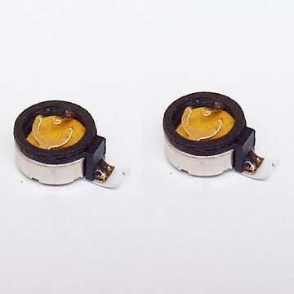

Figure 2. Mobile Phone Micro DC Coin Vibrator Motor

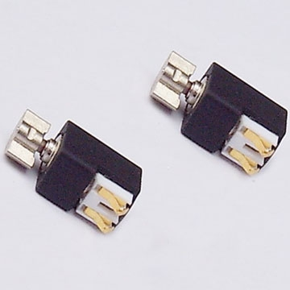

Figure 3. Mobile Phone Micro DC Bar Type Vibrator Motor



Figure 4. Motorola TracFone V120t

The author has a cell phone of the same model as shown in Figure 4. A recording of the phone’s vibration mode is shown in Figure 5. Whether this model has a coin or bar type motor is not immediately clear.

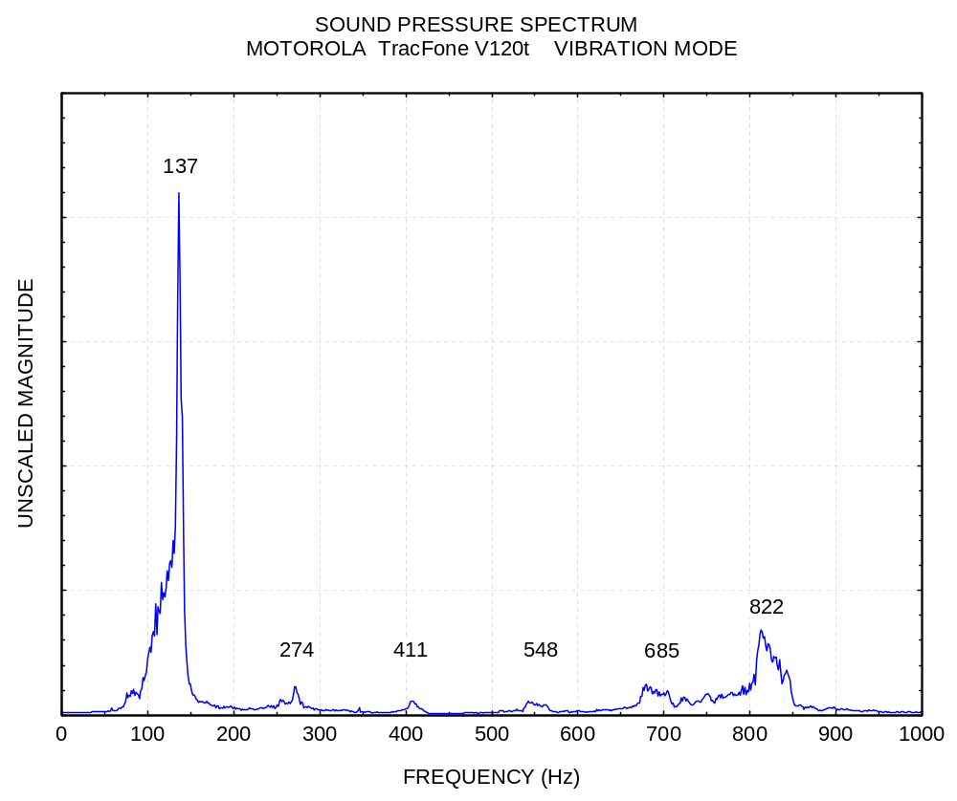

Figure 5.

The fundamental frequency is 137 Hz or 8220 rpm. This is slightly below a C3# note.

Harmonics are present at integer multiples of the fundamental.

