
Welcome to
Vibrationdata

Acoustics • Shock • Vibration • Signal Processing July 2010 Newsletter

Salvete

The Tacoma Narrows Bridge collapse in 1940 remains the most spectacular vibration failure of any civil engineering structure. Engineers have studied Galloping Gertie’s collapse extensively. Yet wind problems still occasionally plague new bridge designs. For example, the London Millennium Bridge which opened in 2000 required a retrofit with dampers to solve an oscillation problem, as described in the Vibrationdata August 2002 Newsletter. The most recent bridge to experience severe wind-driven oscillations is the Volgograd Bridge in Russia, which is the lead article in this month’s newsletter.

The topic of the second article is civil defense sirens. I have childhood memories of the Saturday “noon whistle” tests in Phoenix, Arizona in the 1960s. That system was abandoned many years ago with the perceived diminished threat of a thermonuclear attack. My family and I now live in Madison, Alabama which has a functioning system of tornado warning sirens.

Pax vobiscum,

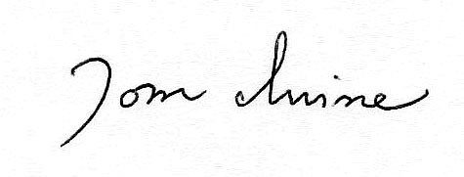
Tom Irvine
Email: tomirvine@aol.com

Feature Articles



Volgograd Bridge Oscillation page 1

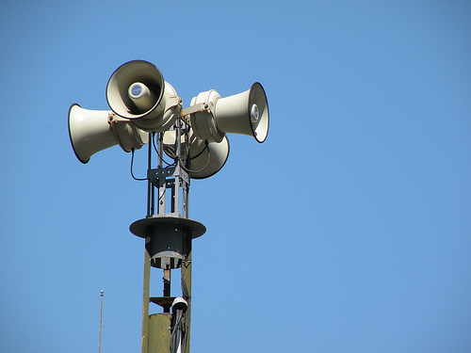

Civil Defense Sirens page 4

eminC

Volgograd Bridge Oscillation by Tom Irvine



Figure 1. Volgograd Bridge Bending Oscillations

The Volgograd Bridge is a concrete girder bridge over the Volga River. It was inaugurated on October 10, 2009 after 13 years of construction.

Authorities closed the bridge to all motor traffic on May 20, 2010, due to strong oscillations driven by gale-force winds, with speeds up to 18 meters/second.

One motorist, who drove over the new bridge before its closure, said: “I was driving to my country house when my car started bouncing like a ball. I thought there was something wrong with my suspension.”

Another driver, Andrey Bystrov, reported:
“My first feeling was that my wheels were going in different directions. I started thinking, maybe something had happened with my suspension. Then I looked ahead to the coming vehicles and they were all swinging up and down.”
President Dmitry Medvedev then ordered the inspection of the bridge for damage. The bridge thus remained closed until the morning of May 25, when it was reopened for public access.

The sights and sound of the bridge oscillation are available on several YouTube videos, including:

http://www.youtube.com/watch?v=5smsMzA_xII

http://www.youtube.com/watch?v=WEQrt_w7gN4&feature=fvw

The bending frequency was 0.46 Hz, as calculated by the author from the audio tracks of the videos.

Note that this frequency is well below the lower frequency limit of human hearing, which is about 20 Hz. Neverthess, creaking at higher frequencies occurred as the bridge’s bending mode reached each of its extremes, with a unique sound at each peak.

The creaking was most likely due to joint slippage, strain energy redistribution and other effects. The natural frequency could thus be calculated from the corresponding sound file in the time domain. The 0.46 Hz frequency also agrees with the video footage.

Note that the bridge underwent a self-excited oscillation, rather than a true resonance. This is a form of aerodynamic flutter.

The reported amplitude was up to 1 meter, peak-to-peak. The corresponding acceleration level was 0.43 G.

Russian authorities have not yet announced whether any design modifications will be made to the bridge. A good solution would be to increase the stiffness and to add dampers.

Civil Defense Sirens by Tom Irvine

Introduction

Sirens are sounded to warn against many types of danger including:

- Air raid
- Nuclear fallout
- Tornado
- Tsunami
- Fire
- Hazardous chemical leaks

The peak years of siren usage in the USA occurred during the Cold War era, when most large communities had sirens to warn against a nuclear strike. Many of these systems have now been relegated to museums, collectors and scrap dealers.

Sirens are still used throughout many communities, however, to warn of tornados or other natural disasters particular to the area. There is also an emerging trend is to use “reverse 911” systems whereby recorded warning messages are sent to residents in affected areas. Reverse 911 systems have the advantage of giving specific verbal instructions to residents, but there are limits to call volume which is a concern in the event of a sudden emergency.

On the other hand, siren systems can immediately generate warning sounds over wide areas. But most siren systems are limited in their ability to give instructions, unless they are of the speaker type which can sound warnings as well as act as a public address system. Note that some siren designs allow for multiple tone types which can be used to convey the type of emergency.

The purpose of this article is to present frequency analyses of a sample of a dozen siren models. Some of these models are historical sirens which are still in service, although no longer in production. The other models are currently available from vendors. In these cases, a vendor website link is provided. A comprehensive database could easily include a few dozen more current and historical models.

The sound files are taken from YouTube videos, as given in the accompanying links. There are a surprising number of siren aficionados who record siren sounds. Some also acquire and rebuild sirens as a hobby.

As an aside, a photograph is given for each siren model, but this is not the same unit as the test unit in terms of serial number. The actual test unit can be seen via the accompanying YouTube link. This presentation method was selected because the YouTube images tended to be more distant and less clear.

Siren Types

Sirens can be categorized by several parameters.

Some sirens have a single horn which rotates 360 degrees, such as the Thunderbolt 1000T. Others are non-rotating, usually with horns pointing in multiple directions. The American Signal T-121 is an example of a siren with multiple horns.

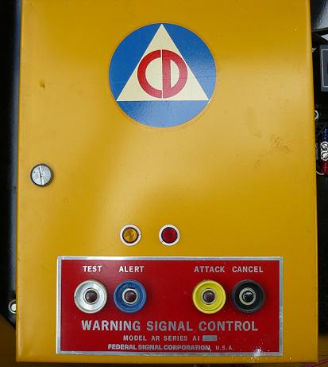

Figure 1. Federal 1000T Control Panel, with Alert and Attack Modes

Ten of the sirens in this article are the traditional electromechanical type which uses a motor to pump air through the horns. The remaining sirens are electronic speaker-type sirens, which can double as verbal public address systems. The electromechanical types provide a richer sound with harmonics, but this is a rather subjective distinction.

Some sirens output a single fundamental tone with integer harmonics. Others have two or more interspersed note patterns.

Some sirens have only one sounding mode. Others may be capable of outputting several tonal patterns. The modes are described by such terms as wail, whoop, attack, hi-lo, and alert. Presumably, these different types of tones could be used to warn of different types of emergencies, but the residents in the affected area must be educated accordingly.

The attack tone is of particular interest. It uses a “sine sweep.” The fundamental frequency begins at a low frequency. Then the frequency is abruptly increased to a steady level, after which it has a prolonged decrease. The harmonics follow the same pattern. The cycle is then repeated. The Sentry Siren 40V2T, which is the first siren in this article, undergoes a test of one cycle in attack mode.

Electromechanical Siren Design

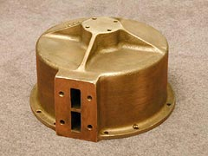 | 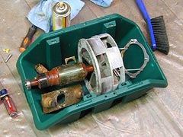

Figure 2. Thunderbolt 1000T Parts, Courtesy of http://www.airraidsirens.com

The image on the left is the stator housing. The image on the right is the dissembled chopper, which is designed to rotate inside the housing.

A typical electromechanical siren has a blower motor, connected to a standpipe which blows or pumps air up to a chopper motor. As the chopper spins, the air forced into it escapes out of rapidly opening and closing holes, creating the siren's sound or "roar."

The siren may also have a rotator gear motor which turns the siren's projector horn 360 degrees when in operation.

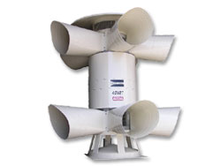

Figure 3. Sentry Siren 40V2T
The Sentry 40V2T is an electro-mechanical, non-rotating siren. It has 40 horsepower and is rated at 130 dBc @ 100 feet, continuous. The following frequencies were measured during the steady-state portion of a sample siren test in northern Ohio. The 298 Hz tone is approximately “D above middle C.” The higher tones are integer harmonics.

Sentry 40V2T
Freq (Hz)
298
588
893
1190
1489
1783

The sound file was taken from:
http://www.youtube.com/watch?v=X2MlmcY8UZU&feature=related
Vendor data for this siren model is given at:
http://www.sentrysiren.com/pdf/Web_40V2T.pdf
Waterfall FFT Sentry Siren 40V2T Test
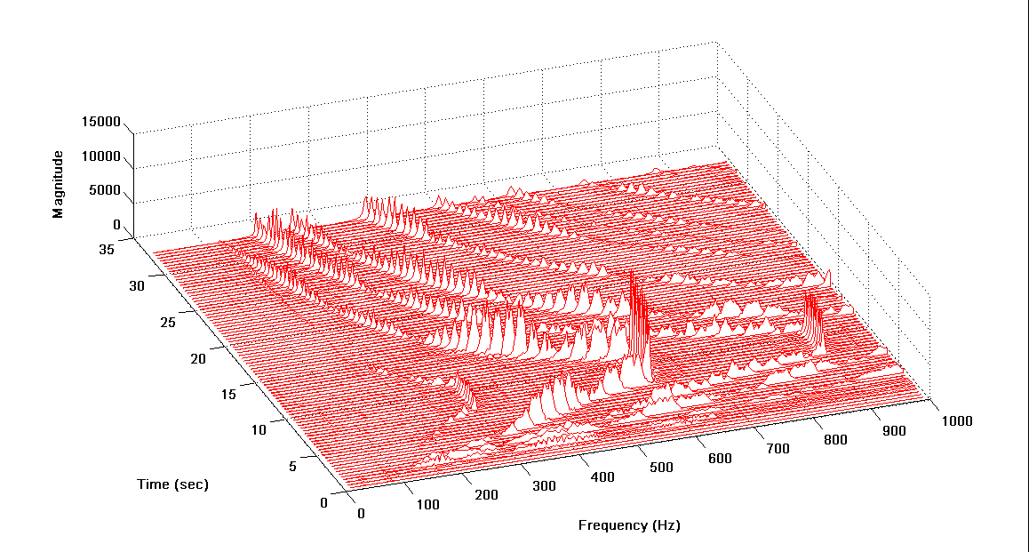

Figure 4.

The waterfall plot covers nearly the entire test duration. The fundamental frequency and its harmonics ramp upward in frequency from zero to 7 seconds. The steady-state portion occurs from about 7 to 11 seconds. The signal then sweeps downward in frequency in a very gradual manner until the end of the recording. This appears to be one cycle of an attack sounding.
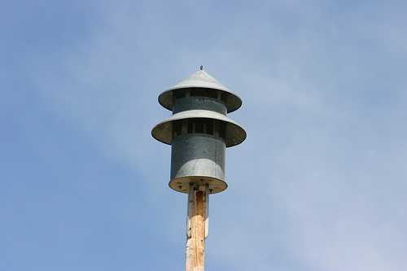

Figure 5. Federal Signal Model 5

The Federal Signal Model 5 siren is no longer in production, although it is still in use in some communities. It has 12 ports.
The following frequencies were measured during a siren test in Shawnee County, Kansas.
Federal Signal Model 5
Freq (Hz)
688
1375
2068
2746
3441

The fundamental frequency is slightly below an F note. The higher frequencies are integer harmonics.
The sound file was taken from:
http://www.youtube.com/watch?v=4v5s55QY0kE&feature=related
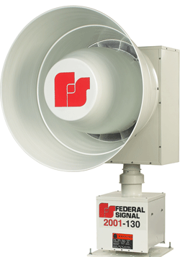

Figure 6. Federal Signal 2001
The Federal Signal 2001 is a rotating, unidirectional electromechanical siren. It produces 130dBc @ 100 feet. Its sound can be heard over four square miles. It has three tones: Wail, Fast Wail and Steady.

The following frequencies were measured during a siren test in Douglas County, Kansas.
Federal Signal 2001
Freq (Hz)
692
1384
2086
2768
The fundamental frequency is slightly below an F note. The higher frequencies are integer harmonics.
The sound file was taken from:
http://www.youtube.com/watch?v=mChIvckPQfs&feature=related
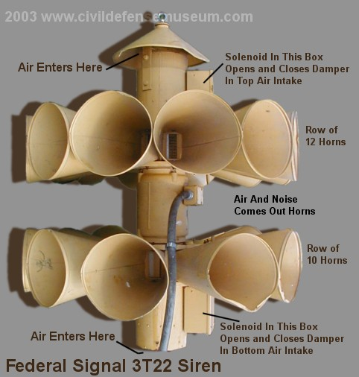
Figure 7. Federal Signal 3t22, courtesy of http://www.civildefensemuseum.com/
The 3T22 is an omni-directional, electromechanical siren. It generated 124 dBc at 100 feet. It could produce three signals: Alert, Attack, and Hi-Lo. Production of the 3T22 was discontinued around 1990. The following frequencies were measured during a siren test in Northport, NY.
Federal Signal 3t22
Freq (Hz)
695
1390
2086
2782

The 695 Hz tone is close to an F note. The higher frequencies are integer harmonics. The sound file was taken from:
http://www.youtube.com/watch?v=J9FslobXbtc&feature=related
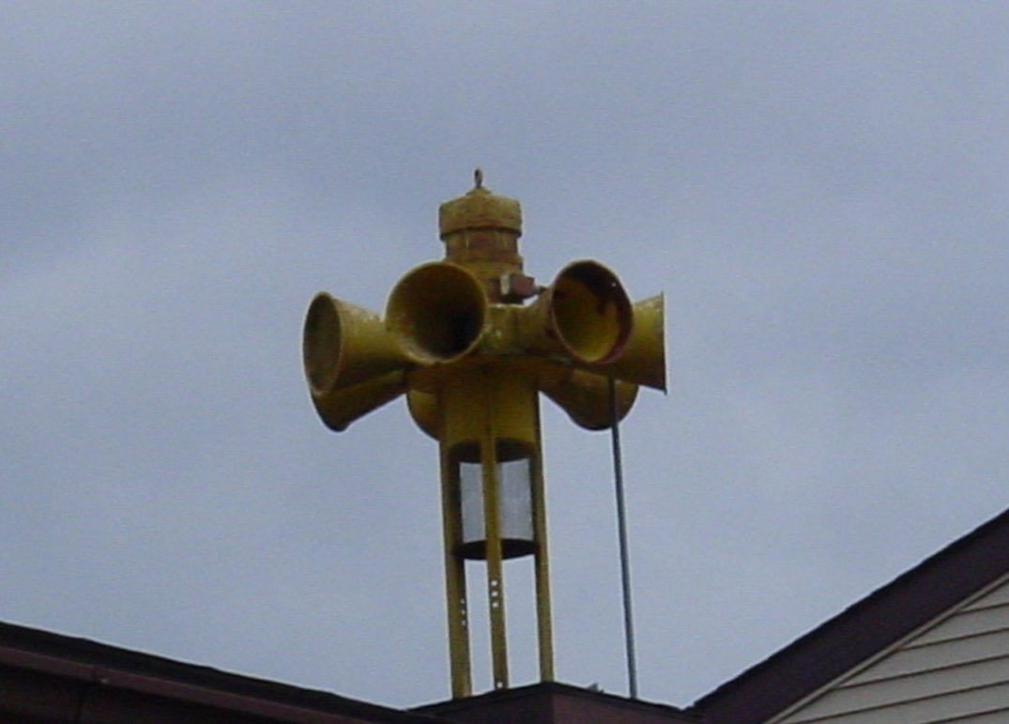
Figure 8. Federal STL-10 Siren
The STL-10 is an omni-directional, electromagnetic siren.
The following frequencies were measured during a siren test in Winthrop Harbor, Illinois.
Federal STL-10
Freq (Hz)
385
770
1155
1540

The fundamental frequency is between F# & G. The sound file was taken from:
http://www.youtube.com/watch?v=xtNOpnUgtMs&feature=related
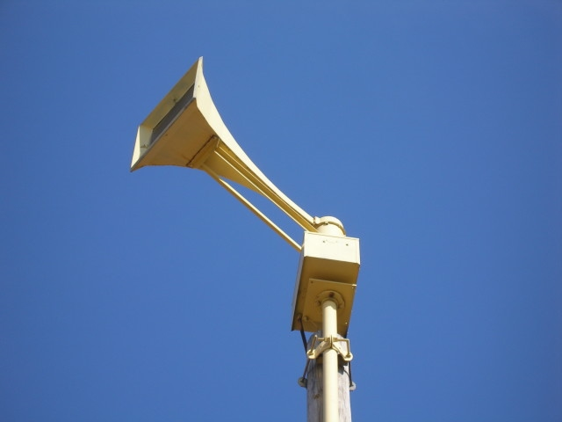
Figure 9. Thunderbolt Siren 1000T
The 1000T is a rotating, electromechanical siren, which is no longer in production. It is a favorite among collectors who restore the weathered sirens.
The following frequencies were measured during a siren test in Maunalua Bay, Oahu, Hawaii.
Thunderbolt Siren 1000T
Freq (Hz) | Nearest Note
348 | F
899 | A
1988 | B
2891 | F

The siren outputs multiple notes. The sound file was taken from
http://www.youtube.com/watch?v=5sTZTm3hFz8&feature=related
Further information is given at:
http://en.wikipedia.org/wiki/Thunderbolt_siren
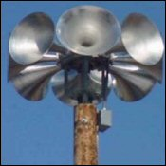
Figure 10. American Signal T-121
The T-121 is an omni-directional, electromechanical siren. It generates a sound pressure level of 121 dBc at 100 feet.

The following frequencies were measured during a siren test in Industry, Illinois.
American Signal T-121
Freq (Hz)
540
1080
1620
2160

The fundamental frequency is slightly above a C note, with integer harmonics.

The sound file was taken from:

http://www.youtube.com/watch?v=MMnGvDiahO8&feature=related
Further information is given at:

http://en.wikipedia.org/wiki/American_Signal_Corporation
http://www.americansignal.com/products/tempest-T-121.php

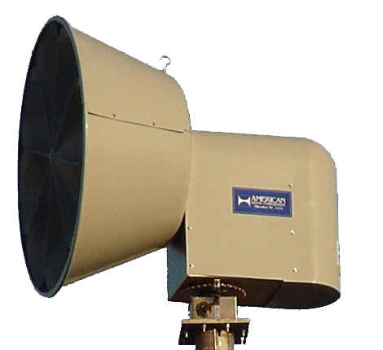

Figure 11. American Signal Corporation (ASC) Tempest T-128 Siren
The ASC T-128 is a rotating, electromechanical siren. Its peak output is 130.9 dB at 100 feet.
The following frequencies were measured during a siren test in New Berlin, Wisconsin.
ASC T-128
Freq (Hz)
536
1073
1609

The fundamental frequency is slightly above a C note, with integer harmonics.

The sound file was taken from:

http://www.youtube.com/watch?v=7MQ5Jx6zuWU
Vendor information is given at:
http://www.americansignal.com/products/tempest-T-128.php
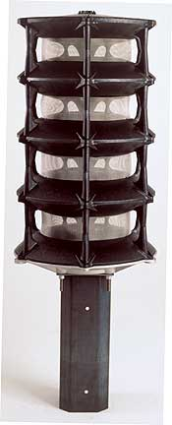
Figure 12. Whelen 2800 Series, with Four Speaker Cells
The WPS-2800 is an omni-directional siren which can be configured with one to ten speaker cells.
The following frequencies were measured during a siren test. The siren was part of the CSEPP (Chemical Stockpile Emergency Preparedness Program), but its location was unspecified.
Whelen 2800 Series in Hi-Lo Mode
Freq (Hz) | Nearest Note
435 | A
592 | D
870 | A
1184 | D
The A and the D notes both have 2x integer harmonics. The sound file was taken from:
http://www.youtube.com/watch?v=mE_nROiH05w&feature=related
Vendor information is given at
http://www.whelen.com/install/135/13563.pdf
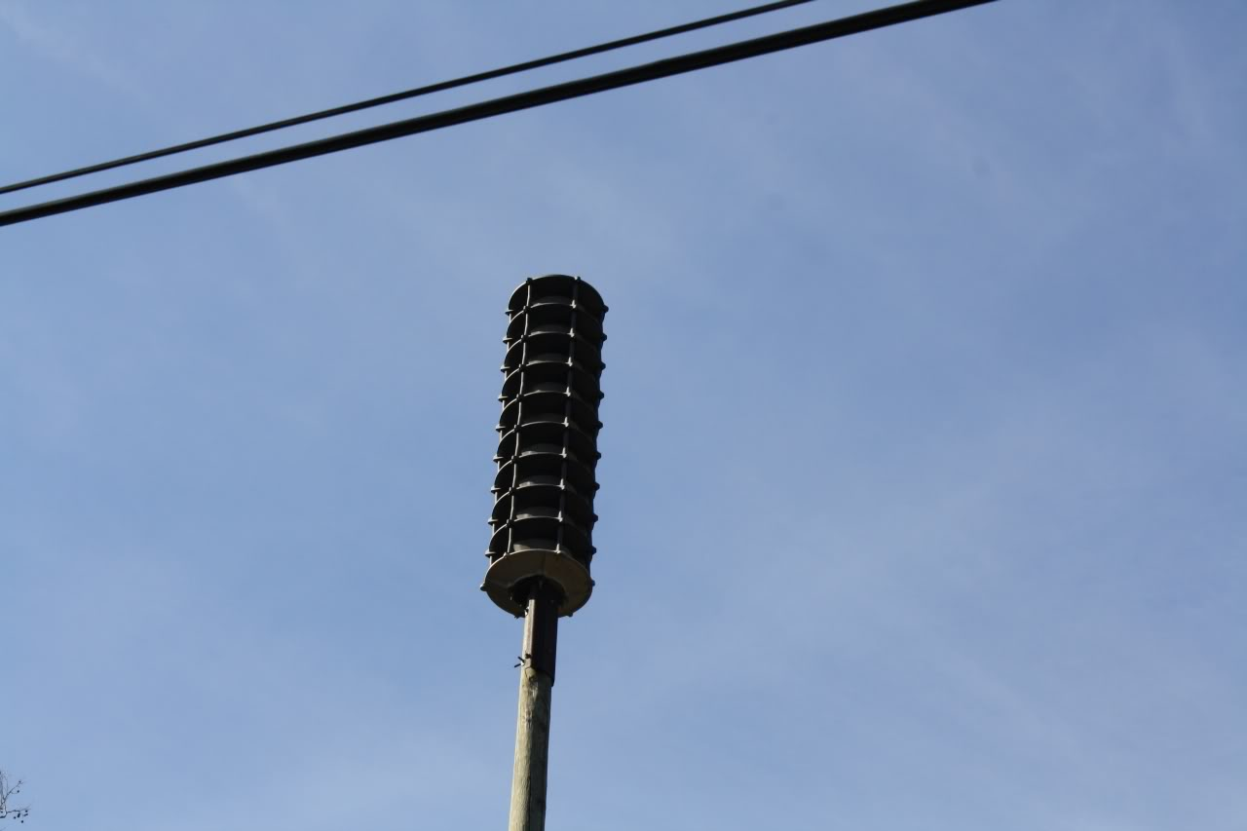
Figure 13. Whelen WPS-2909
The WPS-2909 is an omni-directional siren with nine electronic speaker cells. It generates a sound pressure level of 128 dBc at 100 feet. It has six standard warning tones: wail, whoop, attack, hi-lo, alert and air-horn.
The following frequencies were measured during a siren test inPevely, Missouri.
Whelen WPS-2909
Freq (Hz)
434
869
1303

The fundamental tone is an A note with integer harmonics.
The sound file was taken from:
http://www.youtube.com/watch?v=M3-25fSuoZw&feature=related
Vendor information is given at:
http://www.whelen.com/_MASSNOTIFICATION/2900.php
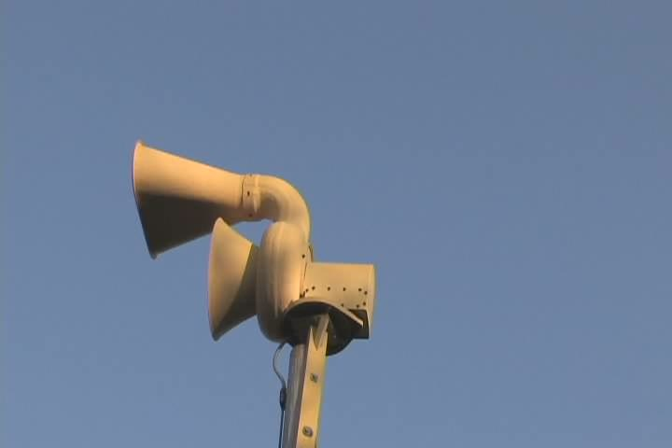
Figure 14. Allertor 125 Siren
The Allertor 125 is an electromechanical siren with two horns. It generates a sound pressure level of 125 dB. This model has been discontinued.

The following frequencies were measured during a siren test in Chaska, Minnesota. There are two tones, each with a 2x integer harmonic.

Allertor 125 siren
Freq (Hz) | Nearest Note
177 | F
525 | C
704 | F
1053 | C

The sound file was taken from:
http://www.youtube.com/watch?v=KceFom3xmTs
Further information is given at:
http://en.wikipedia.org/wiki/ACA_Allertor_125

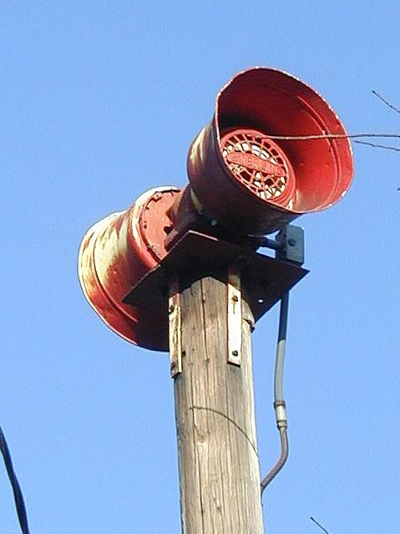
Figure 15. Sterling Little Giant Siren
The Sterling Little Giant is an historical siren. The Sterling Siren company was renamed Sentry Siren in 1972.
The following frequencies were measured during a test at McCranie Warning Sirens, Rhine, Georgia.
Sterling Little Giant
Freq (Hz)
690
1380

The 690 Hz is slightly below an F note.
The sound file was taken from:

http://www.youtube.com/watch?v=leRuA1cu2F8

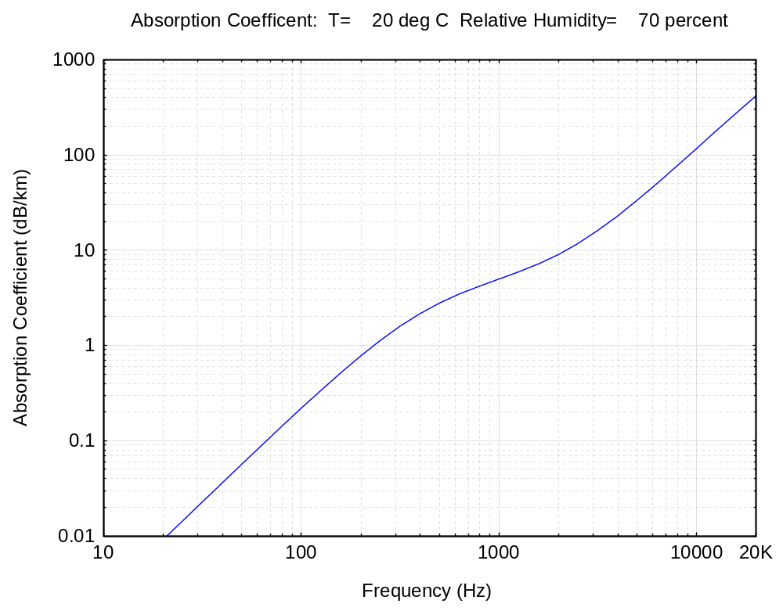
Figure 16.
Siren designers must consider atmospheric absorption with regard to the fundamental frequency of a siren and its harmonics. A lower absorption coefficient is more favorable for propagation of a warning sound.

Atmospheric absorption originates from two effects:

- Thermal conduction and viscosity of the air.
- Relaxation losses of oxygen and nitrogen molecules in the air.

Both effects cause attenuation of the sound wave. Sound energy is converted into heat in both cases.

The attenuation is larger at high frequencies than at low frequencies.

The attenuation also depends on the humidity in the air. The relationship between the absorption coefficient and the relative humidity is complicated. But greater attenuation tends to occurs in drier air over lower and middle audio frequencies.

Several of the sirens in this newsletter had their respective fundamental frequencies near 690 Hz. This frequency would yield 4 dB/km attenuation for the conditions in Figure 16. The attenuation at 2.5 km (1.6 miles) would be 10 dB. The sound would thus be “one half as loud” at this distance according to human perception.

Note that wind, terrain, and other factors also effect the sound propagation.

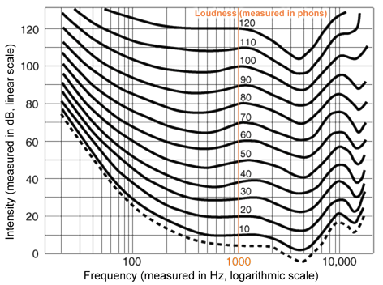

Figure 17. Human Hearing Contours
(Courtesy of http://dvd-hq.info/dvdhq_images_2k8/human_hearing.png)

The graph in Figure 17 shows contours of equal loudness perception for human hearing. For example, a 10 dB sound at 1000 Hz would seems to have the same loudness as an 80 dB sound at 20 Hz.

Human hearing is most sensitive to sounds between 3000 and 4000 Hz. Humans are less able to perceive low frequency sounds below, say, 100 Hz.

Siren designers thus face a trade-off between atmospheric absorption and human hearing perception with respect to selecting a fundamental frequency and its harmonics.

Finally, sirens are not musical instruments per se, but the diagram in Figure 18 provides a references for assigning musical notes to the previously given siren frequencies.
A0 27.5

B0 30.868

C1 32.703

D1 36.708

E1 41.203

F1 43.654

G1 48.999

A1 55.000

B1 61.735

C2 65.406

D2 73.416

E2 82.407

F2 87.307

G2 97.999

A2 110.00

B2 123.47

C3 130.81

D3 146.83

E3 164.81

F3 174.61

G3 196.00

A3 220.00

B3 246.94

C4 261.63

D4 293.66

E4 329.63

F4 349.23

G4 392.00

A4 440.00

B4 493.88

C5 523.25

D5 587.33

E5 659.25

F5 698.46

G5 783.99

A5 880.00

B5 987.77

C6 1046.5

D6 1174.7

E6 1318.5

F6 1396.9

G6 1568.0

A6 1760.0

B6 1979.5

C7 2093.0

D7 2349.3

E7 2637.0

F7 2793.8

G7 3136.0

A7 3520.0

B7 3951.1

C8 4186.0
A0# 29.135

C1# 34.648

D1# 38.891

F1# 46.249

G1# 51.913

A1# 58.270

C2# 69.296

D2# 77.782

F2# 92.499

G2# 103.83

A2# 116.54

C3# 138.59

D3# 155.56

Middle C
F4# 369.99

G4# 415.30

A4# 466.16

C5# 554.37

D5# 622.25

F5# 739.99

G5# 830.61

A5# 932.33

C6# 1108.7

D6# 1244.5

F6# 1480.0

G6# 1661.2

A6# 1864.7

C7# 2217.5

D7# 2489.0

F7# 2960.0

G7# 3322.4

A7# 3729.3

F3# 185.00

G3# 297.65

A3# 233.08

C4# 277.18

D4# 311.13

Piano Keyboard

The number beside each key is the fundamental frequency in units of cycles per seconds, or Hertz.

Octaves

For example, the A4 key has a frequency of 440 Hz. Note that A5 has a frequency of 880 Hz. The A5 key is thus one octave higher than A4 since it has twice the frequency.

Overtones

An overtone is a higher natural frequency for a given string. The overtones are "harmonic" if each occurs at an integer multiple of the fundamental frequency.

Figure 18.

