
Welcome to
Vibrationdata

Acoustics • Shock • Vibration • Signal Processing June 2005 Newsletter

Greetings

The Earth is a natural source of radio waves at audio frequencies. It emits a remarkable symphony of strange noises, which scientists call "tweeks," "whistlers" and "sferics." The primary source is electromagnetic radiation from lightning which propagates vast distances through the Earth’s ionosphere.
The ionosphere is an upper layer of the atmosphere containing ionized atoms. This layer reflects AM and Amateur radio waves, making long distance radio communication possible. This is also the layer where the Aurora Borealis takes place. The Aurora is another source of radio waves.
The articles in this newsletter introduce these phenomena. Please also listen to the accompanying sound files which are posted at:
http://www.vibrationdata.com/newsletters.htm

Have an enjoyable summer!

Sincerely,
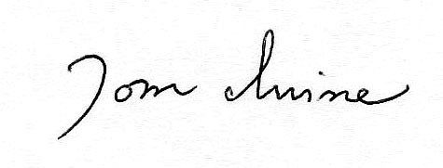
Tom Irvine
Email: tomirvine@aol.com

Feature Articles

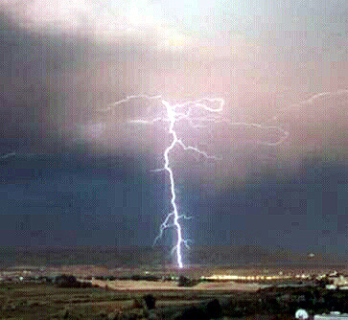

Earth Sferics, Tweeks & Whistlers page 1

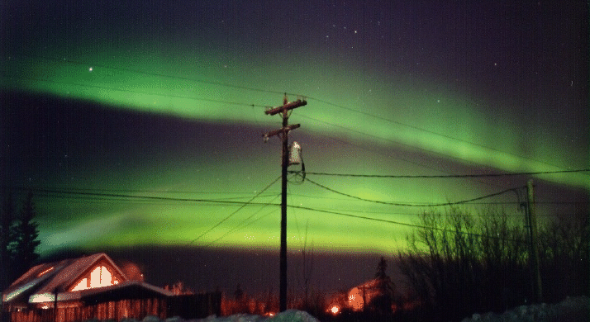

Auroral Chorus page 8

Schumann Resonance page 11

Earth Sferics, Tweeks & Whistlers
By Tom Irvine
Introduction
Lightning strikes emit a broadband spectrum of radio waves. Human ears cannot detect these radio waves directly. Instead, scientists use very low frequency (VLF) radio receivers to transform these waves into audible sounds.
A VLF receiver consists of an antenna and an audio amplifier that is sensitive to radio waves with frequencies between 200 Hz and 10,000 Hz.
This frequency band is typically not used for radio communication, with a few exceptions. One is the Russian Alpha radio navigation at 10 kHz. The US Coast Guard operated a similar system called Omega which has been discontinued due to the availability of global positioning satellites (GPS). Furthermore, the US Navy uses limited submarine communications at or near 70 Hz.
This band below 10 kHz thus remains largely clear for the listener to observe and study naturally occurring radio emissions.
For comparison, AM band radios, like the ones in most automobiles, span a much higher frequency range from 540 kHz to 1.6 MHz.
VLF radio sounds can be heard with the proper receiver at any time of the day, but the hours around dawn and dusk are generally best. Nighttime is also better than daytime.

Lightning Storms
Several million lightning strikes occur daily from an estimated 2000 storms worldwide. The Earth is struck by lightning one hundred or more times per second.
Furthermore, most lightning strikes contain multiple strokes. Each stroke is a potential source of VLF radio waves. Only a very small percentage of lightning strikes produce whistlers, however.

Ionosphere Waveguide Effect
The lightning-induced radio waves propagate vast distances through the Earth’s ionosphere.
The ionosphere is a layer of the atmosphere containing ionized atoms. The ionization is caused by solar ultraviolet radiation.
The ionosphere is composed of three regions: the D, E, and F regions.
F-region: 150-1000 km, contains a range of ion from NO+ and O+ at the bottom to H+ and He+ ions at the top. The electron density is highest in this layer.
E-region: 95-150 km, contains mostly 02+ ions
D-region: 75-95 km, relatively weak ionization due to its position at the bottom.
The ionosphere reflects low frequency radio waves particularly from its E-region, making long distance radio communication possible. The actual direction-change in the ionosphere is closer to refraction, however. The term reflection an over-simplification used for explanation purposes.
Again, VLF waves have a lower frequency and longer wavelength than AM waves.
The length of VLF radio waves becomes so long that they do not reflect from the ionosphere back to Earth, but are conducted in a waveguide consisting of the Earth's surface and the ionosphere. The VLF radio waves can travel around the curve of the earth in a very stable fashion, guided between these partially-conductive surfaces,
Furthermore, some radio waves exit the atmosphere entirely, following magnetic field lines that guide them 10,000 km or more above Earth's surface, into the magnetosphere and then back again.

Sferics
Sferics is short for "atmospherics." Sferics are impulsive signals emitted by lightning. The resulting sound is similar to twigs snapping or bacon frying. Sferics are caused by lightning strikes within a thousand kilometers or so of the receiver.

Tweeks
Tweeks are sferics that travel considerable distances through the ionosphere.
The ionosphere is a "dispersive medium" where low frequencies travel slower than high frequencies do. As a result of dispersion, tweeks sound like a quick musical ricochet.
The dynamic spectrum of a tweek shows a vertical line at the higher frequencies with a curved section, called the "hook," appearing at approximately 2 kHz. This frequency is the fundamental frequency of the ionosphere-Earth surface waveguide.

Whistlers
Whistlers are sferics that propagate to and from the magnetosphere, as shown in Figure 1. A lightening induced emission occurring in the South Pacific might be heard seconds later as a whistler in North America, after having traveled many thousands of kilometers into space and back.
Whistlers are dispersed even more than tweeks because whistlers travel great distances through magnetized plasmas. Note that plasma is a high-temperature ionized gas. Plasma gas is a strongly dispersive media for VLF signals.
The sound of a whistler is a musical descending tone that lasts for a second or more.
Their dynamic spectra reveal a long sweeping arc that illustrates how the high frequencies arrive first, followed by lower ones.
Sample acoustic data from a series of whistlers is given in Figure 2, as recorded in Death Valley.
Additional whistler data is given in Figures 3 and 4.

History
Whistlers were first detected in World War I by a German scientist who was trying to eavesdrop on allied telephone conversations.
NASA, numerous universities, and many amateurs are actively involved in recording and studying whistlers and other natural radio sources.
Steve McGreevy is perhaps the most prominent source of whistler recordings. His sound files are posted at numerous websites.

Other VLF Sources
There are numerous sources of VLF radio waves aside from lightning, although lightning is the most common. The Aurora Borealis is another source, as described in the next article.

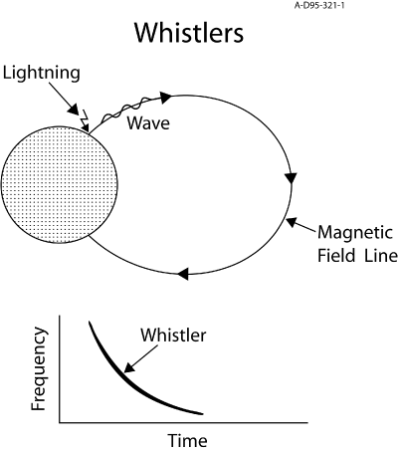

Figure 1. Whistlers in the Earth’s Magnetic Field
Image courtesy of Professor Don Gurnett, University of Iowa.
http://www-pw.physics.uiowa.edu/space-audio/sounds/EarthWhistlers/EarthWhistlers.html
SPECTROGRAM

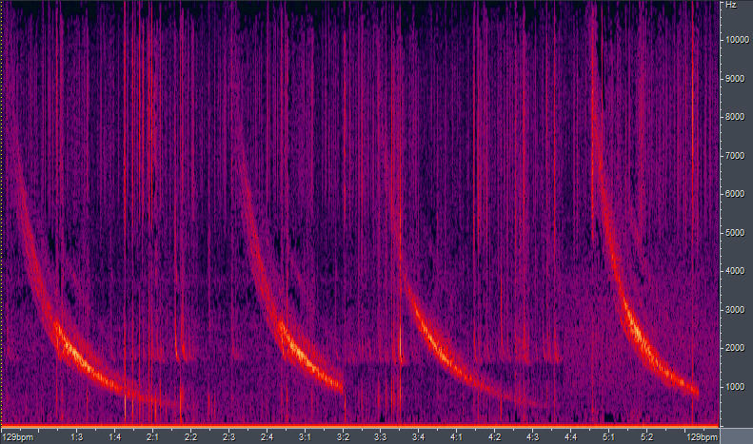
Freq
(Hz)
Time (sec)

Figure 2. Whistlers and Sferics, McGreevy Data
Each of the four curves represents a whistler. Each has a descending frequency with respect to time due to dispersion. The vertical lines are from Sferics.

Audio File Source: Stephen P. McGreevy
http://www.spaceweathersounds.com/sndbites.html

Death Valley National Park Whistlers - April 23, 2002:

Compilation of loud whistlers recorded 23 April 2002 (0700 - 1300 UT) from northern Death Valley a few miles from Scotty's Castle. A coronal-mass-ejection from the Sun caused an electron/proton storm as well as a minor magnetic storm, vastly enhancing already good vernal whistler conditions.

SPECTROGRAM
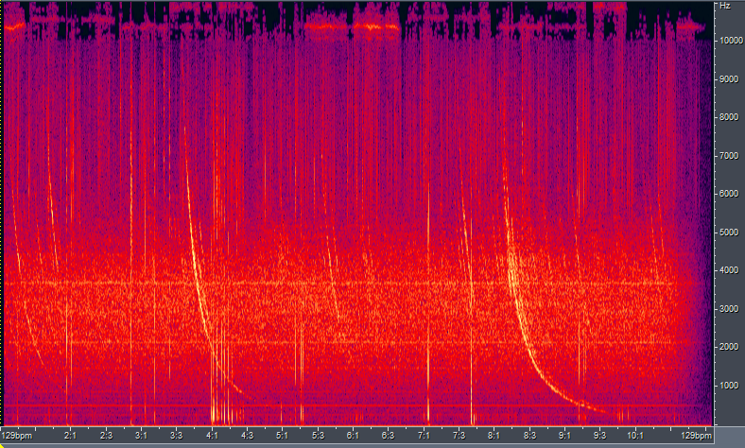
Freq
(Hz)
Time (sec)
Figure 3. Whistlers and Sferics, NASA Data
Audio file courtesy of NASA's INSPIRE program via website:
http://spaceweather.com/glossary/inspire.html

WATERFALL FFT

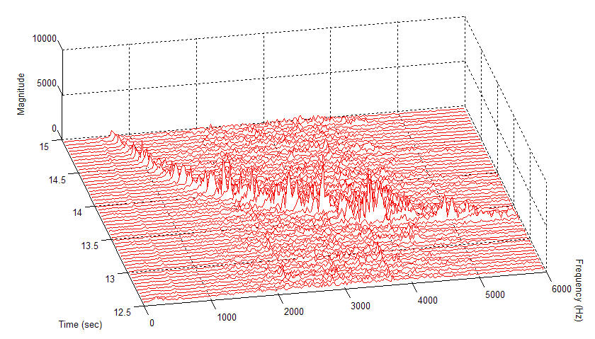

Figure 4. Whistler, NASA Data

The Waterfall FFT shows the frequency variation of the main whistler from the NASA data. The magnitude is unscaled sound pressure.

Auroral Chorus
By Tom Irvine

Solar Wind
The Sun emits a solar wind of charged particles. Magnetic anomalies in the Sun’s corona emit a steady stream of particles. The temperature of the corona is so high that the Sun's gravity cannot retain the coronal particles.
In addition, transient events such as solar flares, prominences, and coronal mass ejections emit very large bursts of particles.
These plasma particles travel through space with supersonic speeds varying from 300 to 1000 kilometers per second. A small fraction of these particles reach Earth, after two to three days. The particles are captured by the Earth’s magnetic field, which is called the magnetosphere. The magnetic field lines guide the particles to Earth's North and South geomagnetic poles.
The solar wind exerts a tremendous pressure against the Earth’s magnetic field, distorting the field as shown in Figure 1.

Aurora Borealis
The Earth’s magnetic field lines intersect an upper region of the atmosphere called the ionosphere. The solar wind thus collides with the plasma in the ionosphere.
The collision energy emits light particles called photons. The effect is similar to that in a florescent light tube. "In a florescent light tube, the inside is a near vacuum," explains Patrick Newell in an article in Nature. "An electric field (the voltage from your wall socket) is applied across the ends. The electric field accelerates electrons that then strike the small amount of gas inside, giving off light."
The Aurora Borealis, or Northern Lights, occur if an intense solar wind produces a sufficient number of photons. A similar effect occurs in the southern hemisphere, called Aurora Australis, or Southern Lights.
The name Aurora Borealis is Latin for the “red dawn of the north.” Galileo Galilei (1564-1642) was the first scientist to use this expression. The Northern Lights consist of mainly red color on the latitude where Galileo was living in Italy.

Radio Wave Emission
The Aurora Borealis radiate a spectrum of radio waves. Human ears cannot detect these radio waves directly. Instead, scientists use very low frequency (VLF) radio receivers to transform these waves into audible sounds, called an Auroral Chorus. This chorus typically sounds like a flock of birds chirping in an eerie manner. An example is given in Figure 2.

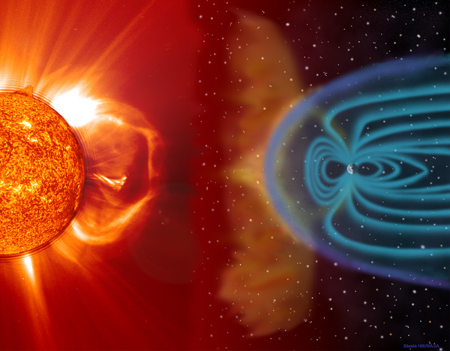

Figure 1. The Solar Wind Interacting with Earth’s Magnetic Field.
(Image courtesy of NASA).

WATERFALL FFT
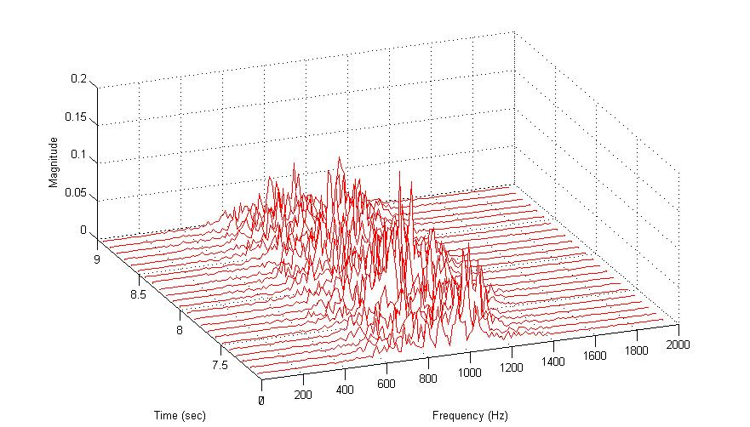

Figure 2. Auroral Chorus

The magnitude is unscaled sound pressure. Most of the sound energy is between 600 and 1200 Hz.

Audio File Source: POLAR Plasma Wave Investigation (PWI)
http://cse.ssl.berkeley.edu/impact/vos/aurora.html

Schumann Resonance
By Tom Irvine

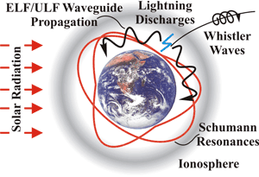
Figure 1. Schumann Resonances
(Image Courtesy of the University of Iowa.)

Introduction
The Earth’s atmosphere is a weak conductor of electricity. A resonant cavity for electromagnetic waves thus exists between the Earth’s surface and the inner edge of the ionosphere, approximately 50 kilometers above the surface.
German physicist W. O. Schumann mathematically predicted this cavity in 1952. Schumann and his colleagues later verified this prediction via measurements.
Nikola Tesla (1856-1943) was aware of this resonant cavity before Schumann’s research, however. Tesla envisioned wireless transmission of electrical power using this cavity resonance. This goal has yet to be achieved.

Natural Frequencies
The cavity’s fundamental frequency is 7.8 Hz. This is in the infrasonic region, below the lower frequency limit for human hearing.
The wavelength corresponding to 7.8 Hz is approximately equal to the circumference of the Earth at the equator.
Furthermore, the cavity has higher frequencies at 14, 20, 33, 39, and 45 Hz.
The fundamental and higher frequencies are referred to as Schumann Resonance (SR) frequencies.
Note that each frequency has some tolerance.
Furthermore, each frequency falls in the ultra-low frequency (ULF) and extremely low frequency (ELF) bands.

Excitation
The cavity frequencies remain dormant unless there is an excitation source. Energy from lightning or other sources is required to excite the natural frequencies.
Lightning is related to thunderstorms and rainfall, and in turn to global temperatures.
Researchers such as Earle Williams of MIT are attempting to use measurement of the SR response as an indirect global thermometer.

