Welcome to
Vibrationdata

Acoustics • Shock • Vibration • Signal Processing March 2012 Newsletter

Feature Articles

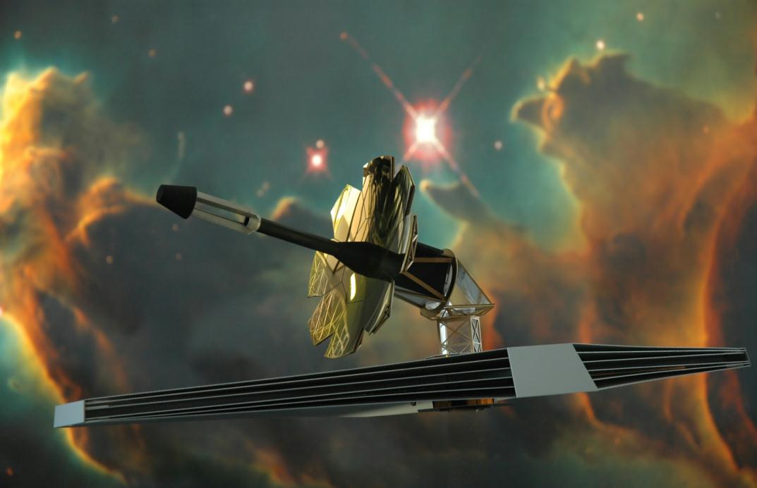
James Webb Space Telescope Isolation page 2
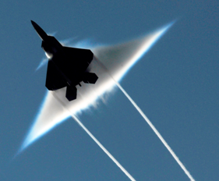

The Prandtl–Glauert Singularity page 8
Seneca Guns page 11
Loudest Stadium Crowd page 14

Dia duit!

The Biblical shepherds had ample opportunity to gaze at the immensity of stars in the night-time skies. King David, who was a shepherd in his youth, asked:

[3] When I consider thy heavens, the work of thy fingers, the moon and the stars, which thou hast ordained;
[4] What is man, that thou art mindful of him? and the son of man, that thou visitest him?
[5] For thou hast made him a little lower than the angels, and hast crowned him with glory and honour. (Psalm 8)
Mankind will further consider the heavens as images are received from the James Webb Space Telescope, scheduled for launch in 2018. The data will enable astronomers to study the birth and evolution of galaxies, and the formation of stars and planets.

Take a moment or so each day to appreciate nature, whether on land, sea or the heavens above.

Sincerely,
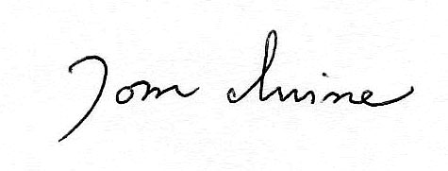
Tom Irvine
Email: tomirvine@aol.com

James Webb Space Telescope Isolation by Tom Irvine

Sunshield
Sunshield Containment Fields
OTE Primary Mirror
Optical Telescope Element (OTE) Secondary Mirror
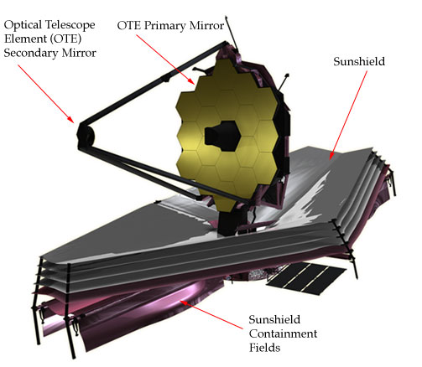

Figure 1. JWST Diagram

The primary mirrior is 6.5 meters (21.3 feet) in diameter. The Sunshield is about the size of a tennis court.

Introduction  The James Webb Space Telescope (JWST) is an infrared-optimized telescope which has a planned launch in 2018 via an Ariane 5 vehicle, as shown in Figure 2.  Its mission is to find the first galaxies that formed in the early Universe, connecting the Big Bang to our own Milky Way Galaxy. |  |  | Orbit  JWST will orbit the Earth at an altitude of about 1.5 million km (930,000 miles). This is roughly four times the distance from the Earth to the Moon. The orbit will be the Lagrangian L2 point, such that JWST always maintains the same relative position with respect to the Sun and Earth as shown in Figure 3.
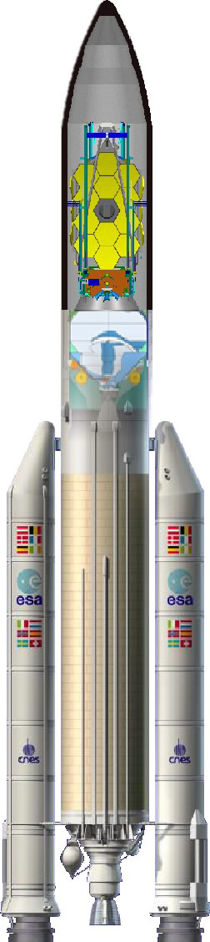  Figure 2. Ariane 5 with Stowed JWST |  | Vibration Limits  The primary mirror has 18 segments.  The vibration displacement of each segment must be less than 10 nanometers in order for the mirror to capture the starlight photons with the required accuracy. Furthermore, pointing errors induced by the vibration must remain below an angle of 4 milliarcseconds.  Vibration Isolation  JWST is divided into two sections: the spacecraft bus and the optical payload. The sections are connected via a set of passively-damped flexural struts as shown in Figure 4.  The struts are used to isolate the payload mirrors from the vibration generated inside the spacecraft bus. The struts have three layers as shown in Figure 5.  In addition, some of the components inside the bus are mounted via passive isolators.  Mirror Natural Frequencies  The primary and secondary mirrors have natural frequencies at 11 and 7 Hz, respectively.  Forcing Functions  The spacecraft bus has reaction flywheels that operate continuously to orient the telescope. These wheels will generate imbalance forces at integer multiples of their spin rate, over the 10 to 100 Hz frequency domain.  The bus also has a cryocooler to maintain the Mid InfraRed Instrument’s focal plane at an extremely low temperature of 6 K (-267° C). The compressor generates pulsating forces at harmonics of the 30-stroke-per-second drive speed.  The reaction wheels and compressor are mounted on passive isolators inside the bus. The isolation frequency is 10 Hz with 5% damping.

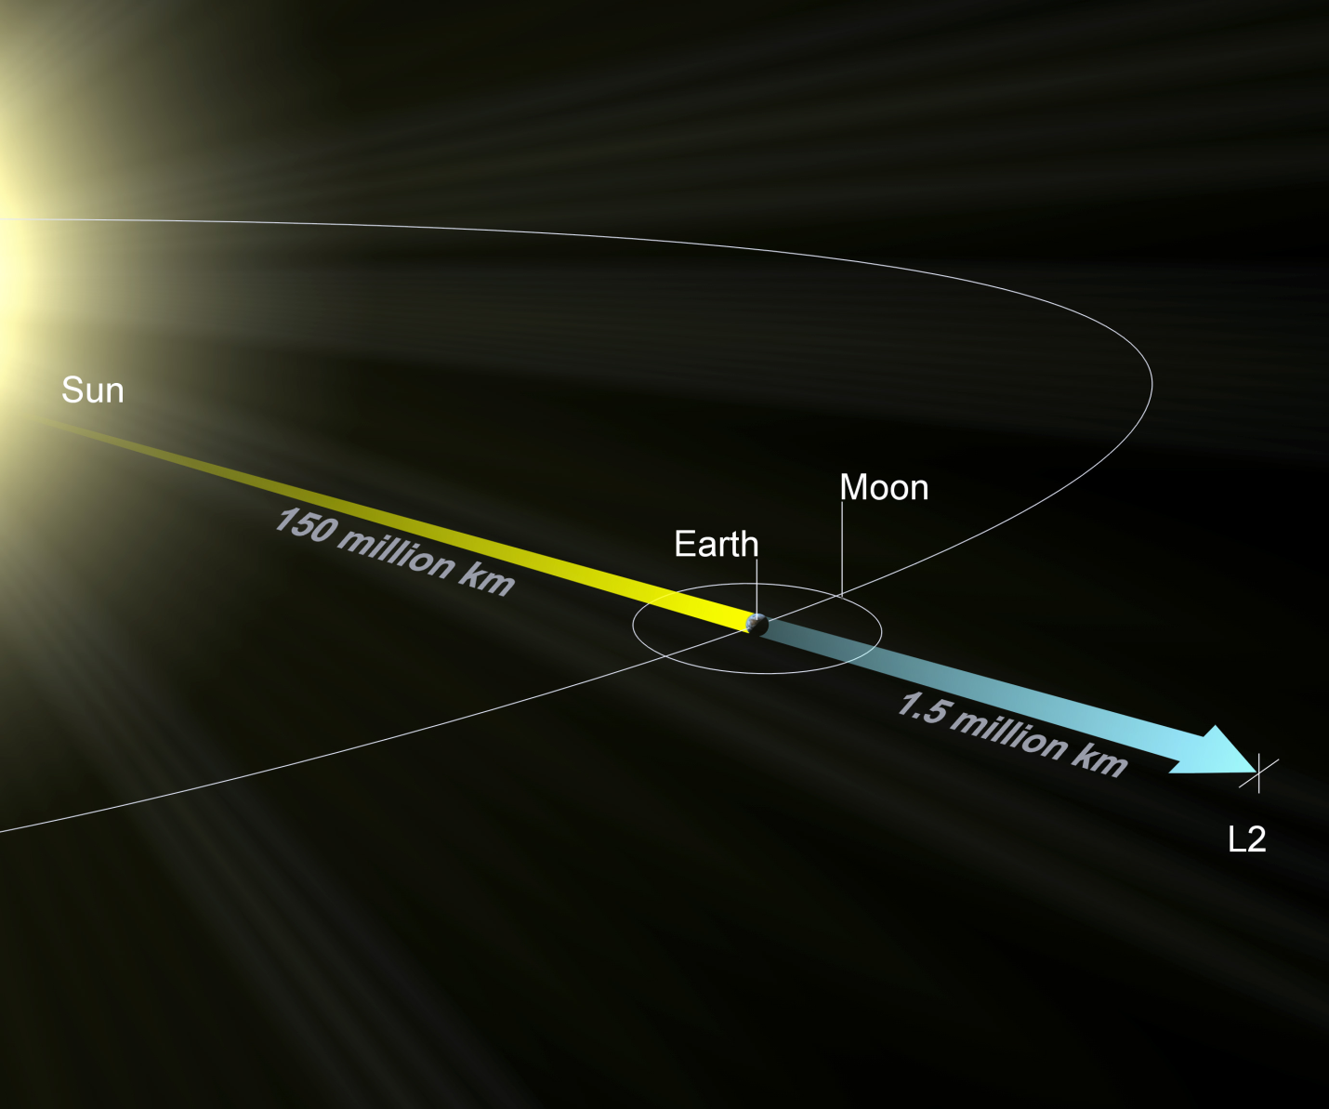

Figure 3. Lagrangian L2 Point

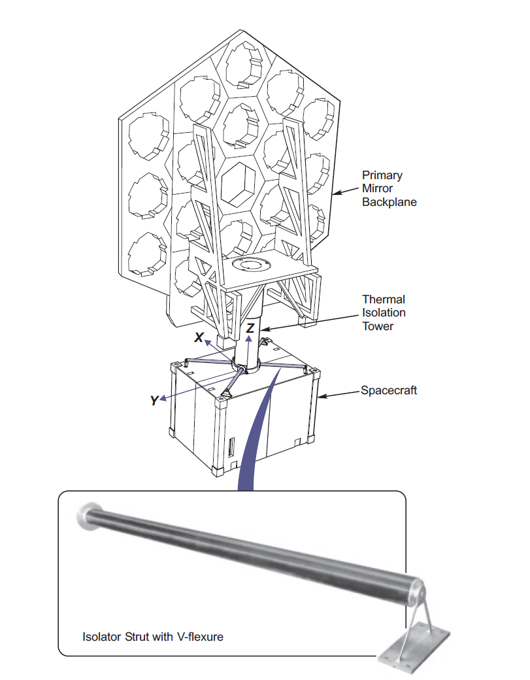
Figure 4. Isolator Struts

The Sunshield is not shown.
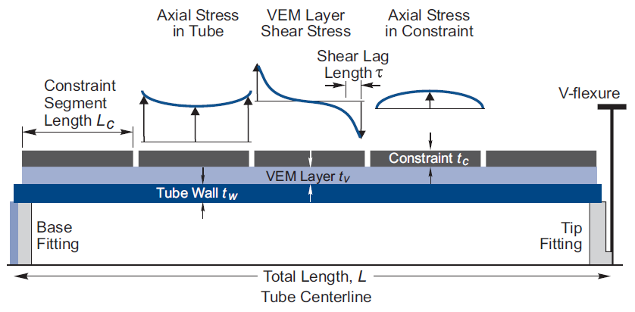

Figure 5. Strut Cross-section along Length

Strut Layers  The struts are tubular with constrained layer damping. The inner tube has a 2.5 inch diameter. The length is 52 inch.  The inner tube material is graphite.  The middle layer is a soft viscoelastic damping material (VEM), overwrapped with a segmented graphite constraining layer. |  | The segmentation forces axial stress in the inner tube to weave through shear stress in the damping layer, and then into axial stress in the constraining layer, and then back to the inner tube.  Strain energy deposited in the lossy VEM is thus maximized, allowing for maximal dissipation of vibrational energy.

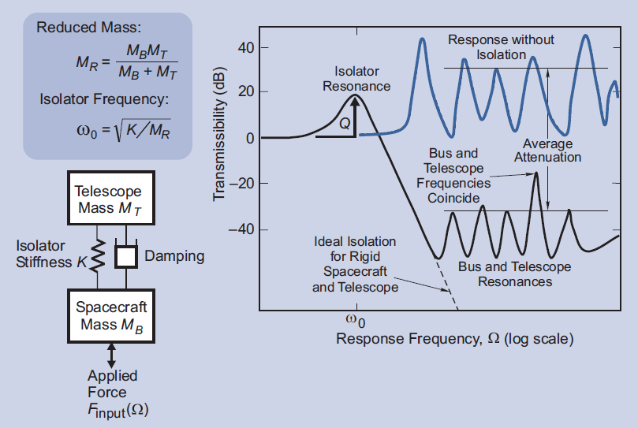

Figure 5. Dynamic Model

Combined System  The strut’s stiffness is very soft by design, such that the system’s natural frequency is 1 Hz in the Z-axis, as calculated using the spring-mass model in Figure 5.  The damping value depends on temperature. The strut temperature will be controlled in orbit to 0° C. The damping based on test data at this temperature is nearly 7%.  The isolation system provides about 60 dB of attenuation as shown in the transmissibility plot in Figure 5. |  | Reference  Bronowicki & Innis, A Family of Full Spacecraft-to-Payload Isolators, Northrop Grumman Space Technology, Fall/Winter 2005.

The Prandtl–Glauert Singularity by Tom Irvine

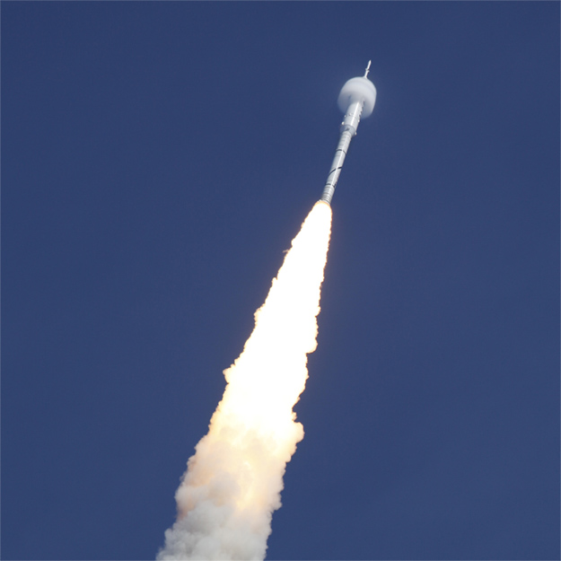

Figure 1. Ares 1-X, Vapor Condensation Cone at Transonic

Introduction

The Prandtl–Glauert singularity is a prediction that infinite flow resistance conditions would be experienced by an aircraft or rocket as it approaches the speed of sound. The resulting pressure would also become infinite. This is related to the early 20th century misconception of the impenetrability of the sound barrier.

In reality, aerodynamic and thermodynamic perturbations get amplified strongly as the aircraft approaches the transonic speed. A true singularity does not occur due to these nonlinear effects.

Shock Wave

Shock waves form as the flow becomes transonic. The shock wave consists of a leading compressed component followed by a pressure drop. The air becomes rarefied in the trailing region. The aerodynamic flow geometry is three-dimensional, with the shock wave forming a cone.

A stationary observer on the ground may hear a resulting sonic boom with a pressure time history similar to that shown in Figure 2.

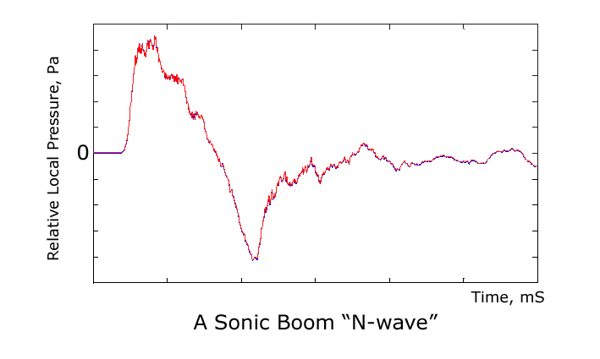

Figure 2. An N-Wave Measured by JAXA/Brüel & Kjær

Condensation Cone

Note that heat does not leave the air mass affected by the shock wave. The pressure change is adiabatic, with an associated temperature drop. The air temperature may drop below the dew point for a humid air mass.

Moisture then condenses to form visible microscopic water droplets

The resulting vapor condensation cone is referred to as a Prandtl–Glauert singularity, taking some liberty with the actual physics.

The air returns to normal ambient pressure at further lengths, due to rebounding effects from its inertia and adiabatic bulk modulus.
Random Vibration

The aerodynamic shock waves and other accompanying flow effects have the potential to generate high random vibration levels in the outer skin of the aircraft or launch vehicle. The vibration then propagates to secondary locations within the vehicle.

Typically, the highest vibration levels for a launch vehicle occur during the liftoff and transonic regimes.

High vibration levels may also occur as the vehicle encounters its maximum dynamic pressure condition, shortly after accelerating through the transonic velocity.

Avionics

The resulting vibration is a concern for sensitive avionics components which may be mounted to the skin or at internal locations.

An example of a skin-mounted component is an antenna. Avionics at secondary locations may include flight computers, inertial navigation system, transponders, transmitters, etc.

Other Prandtl–Glauert Singularity Cases

Super-high-bypass jet engines can create the singularity at takeoff speed. This occurs because the engine inlet has low pressure and the fan blades themselves operate at a transonic speed, even though the aircraft speed is well below transonic.

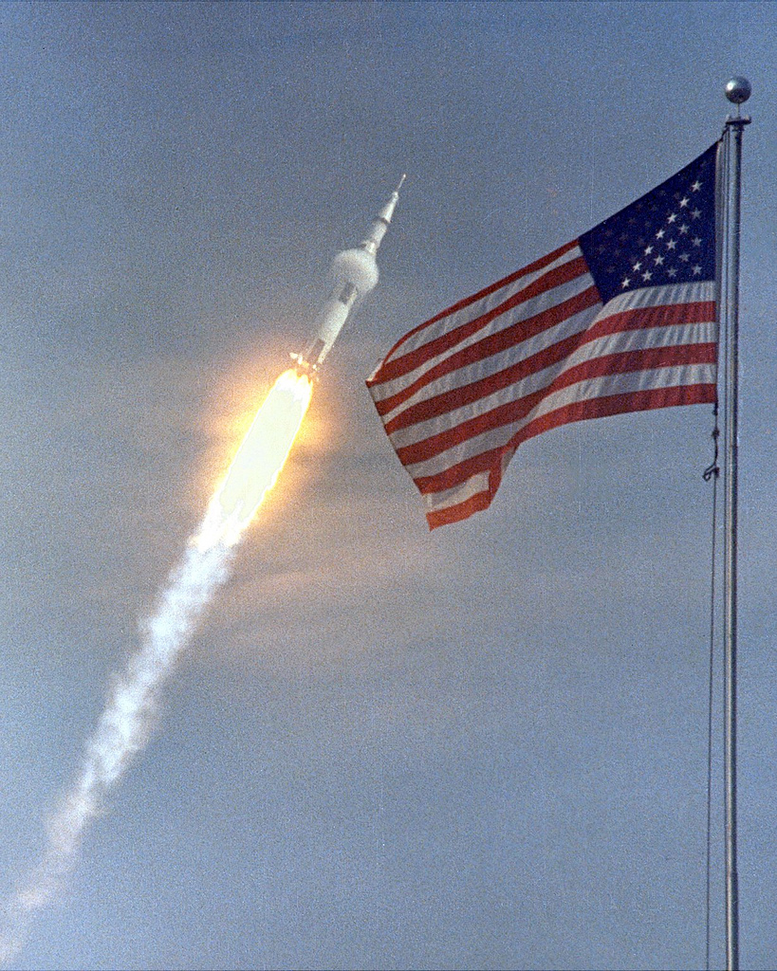

Figure 3. Apollo 11 Mission, Saturn V Booster, Vapor Cone

Seneca Guns by Tom Irvine

Figure 1. Seneca Lake at Sunrise

Introduction

The term “Seneca Guns” is sometimes used to describe any natural or artificial booming noise, particularly along waterfronts.

These sounds are also known as “Mistpouffers,” which means “fog belches.”

James Fenimore Cooper

The term “Seneca Guns” has its roots in a James Fenimore Cooper story.

Cooper published a short story called “The Lake Gun” in 1850 which was set in Lake Seneca in New York.

Cooper wrote:

The "Lake Gun" is a mystery. It is a sound resembling the explosion of a heavy piece of artillery, that can be accounted for by none of the known laws of nature. The report is deep, hollow, distant, and imposing. The lake seems to be speaking to the surrounding hills, which send back the echoes of its voice in accurate reply. No satisfactory theory has ever been broached to explain these noises.

(end quote)

Indeed, people have heard booms on the shores of Lake Seneca and Lake Cayuga. Similar sounds have also been heard occasionally on coastal areas throughout the world.

Civil War Battle

Usage of the term was enhanced by the roar of artillery fire near Seneca, South Carolina during a Civil War battle.

The battlefield was five miles away, but the people still felt the rumble over this distance

The Seneca Press reported "The guns of the Seneca rumbled the houses throughout the night."

Sources

There are many possible explanations for these gun-like sounds.

Natural source candidates are

- A meteorite (bolide) exploding as it enters the atmosphere (Vibrationdata Newsletter, May 2002).

- Methane or other volatile gases escaping from underground vents, limestone caves, or trapped vegetation.

- Earthquakes, tectonic plate shifts and other seismic events.

- Distance thunder focused as it travels through the atmosphere.

- Tsunami or other large waves.

- Booming sand dunes (Vibrationdata Newsletter, March 2006).

Possible man-made sources include aircraft sonic booms, artillery fire, and blasting in quarries and mines.

Case Histories

The following accounts give examples of both known and unknown sources.

Clintonville, Wisconsin

Clintonville, Wisconsin is an inland community, adjacent to Lake Pigeon.

USA Today reported on March 21, 2012 that a series of mysterious booms have been fraying residents’ nerves.
City administrator Lisa Kuss said the booms have roused people from their beds and into the streets — some in pajamas.
"It startled everyone. They thought something had hit their house or a tree fell on their roof," Kuss said Wednesday. A police dispatcher took more than 30 calls from concerned residents between 5 a.m. and 7:30 a.m.
Possible explanations for the ruckus have been nearly exhausted, she said.
Residents have said they believe the booms come from underground. City officials have checked and rechecked methane levels at the local landfill, monitored water, sewer and gas lines, contacted the military about any exercises in the area, reviewed mining explosive permits and inspected the Pigeon River dam next to city hall.
But the source remains unexplained.
North Carolina, Southeastern Costal Region
Star News reported on November 5, 2010, that residents across the area, from Holden Beach to Leland to Wilmington, claim to have felt their homes shake at about 2:20 p.m. Friday and again after 10 a.m. Saturday.
Kenneth Taylor, assistant state geologist with the N.C. Geological Survey, said that no unusual seismic activity occurred on those days.
This same region has experienced similar booms on other dates.
News Channel WWAY reported on February 28, 2012, that residents of Cape Fear (near Wilmington) heard loud noises and felt shaking.
The United States Geological Survey said in areas as far south as Ash in Brunswick County north to Havelock, people felt a weak to light rumble.
Again, seismometers failed to register any corresponding quake event.

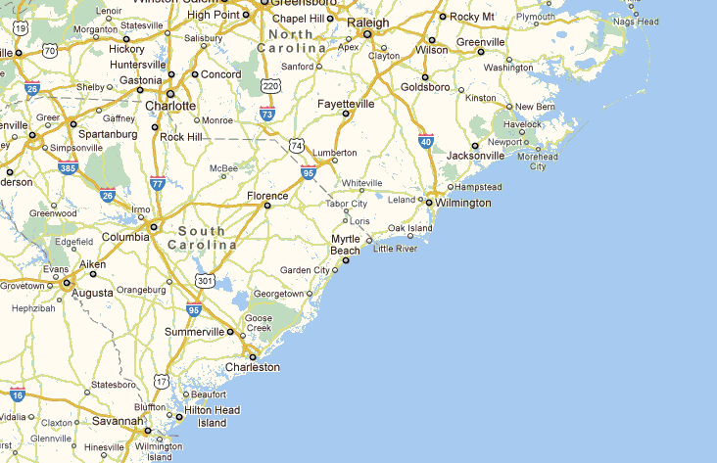
The coastal regions near Myrtle Beach and Wilmington are prone to unidentified booming noises.
1886 Earthquake

Charleston, South Carolina
The Charleston earthquake occurred on August 31, 1886. The residents heard a roaring sound as the main event occurred.
The aftershocks were accompanied by "loud detonations," during the following weeks.
A man named Mr. McGee reported, “They were much like, but somewhat more muffled than peals of thunder at distance of half a mile or more, or perhaps more like the discharge of a blast in a mine or quarry at a little distance."
Booming sounds have been reported for many other earthquakes, including the New Madrid 1811-1812 quakes.

Loudest Stadium Crowd by Tom Irvine

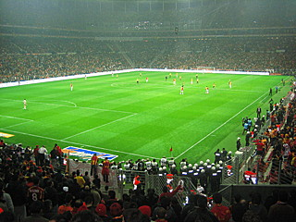

Figure 1. Türk Telekom Arenam, (aka New Galatasaray Stadium)

The loudest stadium crowd noise occurred at the Turkish Galatasaray Sport Club on March 8, 2011 in a deliberate record setting attempt. The noise was generated by 52,000 football (soccer) fans.

Three attempts were made. The record was achieved on the third attempt with an overall sound pressure level of 131.76 dBA according to the Guinness World Records organization.

The previous record was 128.7 dBA, recorded during the Denver Broncos vs. New England Patriots NFL game in Denver, Colorado, USA on October 1, 2000.

Sources vary regarding the threshold of noise-induced pain, with the threshold as low as 120 dBA or as high as 140 dBA.

