
Welcome to
Vibrationdata

Acoustics • Shock • Vibration • Signal Processing May 2010 Newsletter

Saluton Mondo

NASA launched the Ares 1-X vehicle from the Kennedy Space Center in Florida on October 28, 2009. This was an unmanned test flight. The vehicle had a single stage which burned for two minutes, followed by a coast period. The flight lasted a total of six minutes from launch to splashdown.

The flight test yielded valuable engineering data. The first article in this newsletter focuses on the vibration data collected during the roll out from the vehicle assembly building to the launch pad.

The second article presents photos from a public display of a SCUD-B missile along with a brief discussion of avionics, control, and propulsion systems.

As an aside, I now reside in Madison, Alabama, near Huntsville’s Redstone Arsenal and the NASA Marshall Space Flight Center.

I am working as full-time employee of Dynamic Concepts, Inc. I still maintain the Vibrationdata website as a hobby.

Sincerely,

Tom Irvine
Email: tomirvine@aol.com

Feature Articles

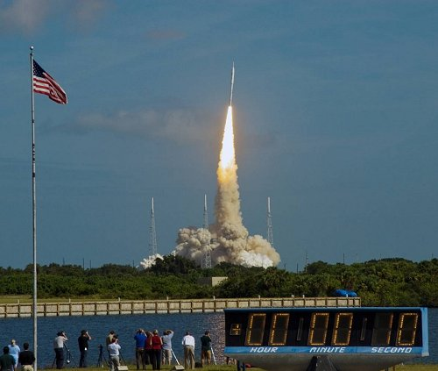

Ares 1-X Roll Out Vibration page 1

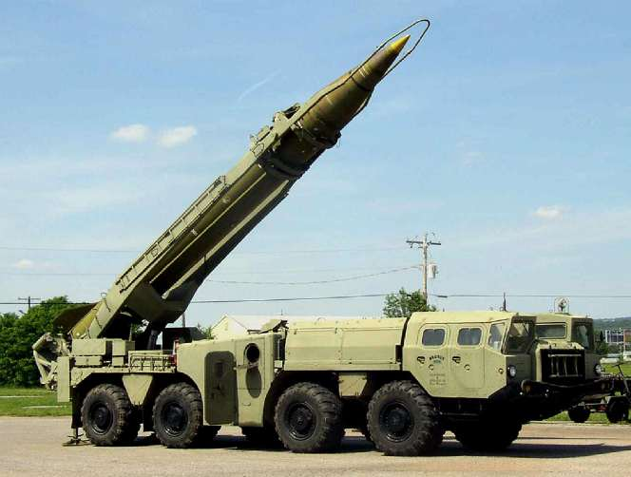

SCUD-B Missile Design page 11

Ares 1-X Roll Out Vibration by Tom Irvine

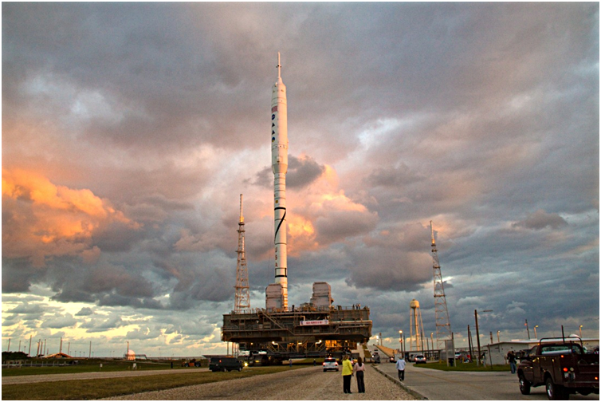

Figure 1. Ares 1-X Roll Out

The 327-foot-tall Ares I-X launch vehicle is shown mounted on the Crawler-Transporter. The nominal travel speed is 0.8 mph. The launch vehicle is like a long cantilever beam which is subjected to excitation from the wind, the road surface, and the motion of the Crawler-Transporter’s rollers and track shoes. The launch vehicle’s body-bending modes are excited by these sources.

Note that the vehicle’s highest tensile load exposure occurs during roll out rather than during liftoff and ascent. There are two reasons for this. First, the vehicle is like a cantilever beam during roll out, but it is like a free-free beam during powered flight. Second, the axial compression from the thrust force during powered flight relieves some of the tension due to bending. This tension relief occurs to a lesser extent during roll out. The maximum axial acceleration during powered flight was 2.5 G, in contrast to the 1 G loading during roll out.

Accelerometer and strain gage measurements were thus taken on the launch vehicle to verify that the resulting loads were within design limits. This article presents the strain gage data taken on the hold down posts (HDPs) which secure the base of the launch vehicle to the Mobile Launch Platform (MLP).

The combined launch vehicle and MLP system is mounted on top of the Crawler-Transporter.

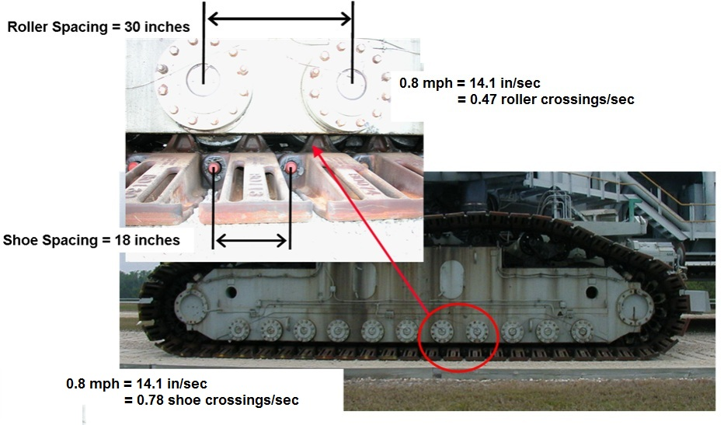

Figure 2. Crawler-Transporter Rollers and Track Shoes

The launch vehicle’s natural frequencies and excitation frequencies are identified in the resulting plots shown in this newsletter article. These frequencies have already been identified in previous NASA reports and presentations. This article builds upon this data by identifying the corresponding damping ratios as well.

For the roller excitation:

(14.1 in/sec ) / 30 inches = 0.47 roller crossings/sec

For the shoe excitation:

(14.1 in/sec ) / 18 inches = 0.78 shoe crossings/sec

Each of these crossing rates may be consider as a frequency (Hz).

Furthermore, each excitation frequency has potential integer harmonics. The shoe excitation frequency and integer harmonics are readily apparent in the spectral plot in Figure 7.

Note that the Crawler-Transporter speed must be set to minimize the excitation of the vehicle body-bending modes due to the roller and shoe excitation. Other resonance might occur.
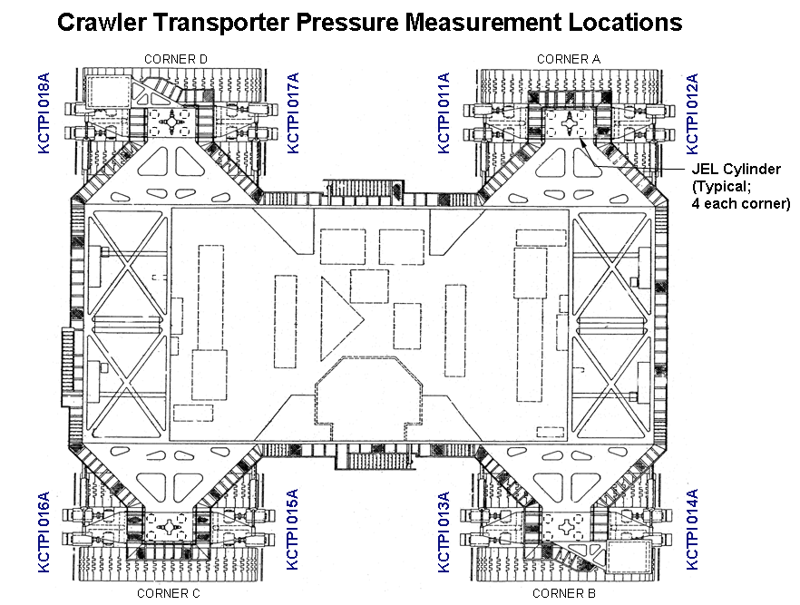

Figure 3. Crawler-Transporter Diagram, Top Looking Down

The Crawler Transporter has four “trucks” each with two tread or track sets. Each tread has 57 shoes.

The crawler has 16 traction motors, powered by four 1,341 horsepower (1,000 kW) generators, in turn driven by two 2,750 horsepower (2,050 kW) Alco diesel engines.

In addition, two 1,006 horsepower (750 kW) generators, driven by two 1,065 horsepower (794 kW) engines, are used for jacking, steering, lighting, and ventilating.

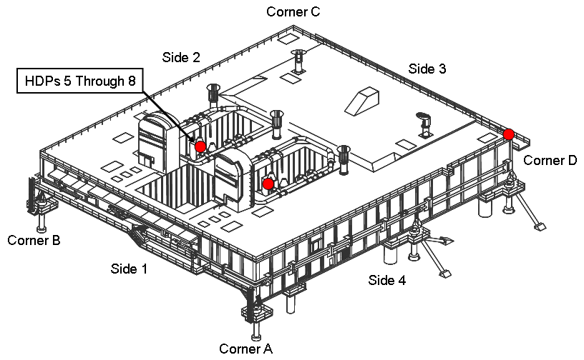

Figure 4. Ares 1-X Mobile Launch Platform

Again, the hold down posts are represented by the acronym HDP.

The Mobile Launcher Platform is set atop 6 legs inside the Vehicle Assembly building. The Ares 1-X was mounted on top of the MLP inside this building.

The Crawler-Transporter then carried the combined platform and launch vehicle to the launch site, and deposited them there together.

Once the launch had been completed, the Crawler-Transporter retrieved the empty MLP from the pad.

Note that the Space Shuttle roll out uses the same Mobile Launch Platform and Crawler-Transporter.

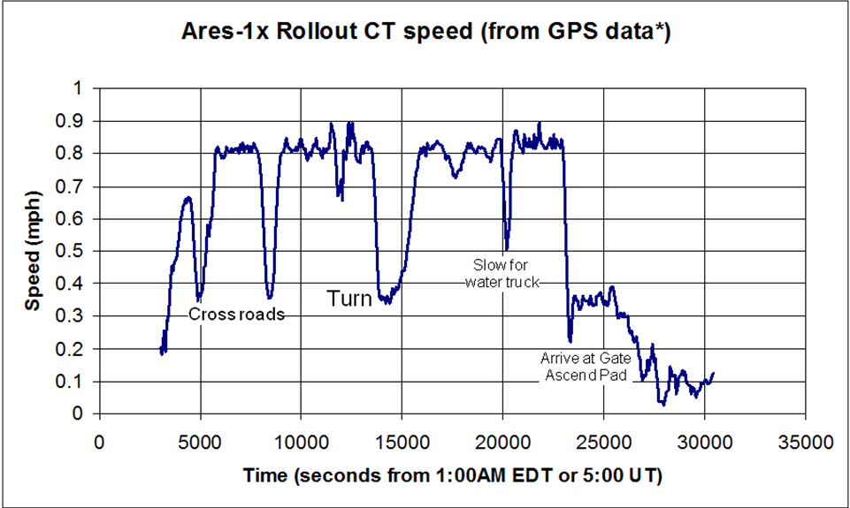

Figure 5. Ares 1-X Roll Out, Approximate Speed

The roll out was performed on 10/20/09. The Crawler-Transporter’s speed sensor was inoperative. The speed was calculated from GPS readings instead.

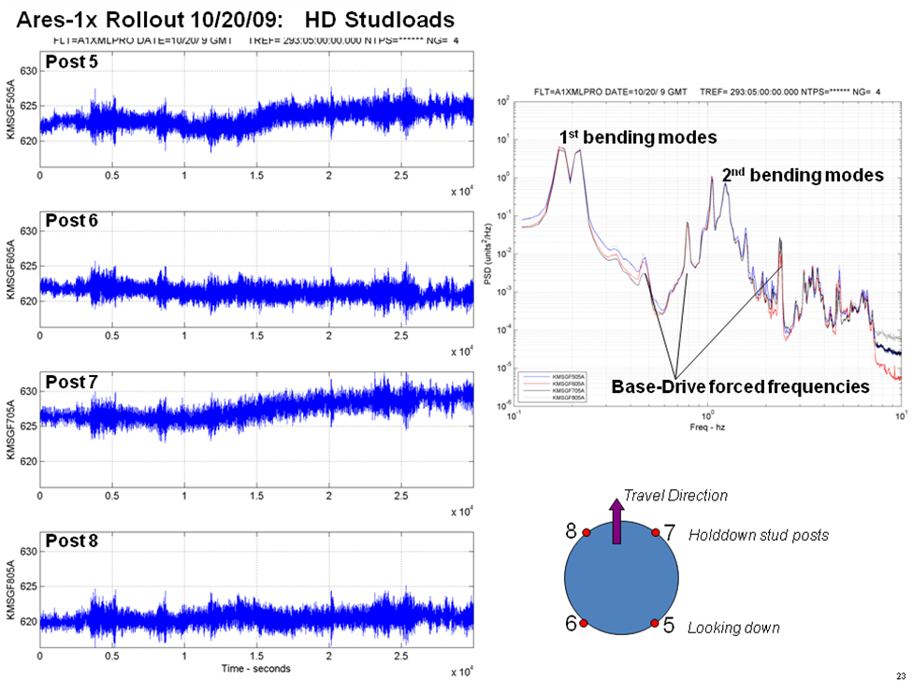

Figure 6. Ares 1-X Strain Gage Data

The data was measured at the Hold-Down Posts. The plots were taken from a public-domain NASA presentation.

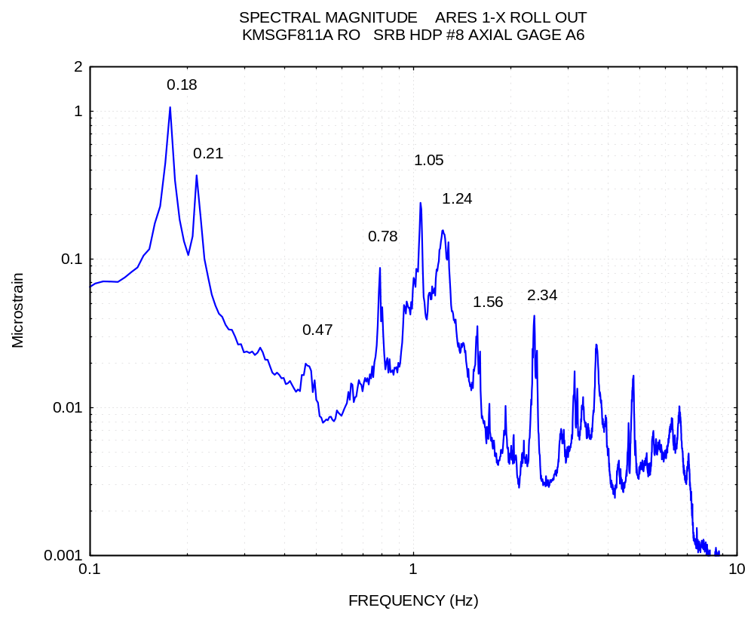

Figure 7. Ares 1-X, Roll Out, Hold Down Post, Sample Strain Gage Data

Table 1. ARES 1-X Rollout, Vibration Frequencies
freq (Hz) | Source
0.176 | First Vehicle Bending Mode
0.214 | First Vehicle Bending Mode
0.47 | Roller Crossing Frequency
0.78 | First Shoe Crossing Frequency
1.05 | Second Bending Mode
1.24 | Second Bending Mode
1.56 | Second Shoe Crossing Frequency
2.34 | Third Shoe Crossing Frequency

Two first vehicle bending frequencies are given because there is a first bending mode in each of two orthogonal, lateral axes. The frequencies differ because the four hold down post are unevenly spaced. Thus the mounted vehicle is stiffer in one lateral axis than in the other axis.

Note that the 0.8 mph Crawler-Transporter speed causes the roller frequency to be at least one octave greater than either of the two first vehicle bending frequencies. A one octave difference means that the higher frequency is twice the lower frequency.

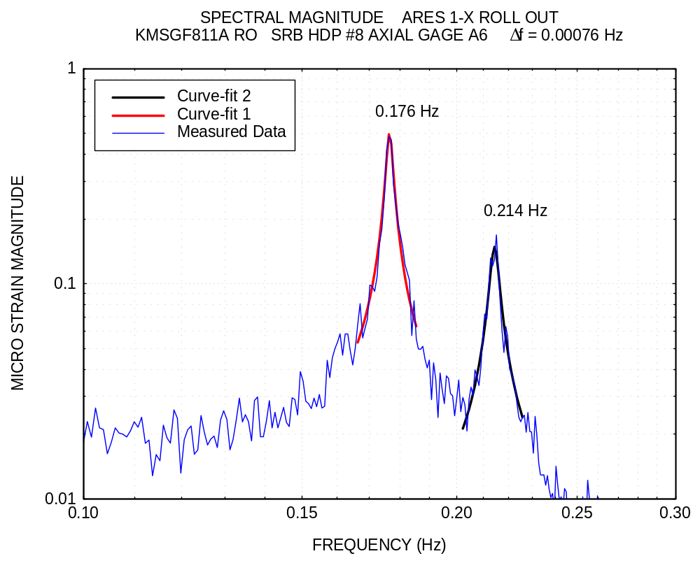

Figure 8.

Table 1. First Bending Mode Set, ARES 1-X Rollout Configuration
fn (Hz) | -3 dB Bandwidth (Hz) | Damping
0.176 | 0.00222 | 0.63 %
0.214 | 0.00364 | 0.85 %

Note that the natural frequencies and the damping ratios are for the configuration where the launch vehicle is mounted as a cantilever beam to the MLP.

The frequencies and damping ratios change during powered flight because the vehicle then behaves as free-free-beam. Furthermore, the mass properties of the vehicle continually change during powered flight due to the propellant discharge.

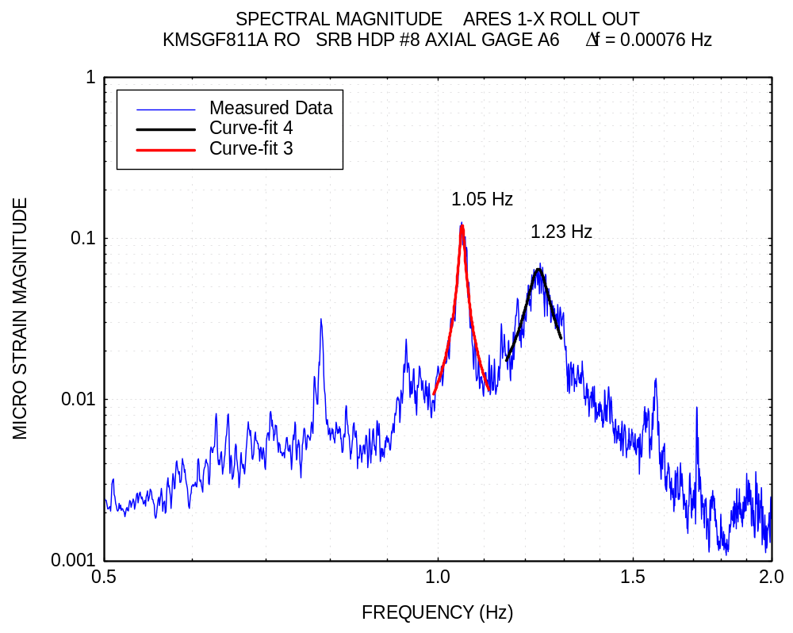

Figure 9.

Table 2. Second Bending Mode Set, ARES 1-X Rollout Configuration
fn (Hz) | -3 dB Bandwidth (Hz) | Damping
1.05 | 0.0112 | 0.53 %
1.23 | 0.0466 | 1.9 %

The damping values are determined using the – 3 dB points. This is also called the “half-powered bandwidth method.”

Further information about this method is given in the tutorials posted at following webpage:

http://www.vibrationdata.com/damping.htm

SCUD-B Missile Design by Tom Irvine

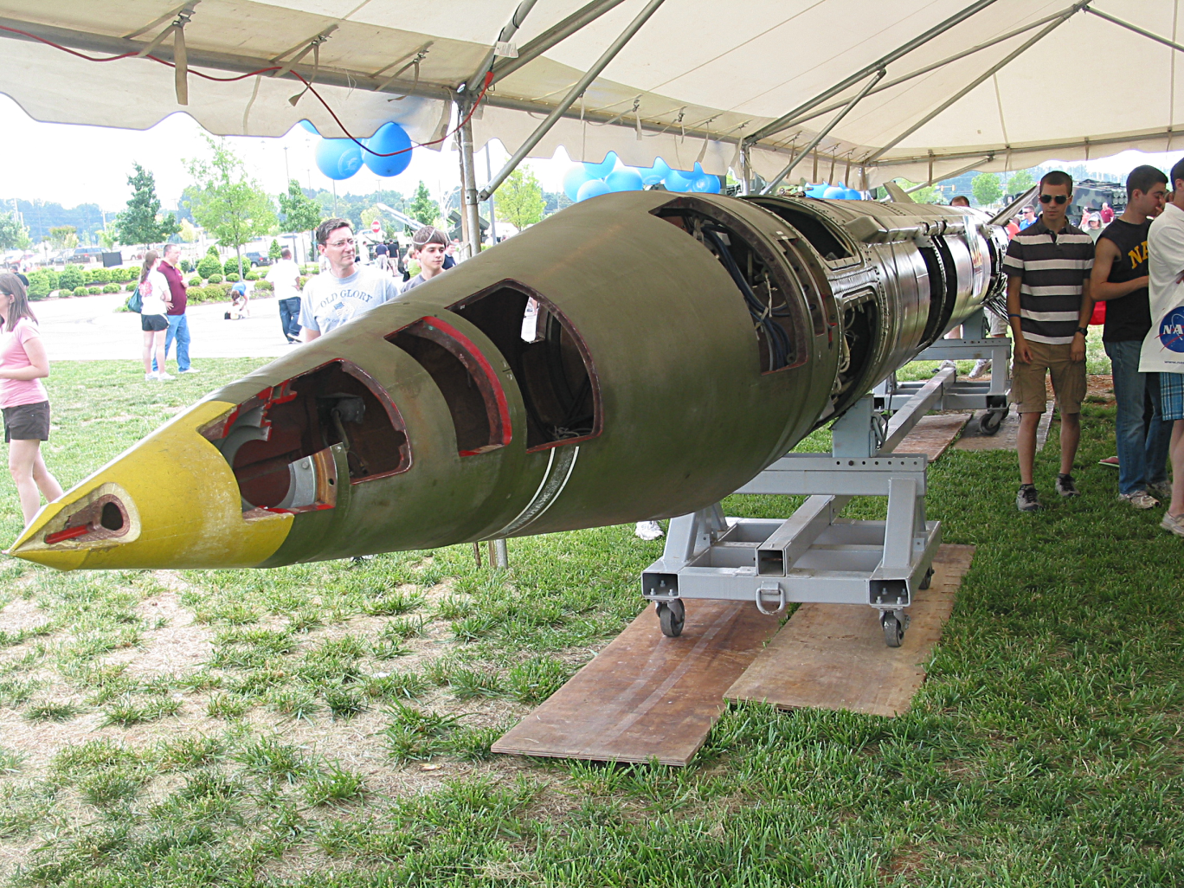

Figure 1. SCUD-B Ballistic Missile

The Redstone Arsenal in Hunstville, Alabama held a public display of military equipment on May 15, 2010, which included the SCUD-B missile in Figure 1. This SCUD-B could have been taken from Iraq, Afghanistan, or from any of the other dozen or so countries which possess this missile and its variants.

Sections of the vehicle skin were removed to allow viewing access. The display missile lacked a warhead, fuel and ordnance; but it did have avonics and mechanical components.

The warhead would be enclosed in the nosecone. It could be a conventional high explosive, chemical, biological, or nuclear payload.

The nuclear warhead could be in the 5 to 80 kiloton range. In comparison, the “Fat Man” atomic bomb dropped on Nagaski in World War II had a yield of 21 kilotons.

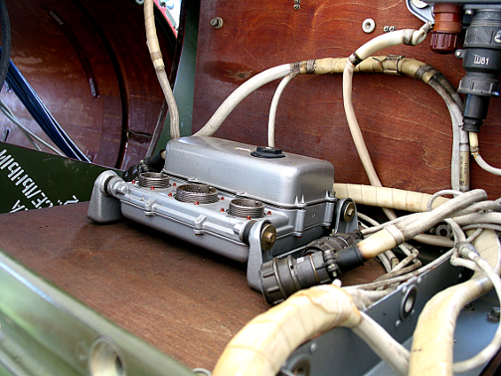
Isolator Bushing
Wooden Avionics Shelf

Figure 2. SCUD-B Typical Avionics Component

The avonics shelves were made from hardwood. The wooden fibers may provide better damping then, say, an aluminum shelf. A possible disadvantage of wood is that the shelf would be unable to serve as an electrical or thermal ground plane.

The bushings are made from some type of rubber or elastomeric compound.

The bushings provide damping, but their main benefits are:

1. To render the isolated system as a single-degree-of-freedom system
2. To lower the natural frequency of the system

The isolators thus attenuate the shock and vibration energy which flows from the instrument shelf into the avionics component.

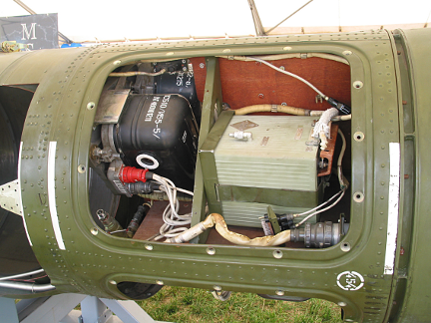

Figure 3. SCUD-B, Additional Avionics Components

The exact function of each component is not readily known, although a translation could be made from the inscribed Russian letters.

A basic set of missile avionics would include

- Batteries
- Flight Computer
- Inertial Nagivation System
- Pyro Driver Unit

Missiles may also have telemetry and transponder components, although the SCUB-B may lack these.

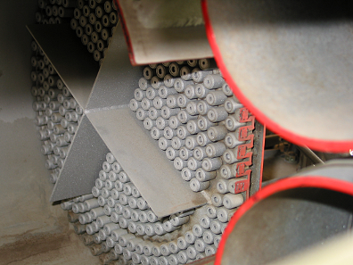

Figure 4. SCUD-B, Fuel Injector

The SCUD-B is a single-stage vehicle, with liquid propellant and an oxidizer. Its design is derived from the German V-2 rockets used in World War II.

The typical fuel for the SCUD-B is TM-185, which is 80% kerosene and 20% gasoline. The oxidizer is AK-27I, which is 73% nitric acid and 27% nitrogen tetroxide.

Alternate fuels include corrosion Inhibited Red Fuming Nitric Acid (IRFNA) and UDMH, unsymmetrical dimethylhydrazine.

The fuel injector is like a shower head which spays separate streams of fuel and oxidizer into the combustion chamber. It must be designed properly to avoid a potential combusion instability problem called “chugging.”

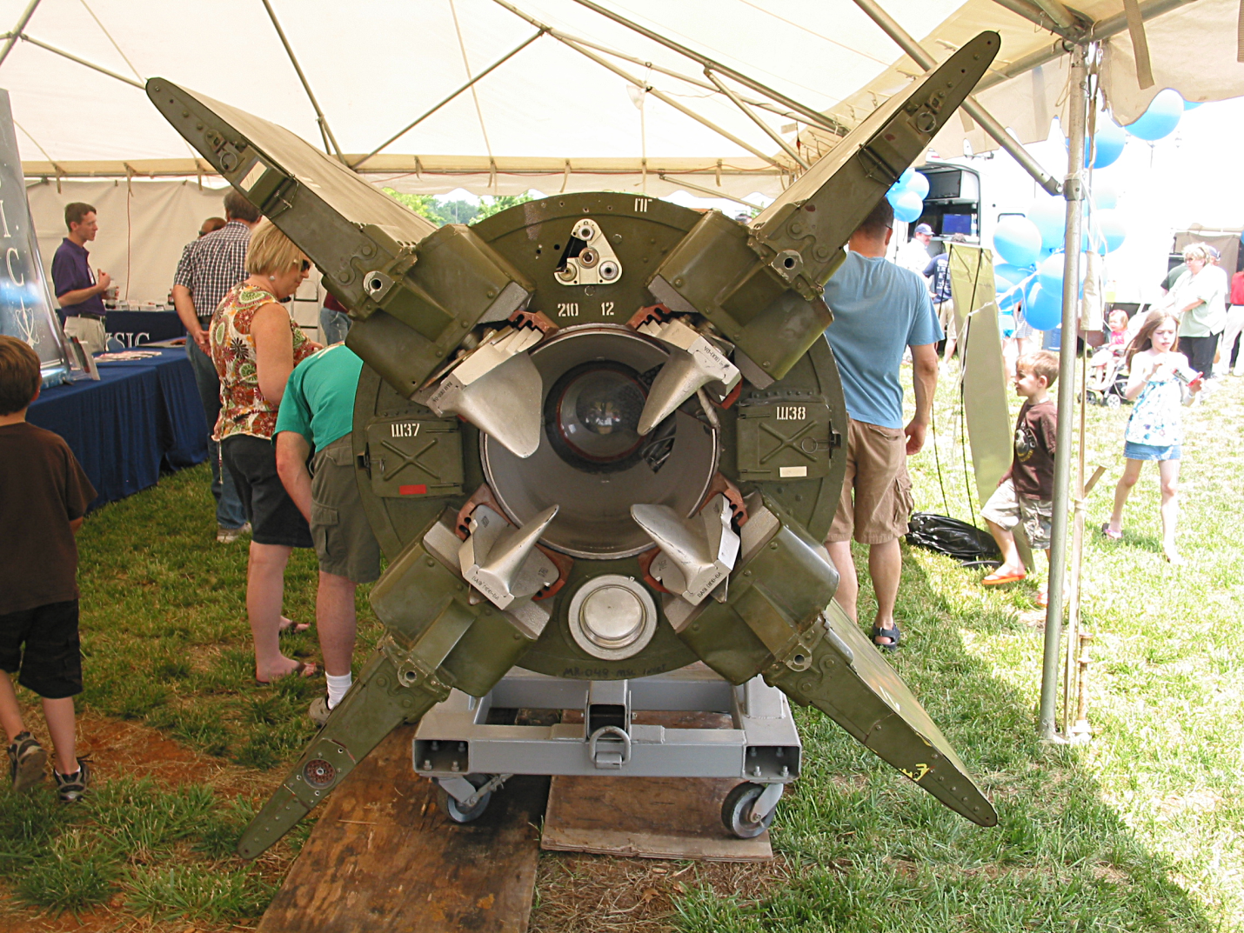
Jet Vane

Figure 4. SCUD-B, Aft End

The four jet vanes protrude into the exhaust flow. The vanes are swivled by actuators to deflect the exhaust flow in order to steer the vehicle. This is part of a control loop which includes the inertial navigation system and flight computer.

Note that the exhuast flow erodes the vanes during the burn.

