Welcome to
Vibrationdata

Acoustics • Shock • Vibration • Signal Processing September 2011 Newsletter

Feature Articles
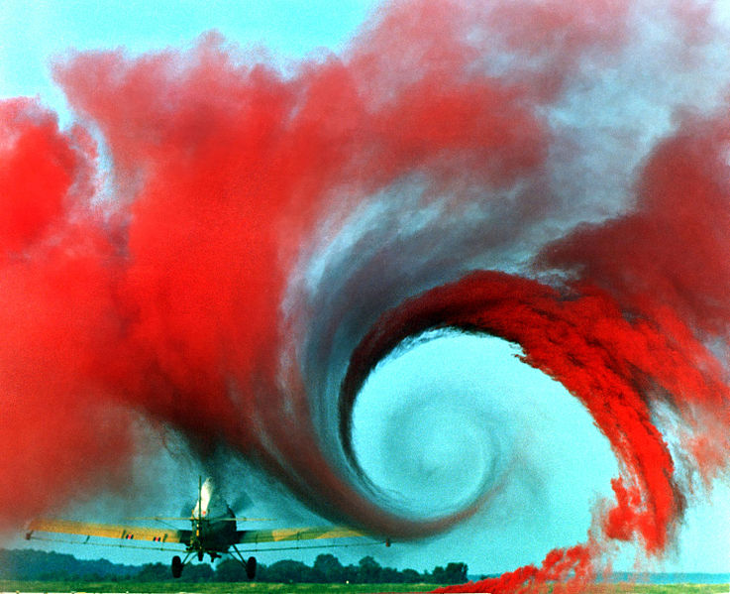

Wake Turbulence page 1

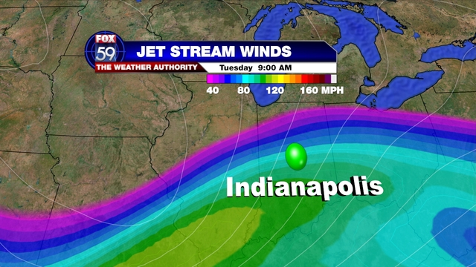

Atmospheric Turbulence page 10

NOAA Hurricane Hunter page 16

Greetings from the Flight Deck

This newsletter continues with last month’s aviation theme. My interest is in the inertial acceleration that aircraft experience during severe flight events.

Turbulence is the excitation source covered in this newsletter. Turbulence occurs near storms, jet streams, mountains, and in the wake of preceding aircraft.

An extreme example is the WP-3D Orion which flew into Hurricane Hugo in 1989 as part of a research mission. The aircraft experienced a jolting acceleration of 5.5 G as it penetrated the eyewell. The WP-3D crew eventually made a safe landing with no injuries. The mission is discussed in the third article.

In preparation for this newsletter, I came across a blog about airline pilots and passengers who encounter turbulence. The blog had a profound quote "It isn't turbulence that causes the problem but panic attacks."

I think this quote has broad application in life. :)

Sincerely,
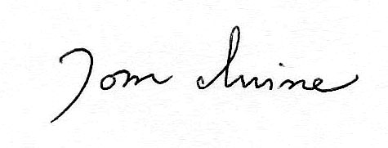
Tom Irvine
Email: tomirvine@aol.com

Wake Turbulence by Tom Irvine

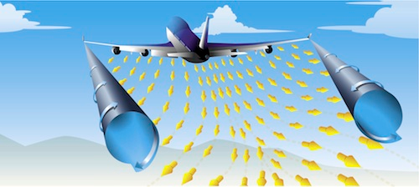

Figure 1. Wingtip Vortices

Introduction
Airflow over an aircraft’s wings generates of pair of counter-rotating vortices, as shown in Figure 1.
The vortices are hazards to other aircraft following behind in the wake, or crossing through the wake. A particular concern is that the trailing aircraft may experience severe displacement and acceleration, causing loss of control, structural damage, or even a fatal crash.
Flow Mechanism
The air pressure above the wing is less than the air pressure below the wing during flight. This is necessary for lift. The high-pressure air below the wing flows upward to the low pressure region.
The fuselage blocks this flow, so the path of least resistance is toward the wingtips.
Meanwhile air curls up over the wing tips and then flows from the top of the wing downward, creating down wash, as shown in Figure 2. The two flow effects combine at the wingtip and create a fast spinning vortex similar to horizontal tornadoes, trailing the aircraft.
Characteristics
The main characteristics of aircraft wake vortices are:
Sink rate: 300 to 500 feet/minute
Stabilization at 500 to 900 feet under the aircraft at the origin of the vortices
Lateral movement at 5 knots when reaching the ground
Life span: 30 seconds to a few minutes depending on the aircraft’s size, weight, speed and wing shape, as well as the wind conditions
The greatest vortex strength occurs when the generating aircraft is heavy-clean-slow, such as the Boeing 747.
Peak vortex tangential speeds up to nearly 300 feet per second have been recorded.
Engineers have measured vortices in tests stretching about 8 miles long.

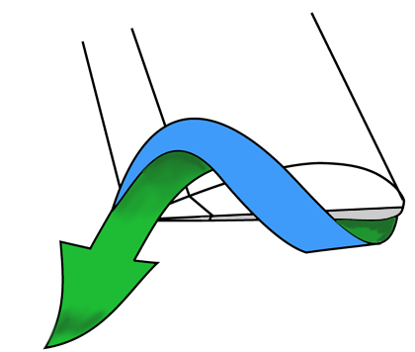

Figure 2. Wingtip Flow

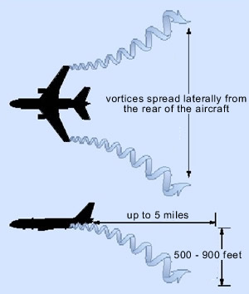

Figure 3. Vortex Propagation

Note that the vortices only spread apart when they are in “ground effect.” Otherwise they move together as shown in Figure 4, until they become unstable and pinch off into connected rings.

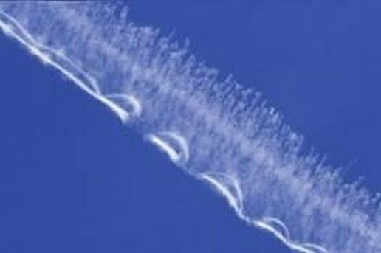

Figure 4. Crow Instability

In aerodynamics, the Crow instability is an inviscid line-vortex instability, named after its discoverer S. C. Crow. The Crow instability is most commonly observed in the skies behind large aircraft, when the wingtip vortices interact with contrails from the engines, producing visible distortions in the shape of the contrail.

The image was taken from: http://www.weathervortex.com/vortex.htm

Flight AC-190

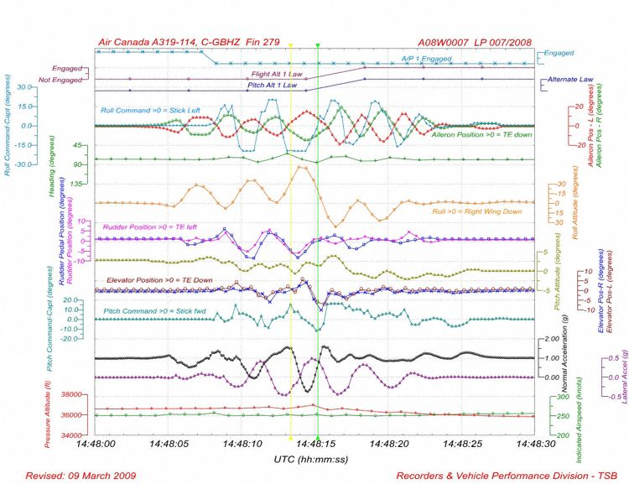

Figure 4.

An Air Canada Airbus A319-114, flight AC-190 from Victoria, British Columbia to Toronto, Ontario, encountered wake turbulence form a United Airlines Boeing 747-400 over Washington State. This occurred on Jan 10, 2008.

This was an example of clear air turbulence.

The aircraft were separated by more than the minimum separation standard, but the wake vortices from the 747 had not dissipated.

The Airbus experienced sharp jolts followed by a series of roll oscillations. The captain, who was the pilot flying, disengaged the autopilot at the onset of the jolts and then flew the aircraft manually.

The pilots then performed evasive maneuvers and diverted to Calgary, Alberta, where the airplane landed safely.

Three people received serious injuries due to falls and collisions with aircraft furnishings. Eight people received minor injuries.

The Canadian TSB noted that the captain’s rudder pedal reversals during recovery may have exacerbated the structural loading from the turbulence.

The flight data recorder showed that during the event vertical accelerations peaked in +1.57 G and -0.77 G, lateral accelerations reached 0.46 G left and 0.49 G right, and the side stick inputs were 90 degrees out of phase with the rudder inputs. The data is shown in Figure 4.

The aircraft underwent a heavy turbulence inspection after landing. The vertical stabilizer was removed from the aircraft and underwent non-destructive examination and testing with no structural damage was found in the stabilizer and its fittings. An analysis showed that the rear fitting of the vertical stabilizer experienced 129% of its specified load limit.

Flight 587

Events
American Airlines Flight 587, an Airbus A300, crashed into the Belle Harbor neighborhood of Queens, a borough of New York City, New York, shortly after takeoff from John F. Kennedy International Airport on November 12, 2001.
The Airbus encountered wake turbulence from a Japan Airlines Boeing 747.
The Airbus first officer attempted to keep the plane upright with aggressive rudder inputs. Note that the A300 was designed with unusually sensitive rudder controls.
The aircraft then underwent large roll and yaw oscillations.
The airflow over-stressed the plane's vertical stabilizer, as shown in Figures 5 and 6. The inertial acceleration was a smaller factor.
The tail and rudder assembly separated in flight and fell into Jamaica Bay, about one mile north of the main wreckage site.
The rudder experienced lateral loading of 0.8 G, before breaking off.
The plane's engines subsequently separated in flight and fell several blocks north and east of the main wreckage site.
All 260 people aboard the plane and 5 people on the ground died, and the impact forces and a post-crash fire destroyed the plane.

Accident Report
The National Transportation Safety Board attributed the disaster to the first officer's overuse of rudder controls in response to wake turbulence.
This led to increasing sideslip angles. The resulting hazardous sideslip angle led to extremely high aerodynamic loads that resulted in separation of the vertical stabilizer.
The natural stability of the airplane would have returned the sideslip angle to near 0° if the first officer had stopped these inputs prior to the vertical stabilizer separation.

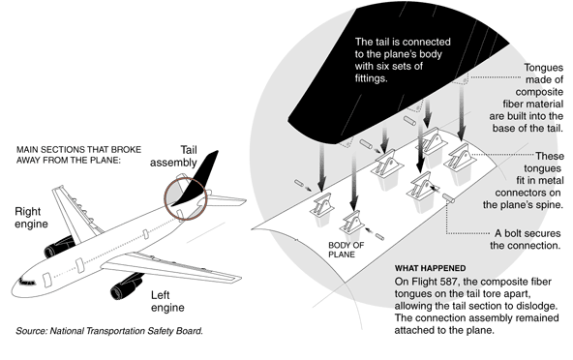

Figure 5. Airbus A300 Tail Assembly

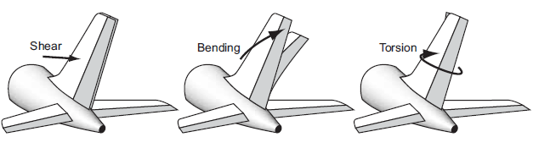
Torsion
Bending
Shear

Figure 6. Shear, Bending and Torsion Loads Due to Aerodynamic Loading

Separation Distance

The following is an excerpt from the FAA document in Reference 3.

7-3-9. Air Traffic Wake Turbulence Separations
a. Because of the possible effects of wake turbulence, controllers are required to apply no less than specified minimum separation for aircraft operating behind a heavy jet and, in certain instances, behind large non-heavy aircraft (i.e., B757 aircraft).
1. Separation is applied to aircraft operating directly behind a heavy/B757 jet at the same altitude or less than 1,000 feet below:
(a) Heavy jet behind heavy jet-4 miles.
(b) Large/heavy behind B757 - 4 miles.
(c) Small behind B757 - 5 miles.
(d) Small/large aircraft behind heavy jet - 5 miles.
2. Also, separation, measured at the time the preceding aircraft is over the landing threshold, is provided to small aircraft:
(a) Small aircraft landing behind heavy jet - 6 miles.
(b) Small aircraft landing behind B757 - 5 miles.
(c) Small aircraft landing behind large aircraft- 4 miles.

References
- Transportation Safety Board of Canada, Aviation Investigation Report Encounter with Wake Turbulence Air Canada Airbus A319-114 C-GBHZ Washington State, United States 10 January 2008, Report Number A08W0007.

- National Transportation Safety Board, In-Flight Separation of Vertical Stabilizer American Airlines Flight 587 Airbus Industries A300-605R, N14053 Belle Harbor, New York, November 12, 2001.

- Federal Aviation Administration Aeronautical Information Manual, Official Guide to Basic Flight Information and ATC Procedures; February 11, 2010.

Readers’ Comments

Engineer & Pilot Mike Skrzecz wrote:
I see that you state this: "The greatest vortex strength occurs when the generating aircraft is heavy-clean-slow, such as the Boeing 747".

The characterizations "heavy-clean-slow" is not unique to the 747. Basically, a heavier aircraft will have stronger wake turbulence compared to a lighter craft of the some type. "Clean" (vs. "dirty") in aviation jargon means no lift enhancing devices (such as wing flaps & slats) are deployed on the wing. Finally, "slow" is a relative term compare to a cruise velocity, for example.

You might want to mention the Airbus A380. I recall that during development of the type, there was concern about the wake turbulence. I have not followed this thoroughly, but I see that Wikipedia mentions a "Super" designation that only applies to the A380, for defining in-trial separation from other aircraft. Here is the ICAO standard for A380 separation standards: http://www.icao.int/icao/en/ro/apac/2006/RASMAG6/ip02.pdf

Note that the B747 carries a “heavy” designation for in-trail separation standards. “Heavy” applied to an aircraft with a takeoff weight of 300,000 pounds or greater.

Impala MB-326 Test
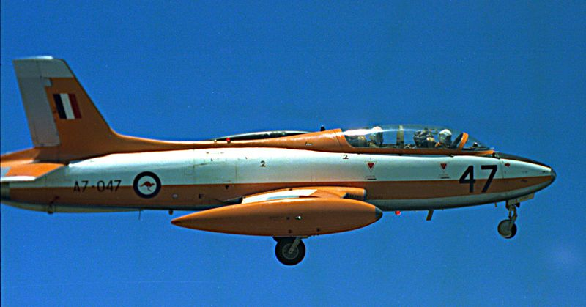
Figure 7. Typical MB-326

George Leaf noted a study after the Flight 587 accident titled “The Effects of Rapid Rudder Reversals on Tail Loads.”
An Italian-designed Impala MB-326 (N155TP) was instrumented with strain gages and accelerometers on its wings and tail sections. It was then subjected to a series of rapid rudder reversals in a test flight.
The post-flight conclusions were:
• Rapid rudder reversals dramatically increase vertical tail loads
– Approximately 3x increase when rudder returned to neutral
– Approximately 5x increase when rudder driven past neutral by 1/2
• Flying below maneuvering speed does not protect you
• Aircraft vertical tail loads are certified for full rudder deflection steady heading sideslips and return to neutral – not for rapid rudder reversals
• Full rudder inputs may not be the best solution for unusual attitude recovery
Further information is given in:
http://www.ukintpress-conferences.com/conf/aerona05/pres/otf_2/cusimano.pdf

NASA Aerodynamicist Craig Streett wrote:
Trailing vortices do in fact sink by their mutual interaction, but they also move together, until they become unstable and pinch off into connected rings - the so-called Crow instability. There are literally thousands of pictures and studies documenting this behavior. Only when the tip vortices are in ground effect, when they are interacting with their below-ground images, do they travel away from each other.
Also, you needn't appeal to a heuristic argument to explain the existence of trailing vortices. Inviscid vortex dynamics requires that a vortex cannot simply end in free space, and so the bound vortex responsible for the lift of the wing must go somewhere at the wing tip; this is the so-called Lighthill horseshoe vortex system, which also explains the cause of induced drag.
http://en.wikipedia.org/wiki/Horseshoe_vortex
Finally, while the popular press calls trailing-vortex encounters under the generic term of "turbulence", they are classified formally in flight sciences as "gust" encounters, to distinguish from true atmospheric turbulence resulting from meteorological mechanisms.

Atmospheric Turbulence By Tom Irvine

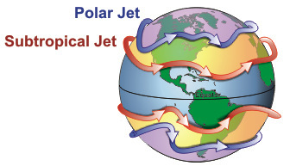
Altitudes

Polar Jet:
7–12 km (23,000–39,000 ft)

Subtropical Jet:
10–16 km (33,000–52,000 ft)

Figure 1. Jet Streams

Jet streams flow from west to east in the upper portion of the troposphere. They are caused by the temperature difference between the warm equator and cold poles. High pressure air from the warm tropics flows toward the low pressure at the cold poles, but the Coriolis force from the Earth's spin deflects these winds to the east so that they make an eastward circle around the globe.

Introduction

There are numerous sources of atmospheric turbulence, including mountain waves, Kelvin-Helmholtz instabilities, thunderstorms, jet stream, as well as thermal updrafts and downdrafts.

Clear Air Turbulence

The turbulence may be clear air turbulence (CAT) if there are no clouds or other visible signs. This turbulence can cause "air pockets." An air pocket is a downward air current that causes an aircraft to undergo a sudden decrease in altitude.

Jet Stream

The main jet streams are located near the tropopause, the transition between the troposphere (where temperature decreases with altitude) and the stratosphere (where temperature increases with altitude).

Jet streams are caused by a combination of the Earth's rotation about its axis and atmospheric heating.

The Polar Jet Stream is formed as a result of the temperature gradient between the cold polar air mass and the warmer sub-tropical air mass.

Severe clear air turbulence may occur along the edges of the jet stream due to shearing effects between the jet stream and the slower-moving surrounding air.
Jet streams are fast rivers of air. Below and above these rivers are wind shears, or rapid changes in wind speed.
Bob Sharman is a project scientist at the National Center for Atmospheric Research. He explained "The worst turbulence isn't right at the heart of the jet stream, it's at the sides of the jet stream. That's where the shear is largest, and the shear kind of rips apart the air and causes turbulence."
Not all jet streams are turbulent, but aircraft exploiting the tailwinds afforded by a jet stream may experience light to moderate turbulence for much of the flight.

Mountain Waves

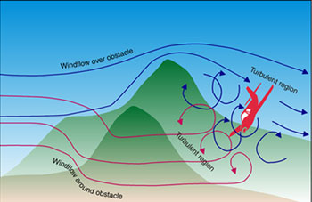

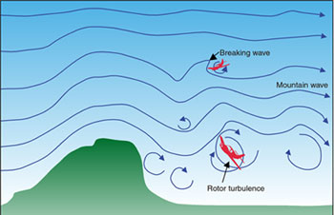

Figure 2. Mountain Waves & Turbulence

(Images courtesy of Australian Transport Safety Bureau)

Wind flowing over mountains may generate mountain waves. These waves are also known as orographic waves or lee waves. The combined effects of gravity and the mountain terrain affect the formation of these waves.

Gravity acts on local variations in air density and creates a vertical undulation in the atmosphere. Stable air that is lifted over a mountain cools and becomes denser. The cooled air mass sinks again on the lee side due to the effects of gravity. The air mass warms as it descends downward. The cycle is then repeated as the warm air then rises downstream. The oscillation creates a waveform. The waveform may be a standing wave that continues for several hundred kilometers. Further information on mountain waves is given in the Vibrationdata Newsletter, October 2002 edition.

Kelvin-Helmholtz Instabilities

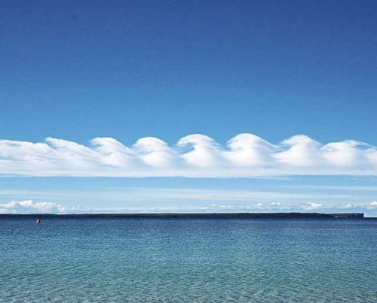

Figure 3. Kelvin-Helmholtz Cloud

(Image courtesy of Giselle Goloy)

Kelvin-Helmholtz clouds form between two layers of air traveling at different speeds. The top layer is a warm layer with low density. The bottom layer is a colder, dense layer. Eddies will develop along the boundary if the wind shear is sufficiently strong. A shearing instability is thus considered to exist at the boundary.

Kelvin-Helmholtz clouds are also called Billow Clouds. They resemble ocean waves breaking on a shore. The clouds provide a visible signal to pilots of potentially dangerous turbulence. These clouds and ocean waves are in fact caused by the same shear instability mechanism, which is called the Kelvin-Helmholtz (KH) instability.

These clouds tend to have a lifetime of a few minutes.

Professor James Graham of the University of California at Berkeley wrote, “The most common example of the Kelvin-Helmholtz instability is provided by the observation that a wind blowing over a water surface causes the water surface to undulate.”

Note that this topic was also covered in the Vibrationdata Newsletter, October 2002 edition.

Thunderstorms
Turbulence
Anvil
Storm Movement
Wind Shear Turbulence
Wind Shear Turbulence
Roll Cloud
First Gust
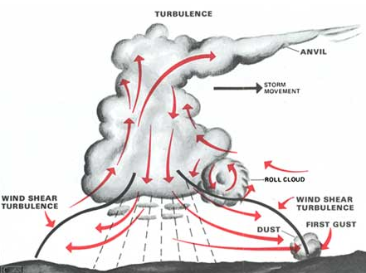

Figure 3. Cumulonimbus Storm Cloud Turbulence

A thunderstorm acts almost like a solid object to winds blowing over or around it. Note that some thunderstorms move slower than the winds at higher levels.

Like a mountain, a thunderstorm can create waves in winds flowing over it. At lower levels, thunderstorms can create eddies as winds flow around it.
Thermal updrafts and downdrafts may occur within or below a thunderstorm as shown in Figure 3. The FAA Instrument Flying Handbook warns pilots “Never attempt to fly under a thunderstorm.”
Furthermore, turbulence may be present up to 20 miles from severe thunderstorms and will be greater downwind than into wind.
Convection Induced Turbulence (CIT) is the turbulence in the air either above the thunderstorm top, under the anvil, or near the lateral visible boundaries.

Other Thermal Updraft & Downdraft Sources

Columns of warm air begin to rise on calm, sunny days. Glider pilots use the rising air to keep their aircraft aloft without engine propulsion. But these thermals can also create bumpy rides due to the interaction of the columns with the prevailing winds aloft.

Meteorologist and pilot Scott Dennstaedt explains that the thermals act as obstructions to the normal air flow. The prevailing wind must deviate around the convective thermals resulting in turbulent eddies. The turbulent eddies are then carried downwind some distance before dissipating.

Failures due to Mountain Waves & Turbulence

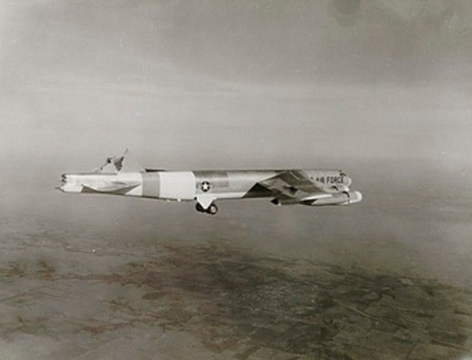

Figure 4. B-52 with Missing Vertical Stabilizer

- A B-52 had about three-fourths of its vertical stabilizer bitten off by 95-mph gusts at 14,300 feet over southern Colorado in 1964. The crew made a safe landing.

- A mountain wave ripped apart a BOAC Boeing 707 while it flew near Mt. Fuji in Japan in 1966. All 113 passengers and 11 crewmembers were killed in the disaster.

- A Fairchild F-27B lost parts of its wings and empennage at Pedro Bay, Alaska, in 1968. All 36 passengers and three crewmembers died.

- A Douglas DC-8 cargo aircraft lost an engine and wingtip in mountain wave encounters southwest of Denver, in 1992. The aircraft landed safely with no crew injuries.

Flight 826, Boeing 742-122

A United Airline Boeing 747-122, N4723U, was flying from Narita, Japan to Honolulu on December 28, 1997.

The airplane encountered "wave action" with an oscillation amplitude of 50 feet. This occurred approximately one hour and forty minutes into the flight and at an altitude of about 9450 meters (31,000 ft).

The captain turned the seatbelt sign on as a precaution. He also radioed Northwest flight 90, ahead of him, requesting a ride report. NW 90 reported that the ride was smooth with an occasional ripple of light turbulence at their altitude.

The Flight 826 aircraft encountered severe turbulence moments after the report. The aircraft suddenly dropped around 30 meters (100 ft).

The captain ordered the first officer to reduce speed, and he complied by reducing the indicated airspeed to approximately 330-340 knots IAS.

During the encounters, the Boeing 747 moved upwards at 1.8 G, sideways (0.1 G lateral) and down again 6 seconds later (-0.G g).

The captain saw a band of clouds with no lightning to the right and below the aircraft, before and after the turbulence encounters, but he did not see any lightning or clouds along the route of flight.

The aircraft returned to Narita. One passenger died of her injuries after landing. More than 70 others were injured. None of the passengers who sustained fatal or serious injuries were wearing their seat belts at the time of the accident

The aircraft was undamaged.

Source: NTSB Identification: DCA98MA015.

Flight 862, Boeing 747-422

A United Airline Boeing 747-422, N182UA, encountered clear air turbulence and wind shear while climbing through approximately 31,000 feet and while in international airspace over the Pacific ocean about 700 miles north of New Zealand. The flight originated in Sydney and was headed to San Francisco. The date was May 1, 2002.
A flight attendant sustained a serious injury. Another crewmember had a moderate injury. Five passengers had minor injuries. The flight diverted to Auckland, New Zealand so that the injured could receive medical treatment. The aircraft was not damaged.
According to the captain the airplane was flying over a flat broken cloud layer with a smooth ride prior to the turbulence event.
He reported, in part: "Passing 25 degrees south at FL310 we noticed that the cloud tops were gradually rising. Radar showed very little - a few green returns off to the right. We were in an area of no forecasted turbulence or cumulonimbus buildups. I turned on the seatbelt sign and made a passenger announcement."
The Digital Flight Data Recorder (DFDR) data showed that the airplane experienced a series of oscillating vertical and lateral accelerations that lasted almost 2 minutes. The vertical accelerations (expressed in units of gravity or G’s, 1.0 is normal) ranged from a low of +0.31 to a high of +1.7. The lateral accelerations (a value of zero is normal) ranged from 0.119 left to 0.115 right.
The National Weather Service Significant Weather Forecast Chart valid for the flight showed a 120 knot jet stream and the possibility of occasional moderate or lesser clear air turbulence south of the accident location and an area of isolated cumulonimbus clouds with tops to 40,000 feet to the north.
Source: National Transportation Safety Board accident database system (ADMS2000), last updated Jan 1, 2010.

NOAA Hurricane Hunter By Tom Irvine

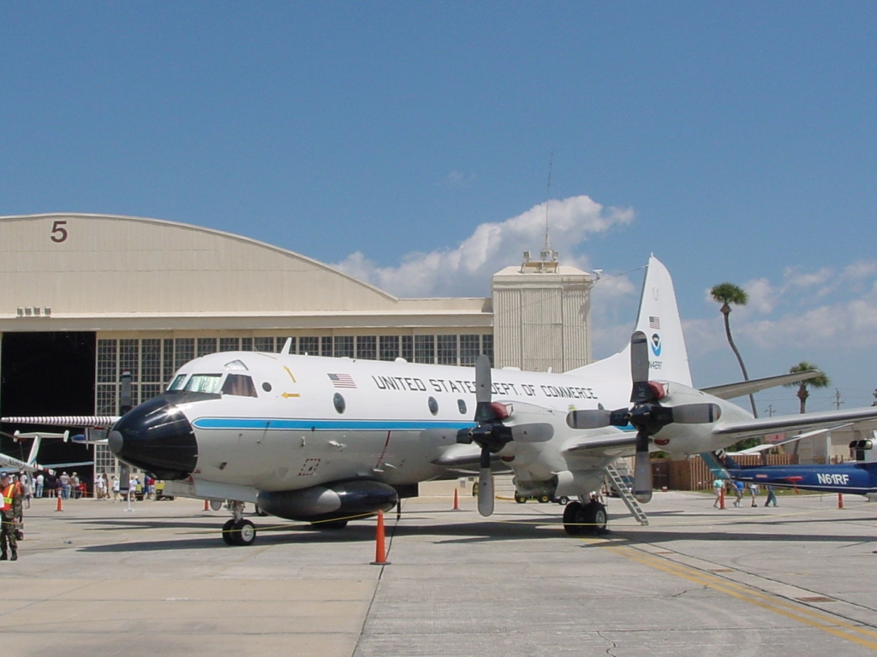

Figure 1. Lockheed WP-3D Orion, N42RF

Introduction

NOAA has two WP-3D Orion turboprop aircraft, designated N42RF and N43RF. The aircraft participate in a wide variety of national and international meteorological, oceanographic and environmental research programs in addition to their widely known use in hurricane research and reconnaissance.

The aircraft are equipped with an array of scientific instrumentation, radars and recording systems for both in-situ and remote sensing measurements of the atmosphere, the earth and its environment.

Hurricane Felix

Hurricane Felix was a destructive Category 5 hurricane on the Saffir-Simpson hurricane scale that struck Central America in 2007

Felix formed from a tropical wave on August 31. It made landfall just south of the border between Nicaragua and Honduras On September 4, in a region historically known as the Mosquito Coast with 160 mph (260 km/h) winds.

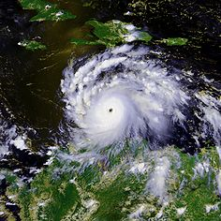

Figure 2. Hurricane Felix during rapid intensification

The following account is taken from meteorologist Dr. Jeff Masters' WunderBlog.

NOAA aircraft N42RF flew at 10,000 feet through Felix to drop a sonde (instrumentation unit) into the southeast eyewall. The swirling winds of the storm were so powerful that the sonde spun a full 3/4 circle around the eye before splashing into the northwest eyewall.

The aircraft next flew into the northwest eyewall. It encountered a powerful updraft followed a few seconds later by an equally powerful downdraft. The resulting extreme turbulence and wind shear likely made the aircraft impossible to control. Four G's of acceleration in both the up and down directions battered the airplane, pushing it close to its design limit of 6 G's.

The aircraft commander aborted the mission and returned safely to St. Croix. No injuries occurred.

Afterward, the aircraft passed a detailed six-hour inspection for damage and was cleared for flight.

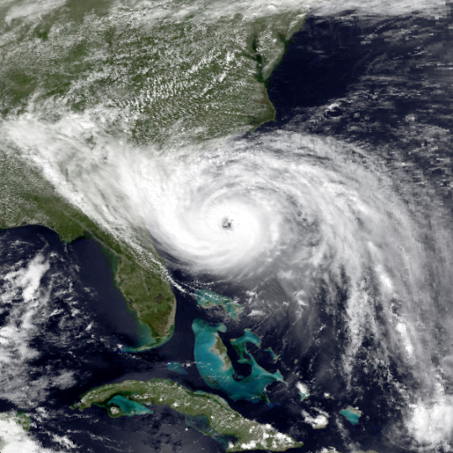

Figure 3. Hurricane Hugo before South Carolina landfall

Hurricane Hugo

Hurricane Hugo was a destructive Category 5 hurricane which struck the Caribbean islands of Guadeloupe, Montserrat, St. Croix, Puerto Rico, Antigua and the USA mainland in South Carolina during September of the 1989 Atlantic hurricane season.

The N42RF aircraft flew in to Hugo on September 15, 1989.

A series of massive jolts rocked the aircraft as it penetrated the eyewall at 1,500 feet. The aircraft made a rolling dive to 880 feet during the extreme turbulence.

The aircraft wings flexed severely and the number 3 engine caught fire. The pilots then shut it down. A de-icing boot was damaged and hung from the number 4 engine.

The pilots then made a spiraling climb in the eyewell. They dumped 15,000 pounds of fuel to lighten the aircraft.

An Air Force C-130 reconnaissance aircraft, which was also investigating the hurricane, flew into the eyewell to escort the N42RF to a safe exit at 7000 feet.

The N42RF landed safely in Barbados.

During the jolts, the aircraft had experienced a pounding of 5.5 G's up and 3.5 G’s down.

A 200-pound life raft and other equipment had dislodged inside the aircraft, but no injuries occurred.

The aircraft spent a month on Barbados undergoing a thorough check of its structural integrity before it was cleared to fly back to Florida, where it received a three-month long maintenance overhaul. No hurricane-related damage to the aircraft was found, except for the missing de-icing boot on the number 4 engine and a failed fuel control sensor on the number 3 engine.

Post-flight data analysis revealed that the aircraft hit a tornado-like vortex embedded in the eyewall when the hurricane was at its peak intensity.

Eyewall vortices had been suspected but never before observed. Ongoing research suggests that similar vortices may be responsible for some of the incredible damage hurricanes can inflict when they strike land.

Meteorologist Dr. Jeffrey Masters was on board the N42RF during the flight. He was deeply affected by the experience and has written about it at:

http://www.wunderground.com/resources/education/hugo9.asp

