S_{v} (in/sec)

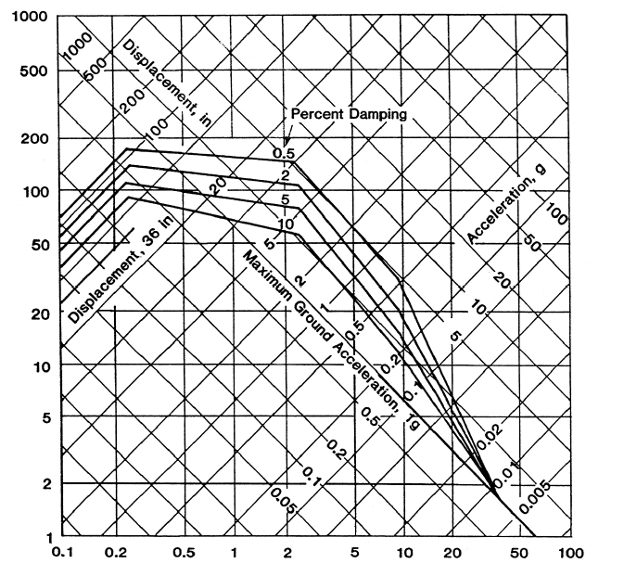
Natural Frequency (Hz)

U.S. Atomic Energy Commission Horizontal Design Spectra, Regulatory Guide 1.60 (1973)

